Enka International Model United Nations (ENIMUN)

11-14.11.2016

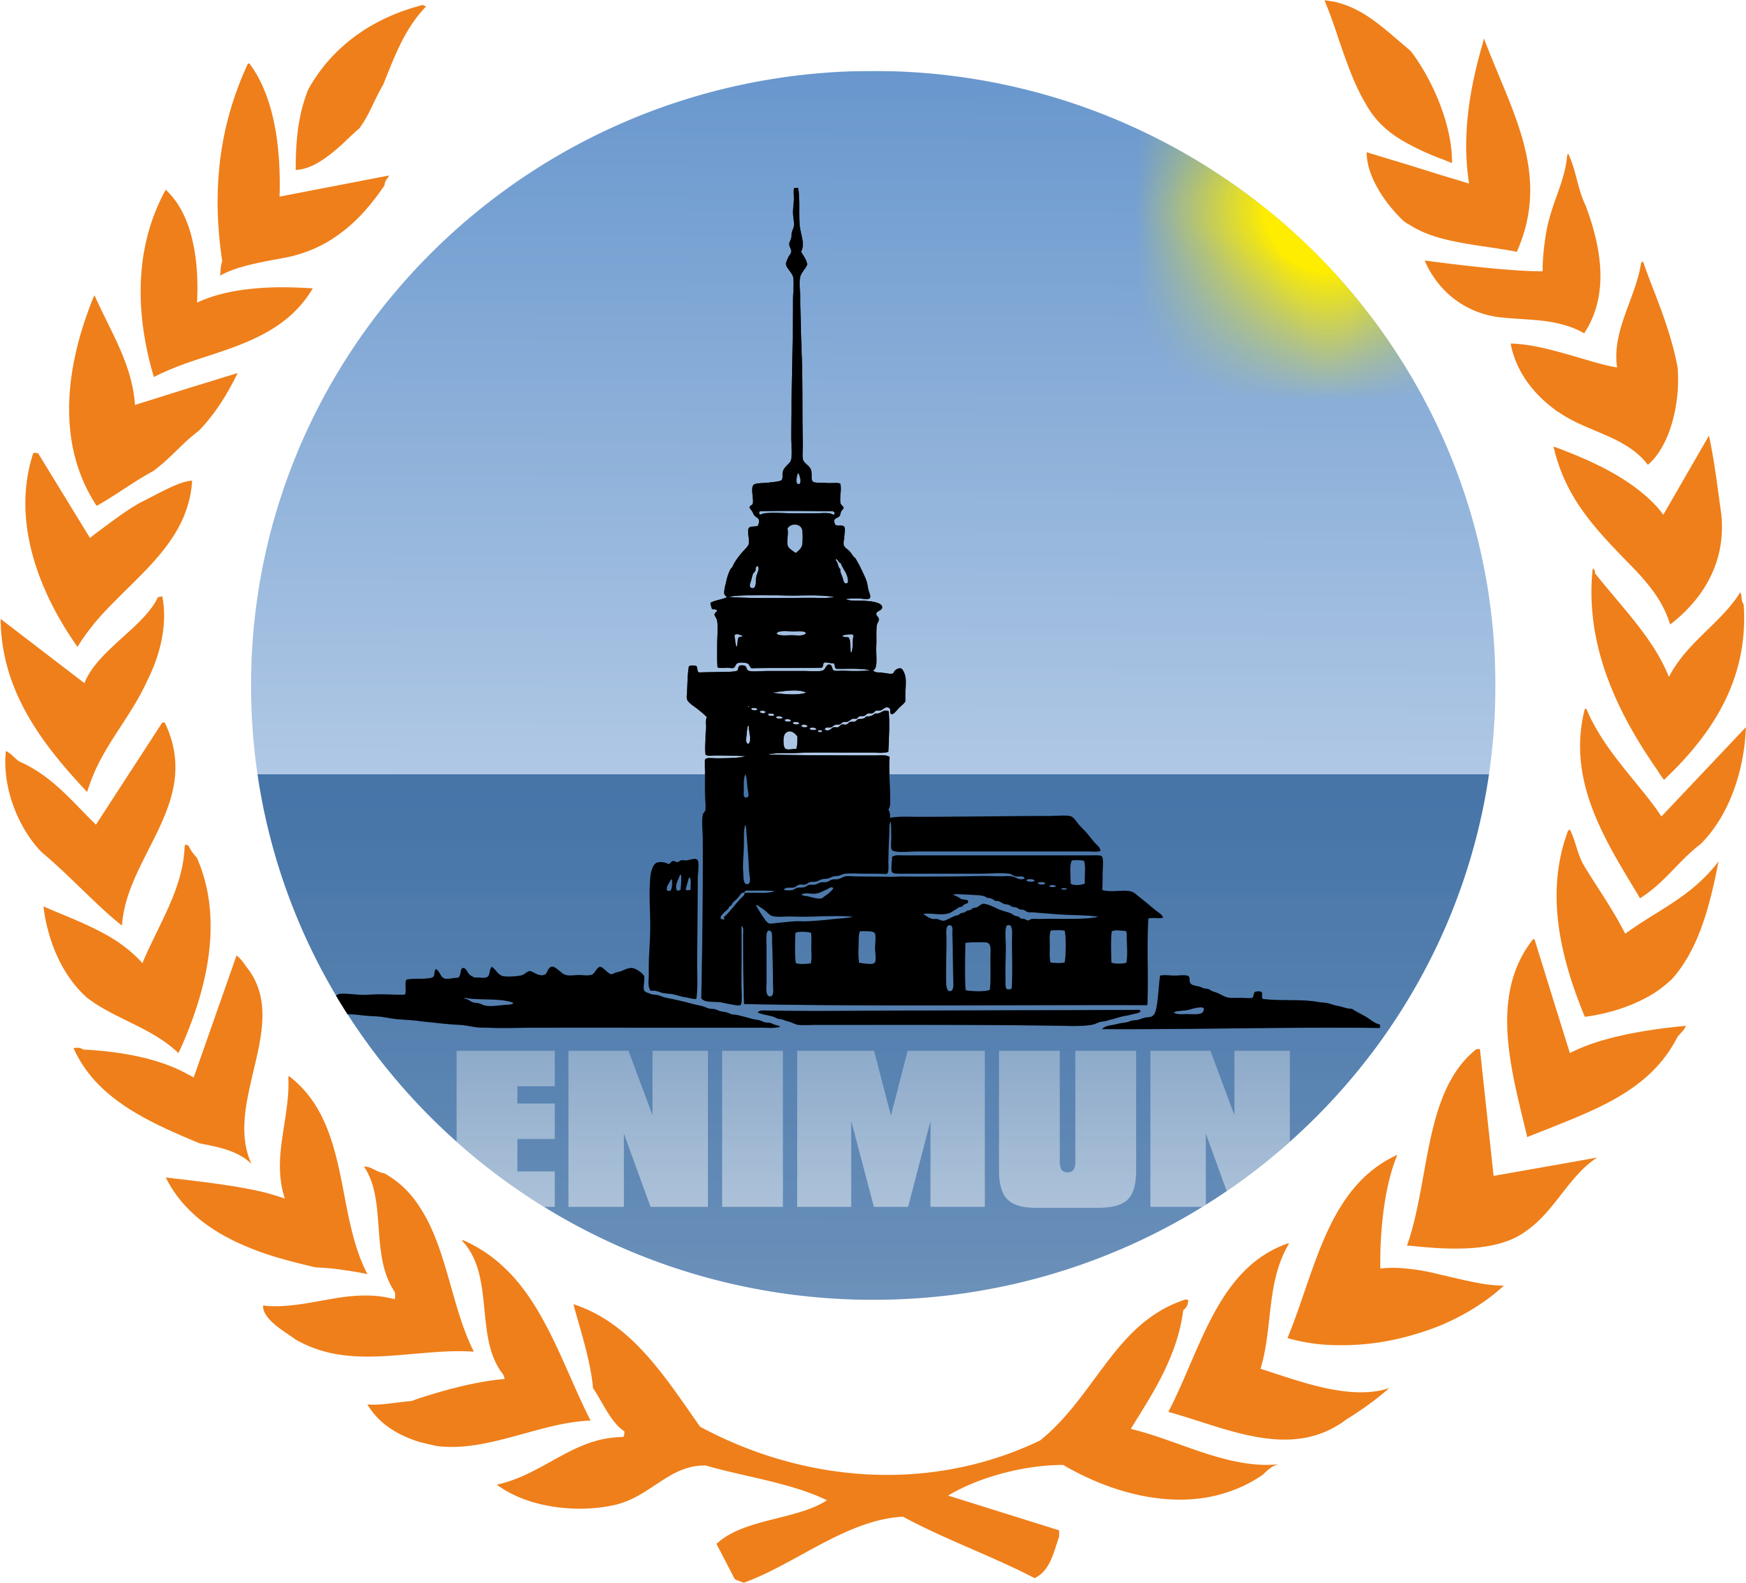

- Conference Explanation
- Explanation of MUN
- Conference Mission
- Conference Schedule
- Conference Committees
- Information on Improviso
- Rules and Procedure

CONFERENCE HANDBOOK

Conference Explanation

After having organized conferences in the past years under the names of MUNICA and ENIMUN, our third year of ENIMUN will once again be presented to high school students around Turkey and the globe. Our aim is to bring together students from different cultures and backgrounds to discuss and debate upon world politics, international and civil conflicts, trade, human rights and other issues of world prominence to find possible and constructive solutions. We aim to create individuals who are aware, international minded, and politically and socially active to create a 21st Century that is more equitable and peaceful for everyone.

To fulfill the aim of create responsible future generations, the experienced members of our school’s high school Model United Nations Club organize our conference. ENIMUN is not for a profit organization and while organized by Enka School students it does not receive financial aid from Enka Schools or the Enka Foundation.

In our 2014 conference, there were more than 220 student participants from private and public schools around Turkey and internationally. This year we are again open to international and intercity participants. These participants and their advisors will be staying at hotels suggested by the conference.

This year we wish to expand the conference and are expecting more than 260 participants. We will be in contact with schools within Turkey and elsewhere for easier communication.

Explanation of MUN

When the United Nations was created in 1945 it had a mission: to restore standing peace to a war-torn world through the use of dialogue, communication and understanding. 70 years after its inception this still continues.

Yet diplomacy between adults is not enough. A foundation for the creation of open-minded and active adults must be formed; therefore the youth of every nation must also work with each other, experience different cultures learn the necessity of peace and collaboratively find solutions to prominent issues that everyone in the world face.

To achieve this goal, the first edition of MUN was organized at Harvard University in 1953. Since then there have been thousands of conferences with participants from over a hundred countries.

There are two distinct types of organizing and running an MUN conference. One is with THIMUN rules of procedures, and the other is with Harvard rules of procedures. ENIMUN follows THIMUN procedures.

Based on the United Nations, there are 4 main committees, modeled after the United Nations General Assembly. Next to these there are specialized committees, modeled after the special and sub agencies of the UN.

Participants within each committee represent various nations and debate upon their committee’s agenda items. The delegates then formulate solutions and write resolutions. After the debate session, if the resolution is accepted the 4 main committees then debate upon it in the General Assembly.

Delegates must make public speeches, write clauses, and defend their ideas. Furthermore, delegates compromise, collaborate and socialize with others.

Conference Mission

When we began this journey in 2013 we were ecstatic that we would finally be organizing our very own conference, after years of participating in other schools conferences.

We started this journey with these objectives:

- Providing an organized platform for delegates to express their ideas and proposals freely,

- Creating opportunities for delegates to enhance their public speaking skills,

- Organizing crises that challenge and develop participants,

- Creating awareness regarding international issues,

- Setting up a spectacular reception and ensuring an enjoyable and unforgettable conference for all,

- Developing skills for participants to use in the future to create a more harmonious world,

- Creating long-lasting friendships that span cultures and distances,

- Understanding the importance of communication and dialogue and the role of the United Nations in achieving world stability.

We have always in our daily lives strived to achieve our ideals as example citizens, and wish to do all of this and more in this year’s conference.

Conference Schedule

Friday
16:00 - 17:00 Registration (Refreshments served)
17:10 - 18:40 Opening Ceremony (Auditorium)
18:45 Departure
Saturday
08:30 – 09:00 Refreshments
08:40 – 08:55 Student Officer Briefing
09:00 – 11:00 1st Session (GA Plenary/Specials in session)
11:00 – 11:20 Coffee Break
11:20 – 13:00 2nd session (Lobbying/Debate in session)
13:00 – 14:00 Lunch
14:00 – 15:30 3rd Session (Lobbying/Debate in session)
15:30 – 15:50 Coffee Break
15:50 – 17:30 4th Session (Debate in session/Lobbying for Improviso)
17:35 – 17-50 Student Officer Debrief
Sunday
08:30 – 09:00 Refreshments
08:40 – 08:55 Student Officer Briefing
09:00 – 11:00 5th Session (Debate in session)
11:00 – 11:20 Coffee Break
11:20 – 13:00 6th Session (Debate in session)
13:00 – 14:00 Lunch
14:00 – 15:30 7th Session (Debate in session)
15:30 – 15:50 Coffee Break
15:50 – 17:30 8th Session (Debate in session)
17:35 – 17:50 Student Officer Debrief
Monday
08:30 – 09:00 Refreshments
08:40 – 08:55 Student Officer Briefing
09:00 – 11:00 9th Session (GA in Auditorium, Specials continue debate)
11:00 – 11:20 Coffee Break
11:20 – 13:00 10th Session (GA in Auditorium, Specials continue debate)
13:00 – 14:00 Lunch
14:00 – 15:30 Closing Ceremony (Auditorium)
15:30 – 16:00 Student Officer Debrief
*At this point in time, the schedule is subject to change under the Executive Team's discretion.

Debrief

Conference Committees

GA1: Disarmament and International Security Committee (DISEC)
- The suspension of the manufacturing of WMDs by the North Korean Government
- Tackling the issue of terrorist financing and arms trade through revising international laws and regulations
GA2: Social, Humanitarian and Cultural Committee (SOCHUM)
- Taking action against gender related killing of women and girls
- Ensuring of access to basic human rights to Syrian refugees
GA3: Special Political and Decolonisation Committee (SPECPOL)
- Settling of the ongoing territorial disputes regarding the East China Sea
- Evaluating and acting accordingly to the outcomes of the impeachment process against Dilma Rousseff, the 36th President of Brazil
GA4: Environmental Committee
- Combatting ocean acidification
- The proper disposing of radioactive wastes

Special Committees
Security Council
- Question of refugees in the Mediterranean regarding stability and security
- The military involvement of Turkey in Jarabulus, Syria
ECOSOC (Economic and Social Council)
- The exit of Britain from the Europan Union (EU) and the drop of the value of the British Pound
- Evaluation of trade policies of the WTO for global economic growth
Improviso
Due to the nature of the Improviso Committee, the agenda item will not be announced.
*At this point in time, all agenda items are subject to change under the Secretariat's discretion.

Information on the Improviso Committee

Improviso is an ENIMUN exclusive special committee that was first held in the conference in 2014.
While most MUN conferences require a lot of research and preparation beforehand, a delegate should be able to adapt, adjust and react appropriately to any given situation. This is the idea behind this committee.
The Improviso Committee forces delegates to think under pressure and create resolutions similar to a crisis scenario. Until the day of the conference, the agenda item of the Improviso committee will not be announced. No one will be aware of the issue except for the Student Officers of Improviso and the ENIMUN Executive Team.
There will be one entire day dedicated to lobbying. Delegates will use this time to do any necessary research and create resolutions. After this day, there will be no more lobbying sessions and the committee will proceed just as the other committees will.
This committee promotes improvising under pressure and this way delegates gain a valuable new experience.

Conference Rules and Procedure
(THIMUN rules and procedures apply for our conference)

A. Modes of Debate
Open Debate: This gives the opportunity for all delegates to take the floor to discuss anything related to the resolution without any restriction. ‘Open debate’ will be the debate mode in GA, ECOSOC, Improviso and Security Council.
Closed Debate: This is the section of the debate where the delegates can take the floor as “in favor” or “against.” However, closed debate ispermitted and required during the debate of amendments in the aforementioned forums.
Ad-Hoc Debate: This is when amendments are used to build the resolution on a clause-by clause basis; the Security Council uses this form of debate.
B. Parliamentary Language
While referring to the…
· Chair: ‘Most distinguished chair’
· Delegate: ‘Honorable delegate’ (The use of he/she is not appropriate during references to other delegates. ’You’ is only appropriate when it applies to the whole delegation.)
· Speaker: 'We’ should be the form of addressing one's delegation. Speakers should NEVER use ‘I’ to address themselves. 'Less Economically Developed Countries (LEDCs)’ in the place of the terms such as ‘poor’ or ‘third world’ and ‘More Economically Developed Countries (MEDCs)’ in the place of terms such as ‘rich’ should be used.

C. Rising to Points
1. Point of Personal Privilege
Definition: A point that is a personal request to alter something. (I.e. the temperature of the room, speaker’s voice cannot be heard) to the comfort of the delegate. Conditions: It may ONLY interrupt the speaker if it concerns the audibility. It does not require any ‘second’s.
2. Point of Order
Definition: It is a point that refers to the procedural matters only. It is used if a chair makes a mistake in the order of debate or in the setting/observing of debate time. Conditions: It may NOT interrupt a speaker. Often delegates are anxious to shout out ‘Point of Order’ but the delegates must wait until the speaker is done and the floor is open for debate. The order is not open to debate and it refers to a matter that just happened. i.e. ‘Is it in order for the delegate to yield the floor to another delegate since the floor was previously yielded to them by Costa Rica?’
3. Point of Information to the Speaker
Definition: A question directed to the delegate that has the floor, and who has indicated that he/she is open to points of information.
Conditions: The speaker asking the ‘Point of Information’ may only speak if recognized by the chair. It must always be in a question format. Otherwise, it is considered inappropriate and is out of order.
4. Point of Information to the Chair
Definition: A question directed to the chair about anything that is not covered by the other points. It is a way for the delegates to clarify information regarding the topic under debate and to ask factual questions. It may also be a question about the schedule of the day…
Conditions: It may NOT interrupt a speaker. If the delegate asks a specific question, the chair may ask the house to allow him/her the time to look up information. Usually, the expert chair who wrote the research report on the issue will provide the necessary information.
5. Point of Parliamentary Inquiry
Definition: A Point of Parliamentary Inquiry is a question directed to the chair about the protocol. Its aim is to clarify the procedures of the debate.
Conditions: The difference between this Inquiry and a Point of Order is that ‘Point of Order’ aims to point out a fact that the delegate wants to make or is missing in the procedure; in contrast to this, Point of Parliamentary Inquiry seeks an explanation about a procedural matter the delegate is confused about.
REMEMBER: A Point of Parliamentary Inquiry CANNOT interrupt a speaker. It is expected that the delegate will refer to the Chair directly with the question.

D. Procedural Motions

1. Motion to Move to the Previous Question: advancing to the voting procedure of the clauses/amendments in regard to the resolution at hand.
How the Process Works: It requires a ‘second’ (support) by the House, and is quickly voted upon if there aren’t any objections.
The Vote: If an objection is voiced, a quick vote is taken. For the motion to pass a 75% majority is required.
2. Motion to Adjourn the Debate: (also used as ‘motion to table the resolution/amendment’) is considered to be a destructive motion. It directly means suspending the debate on a proposal.

How the Process Works: Since this motion almost always serves as a destructive purpose, the motion is rarely entertained by the chair.
The Vote: It needs a simple majority to be passed and for the proposal to be tabled.
3. Motion to Reconsider a Resolution
How the Process Works: It is the motion to bring a resolution back for consideration by the house. It is done at the end of all other committee affairs and is used for tabled resolutions or failed resolutions.
The Vote: It is not debated; rather the house immediately votes upon

4. Motion to Refer the Resolution to Another Forum (e.g. Security Council, Special Committees)
How the Process Works: A motion which sends the resolution to a different committee, almost always is the Security Council, whose decision will be the final decision. The selected house votes and debates on the given resolution.
The Vote: The chair rarely entertains this motion due to time constraints. Often when this motion is moved, there are attempts to avoid this motion by amendments that reword the clause. It requires 75% majority.
5. Objections to the Main Motion
How the Process Works: It is a motion to object to the discussion of a specific agenda item within the context of the resolution. This lowers both the efficiency and the quality of the debate. If the ‘objection to the main motion’ is adopted, the discussion of the resolution on the topic is cut off, without any chance of being reconsidered.
Proposer of the Motion: A delegate whose sovereignty is threatened by this motion. Examples include Israel during the discussion of Palestinian National Authority or China during the discussion of Taiwan/Tibet.
The Vote: It is almost overruled by the chair. However, it is the chair’s discretion and can be entertained just for the sake of debate, considering that it is very difficult for this objection to pass. The proposer of the motion has one minute to explain the objection and the main submitter of the resolution has equal time to defend the agenda item and the resolution. It requires the majority of delegates (at 75%) who support the objection to the main motion.

6. Motion to Extend Debate Time
How the Process Works: This is a motion to call for more time for the discussion of the resolution or amendment that includes the point to be expanded.
The Vote: This motion is not open to debate and is at the decision of the chair. If the chair rules on having the “division of the house,” the chair takes the vote by calling on all delegations in alphabetical order.
E. Amendments
There are three ways to make amendments:
STRIKE OUT: The delegate may strike an entire clause or part of a clause out. A delegate may not strike out multiple clauses or multiple sub clauses.
ADD: The delegate may add an entirely new clause. The delegate may also choose to add a new sub clause. Adding only one clause or sub clause at a time is allowed.
INSERT: The delegate may choose to insert a new continuous phrase into the clause.

F. Voting
VOTING ON RESOLUTIONS
Non-Governmental Organizations (NGOs) and Non Member Delegations (NMDs) are not allowed to vote. Delegates can vote for, against or abstain.

VOTING ON AMENDMENTS
Non-Governmental Organizations (NGOs) and Non-Member Delegations (NMDs) are not allowed to vote. Delegates can vote for or against. Abstentions are not in order.
VOTING ON PROCEDURAL MATTERS
Non-Governmental Organizations (NGOs) and Non-Member Delegations (NMDs) are allowed to vote. Delegates can vote for or against.

NOTE:
It is forbidden to state a motion or point during the voting procedure a motion or point during the voting procedure (“Point of order” is an except ion as long as there is a procedural mistake regarding the voting procedure). The same rules apply during the division of the house.
You can access the THIMUN Rules of Procedure with this link: http://www.thimun.org/images/downloads/Rules_of_Procedure_revised.pdf

Research
Begin by looking at your delegation’s webpage. It generally helps to search for it as “The Permanent/Temporary mission of (Insert Country Name) to the UN.” You will be able to find most of your country’s official statements and speeches to the UN there.
· Read the student officer reports.
· Search for your country on the CIA World Fact Book available online. This site will help you with obtaining facts and information on your designated country.
· Check out your school library for research. DO NOT USE THE INTERNET ONLY. Wikipedia should not be a final source, and more trusted sources such as the BBC, The New York Times and/or the UN webpages should be preferred.
· Create lists or tables of facts and figures to use and check on during debates. You will need these lists while asking questions to delegates or while making strong and clear points. Keep this list composed strictly of facts, figures, statistics and quotes with another paper comprised of your ideas.
· Go over past resolutions and treaties on the agenda item(s) you are working on. A lot of past resolutions can be found on committee pages available on www.un.org
Reminders
· Co-submitting and signing a resolution: Signing onto a resolution does NOT mean that the delegate is FOR the resolution. Being a co-submitter does not mean he/she agrees with it, but it does means that the delegate would like to discuss the resolution.
· Personal pronouns: A delegate has to address his/her own delegation with the “we” pronoun form. Every single word that leaves the delegate’s mouth becomes the policy of his/her country.
· Referring to resolutions within the committee: All delegates must contain their speech content ONLY to the questions at hand. Delegates are not allowed to make references to past or future resolutions of that particular MUN committee. Making references to real past and future resolutions of the UN is encouraged, but the discussion of the past and future MUN resolutions of the committee you are currently a part of is considered a deviation and is out of order. Also, while in closed debate on an amendment, the delegates may only speak on the amendment at task and cannot exploit the floor time they are given to speak on the resolution as a whole.
· Passing resolutions on the same topic: All resolutions shall have an equal and moderate time period to be discussed on objectively.
· Appealing and war declarations: Delegates must forgo from being disruptive. Delegates are not allowed to challenge the decisions of the Chairs publicly and make declarations of war. Any disagreements and problems with the Chair must be handled with a respectful, calm and non- confrontational manner.
· Speeches: Diplomats should consider using facts and research during speeches. Speeches are not a platform for analogies, parodies or informal content. Solid speeches do not just contain the strengths and weaknesses of resolutions. The best speeches have a thesis idea that is more sophisticated and well structured than “This resolution is effective/weak.”

We wish all delegates a pleasant conference!

