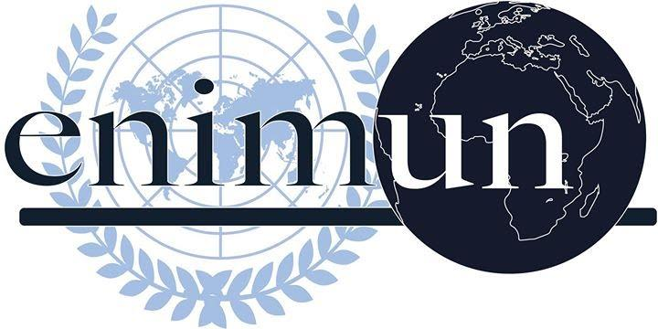

CHAIR REPORT

Special, Political and Decolonization Committee

(SPECPOL)
2019

The question of sovereignty of British Overseas Territories

Zeynep Poyanlı

Deputy Chair

Introduction
The question of sovereignty has been an issue that has been debated since the establishment of the idea in the 19th century. The desire of being an independent state has led the willing governments to take advantage of the political landscape and establish their independence, however, circumstances have prevented some to succeed. In the present, despite the fact that “Declaration on the Granting of Independence to Colonial Countries and Peoples” has been adopted, certain circumstances continue to prevail, especially for the British Overseas Territories (BOTs).
British Overseas Territories (BOTs) were initially considered as colonies of the United Kingdom. Over the course of multiple wars, agreements, and declarations, the United Kingdom had acquired these territories and put itself in the position of an ally, since it helped the BOTs to stimulate their economies. In 1982, with the British Nationality Act, these territories were no longer “crown colonies” and were renamed as “dependent territories.” This resulted in the British Overseas Territories being less contingent on the United Kingdom and British citizenship was not granted to the majority of the BOTs. After 30 years, the British Overseas Act was established, and the citizens of the British Overseas Territories were granted citizenship. In the present, different aspects and wishes of the territories, while preserving their identities and considering their histories and their relationships with other nations, create the question of sovereignty and continue to be an issue.
This issue highlights the importance of global collaboration, or the lack thereof. Without global collaboration and thinking solely of the assets and liabilities a nation has, there will be suffering and inequity. In territories that were dependent on the United Kingdom for centuries, answering the question of sovereignty in the British Overseas Territories is crucial while keeping in mind the British Overseas Territories itself, and those of other nations.

Key Vocabulary
Sovereignty
Sovereignty is the authority a state has to govern itself. A state which is sovereign has the right to do everything that is necessary to govern itself, such as but not limited to establishing laws, forming international alliances and collecting taxes without any interference from outside forces. The extent of sovereignty may differ between governments since a state decides whether it is going to recognize another state’s sovereignty or not. British Overseas Territories (BOTs) are under the sovereignty of the United Kingdom in the present.
British Overseas Territories
British Overseas Territories are islets that are politically bound to another state in different ways, such as being a colony or an integral part of the established state, however, since these territories are “overseas”, they have to be geographically separated from the “mother state” with the sea.
Commonwealth of Nations
The Commonwealth of Nations is an association of 53 independent nations and territories that are associated with the United Kingdom by being former parts of the British Empire. Membership to the Commonwealth is voluntary and the purpose of this organization is to increase international cooperation and collaborate on different matters, especially regarding economics and trade. It is important to note that the decisions made by the Commonwealth are non-binding since the involved parties are not obligated to implement the rulings made by the Commonwealth.
Autonomy
A nation which is autonomous and self-governing has the functions of a central government to an extent and may create legislations. However, the right to execute these functions is given to the autonomous regions by the central government. In an autonomous region, the state can pursue its understanding of governance under the ruling of another nation. Therefore, British Overseas Territories are considered as self-governing regions that are given the right to govern by the United Kingdom and have to comply with their central authority to an extent.
Tax haven
Tax haven regions have a significantly lower tax rate when compared to other countries, therefore, companies that do not want to pay higher taxes in their own countries are often registered to these regions. This may create a tendency of corruption in tax haven nations, like the British Overseas Territories, when not properly regulated. The regulation of the BOTs is one of the main concerns of the nations which are against the establishment of their sovereignty.
Crown dependencies
Unlike British Overseas Territories, Crown Dependencies are neither a part of the European Union (EU)—despite the fact that they are in the EU territory—, the BOTs or the United Kingdom, but they are self-governing and non-sovereign states. They are nonetheless dependent on the United Kingdom to an extent since the United Kingdom ultimately has a say on the legislation affecting their territories. The Crown dependencies have their Head of State as the Queen and continue to have a constitutional relationship with the UK.
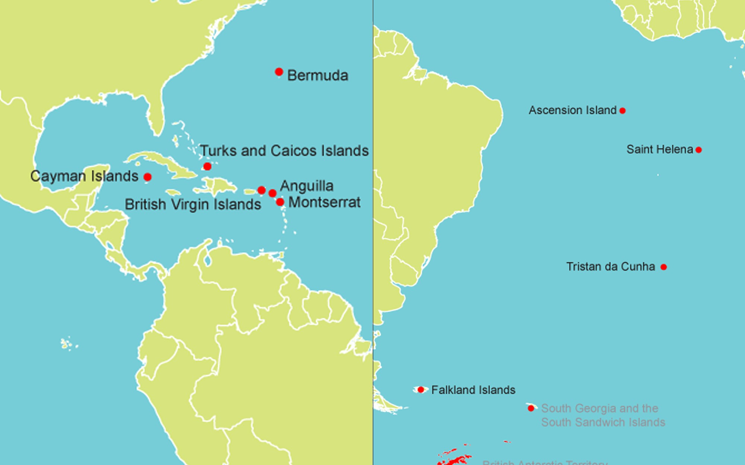
Focused Overview

Picture 1: Geographical Location of the British Overseas Territories
The British Overseas Territories (BOTs), namely Anguilla, Ascension, British Virgin Islands, Bermuda, Cayman Islands, Falkland Islands, Gibraltar, Montserrat, Pitcairn Islands, Saint Helena, Tristan de Cunha and the Turks and Caicos Islands, are a group of 12 essentially self-governing territories that are spread throughout the Northern and Southern Hemispheres, as seen in Picture 1. BOTs are not a part of the UK and they have the right to legislation according to their own policies, however, they are also bound to the UK in differing areas, such as having pride in their British identity. They also have a diverse range of cultures and environments among themselves.
The United Kingdom acknowledges the right of sovereignty to each British Overseas Territories; however, different conditions exist for different territories, which is the starting point of the question on sovereignty. For instance, the state of Gibraltar is a member of the European Union (EU) in the present, however, the slow process of the Brexit deal creates an issue within the European Union itself. Gibraltar currently has the right to vote in EU elections, however, if the Brexit deal is finalized, Gibraltar will have to leave the EU since the majority of the UK voted for it to “leave”. This situation with the EU sparked the conflict between Spain and the United Kingdom since both of these nations are claimants on Gibraltar. Furthermore, there are certain BOTs that are economically dependent on the UK, which hinders their will of autonomy.
Currently, the Foreign and Commonwealth Office of the United Kingdom (FCO) is responsible for the affairs between the BOTs and the UK, which is an area of concern for some BOTs. Some BOTs believe that the FCO, which is the department responsible for foreign affairs, having responsibility on their territories results in them being managed, which is against the constitutional rights of the BOTs. Consequently, the BOT governments lack representation on the decisions made on their own countries and still remain dependent on the United Kingdom, despite the fact that they are officially independent and “partners” that engage in mutually beneficial actions with the United Kingdom.
There are certain disparities in the policies that the BOTs and the United Kingdom established in their own territories, which resulted in the desire of sovereignty strengthening for some BOTs. Same-sex marriage has been legalized in all of the BOTs except the ones that are in the Caribbean (Anguilla, British Virgin Islands, Cayman Islands, Montserrat, and Turks and Caicos), which is against the policy that the United Kingdom follows in their own territories, as well as the remaining BOTs. This creates an issue among the aforementioned nations since there are certain groups, such as certain societal and religious groups that are strictly opposed to this idea. The second disparity is on the matter of “belongership”. The extent of their connection to the United Kingdom has been mentioned in the constitutions of Anguilla, Bermuda, British Virgin Islands, the Cayman Islands, the Falkland Islands, Gibraltar, Montserrat and Turks and Caicos. However, the definition of citizenship varies between nations. The individuals who reside in the areas which are not considered as “belongers” cannot vote or become a part of the office, even if they are permanent BOT residents or UK citizens. For instance, in Turks and Caicos, solely the individuals with the “belonger” status are able to use the rights that are generally associated with citizenship, such as voting.
Major Parties Involved and Their Views
United Kingdom: United Kingdom’s support for the sovereignty of the British Overseas Territories depends on the opinions of the individuals residing in the area. The UK gives the option of proceeding with self-governance to every willing territory. Recently, a referendum was held in Bermuda, in which 73 percent of citizens voted in favor of retaining the link between Bermuda and the UK.
Spain: Spain and the UK have disputed over Gibraltar, which is an overseas territory that is close to Spain in geographical proximity but is under the sovereignty of the UK. As a result of the war between Spain and the UK which took place in 1713, Spain gave up Gibraltar to the UK, however, Spain continues to claim sovereignty on the territory. It is also important to note that the majority of the economic activities in Gibraltar depend on the border with Spain.
Argentina: Argentina has claimed sovereignty on 3 BOTs, namely Falkland Islands, South Georgia, and the South Sandwich Islands. The Argentinian government alleged that it regained the sovereignty of the aforementioned three areas in “peaceful ways”, therefore, the idea of “Argentine Irredentism” was established. Furthermore, the nations of Chile and Argentina are actively disputing the sovereignty of the British Antarctic Territory (BAT), which has the largest area among the BOTs.
Chile: Since both Chile and the UK are geographically proximate to the Falkland Islands, there have been disputes regarding the sovereignty of these areas between the two states.
Mauritius: Mauritius is against the sovereignty of the United Kingdom on the Falklands Islands since it has declared sovereignty to the Islands itself. The UK does not recognize the sovereignty claims of Mauritius, however, they support the islands to be handed over to the UK after the area can no longer be used for defense purposes.
European Union (EU): None of the British Overseas Territories except Gibraltar and Southern Cyprus are the members of the EU, therefore, the question of sovereignty, alongside with the recent developments in the UK, such as Brexit, lead the EU to incline towards not supporting UK sovereignty of the British Overseas Territories.
Timeline of Events

Date of Event | Description of Event
1960 | Declaration on the Granting of Independence to Colonial Countries and Peoples was adopted by the Member States of the United Nations
1965 | Chagos archipelago was given to the United Kingdom in exchange for Mauritius’ independence and became a British Overseas Territory
1982 | Falkland Islands got under the governance of the UK after the Falklands War between the UK and Argentina
1982 | British Nationality Act, which was the initial document that declared the rights of citizenship for the citizens accommodating in the British Overseas Territories, was ratified
1973 | United Kingdom joined the European Union
2002 | British Overseas Territories Act which elaborated on the term “British Overseas Territories” was ratified and the British Nationality Act of 1982 was amended
2009 | The United Kingdom partially suspended the constitution of the Turks and Caicos Islands, which is one of its British Overseas Territories
2010 - 2020 | The given timeframe is declared as the Third International Decade for the Eradication of Colonialism

Evaluation of Previous Attempts to Resolve the Issue
- A/RES/1514 (2018)
This General Assembly resolution is one of the prime documents that define the right of independence to pre-colonial countries or territories, which fit the current classification of the BOTs. Specifically, Clause 2 indicates that territories can establish its independence upon their will, and Clause 3 states that dependency may serve as a reason to delay independence, therefore, both the United Kingdom’s and the BOTs point-of-views are justified.
- International Court of Justice (ICJ) Antarctica Cases (1956)
  - United Kingdom v. Argentina
  - United Kingdom v. Chile
United Kingdom delivered two different cases to the ICJ, one against Argentina and the other against Chile, both concerning the sovereignty of certain lands in Antarctica. After the verdict was rendered, the United Kingdom stated that Chile and Argentina haven’t accepted the verdict according to their knowledge, which Chile and Argentina responded by saying that they were not going to accept the jurisdiction. This proves that although an attempt has been made in order to resolve the issues that international affairs create, a result has not been reached on the lands in Antarctica, which are currently considered as BOTs.
- A/AC.109/2019 (2019)
This draft resolution, meaning that it hasn’t been voted on yet, was approved by the Special, Political and Decolonization Committee (SPECPOL) very recently. It includes matters regarding different non-self-governing territories, as well as 2 BOTs, namely British Virgin Islands, and Turks and Caicos. The approval of this resolution highlights the fact that recent discussions have taken place, and therefore, shows the urgency to tackle the issue at hand.

Possible Solutions
Since this issue concerns multiple territories that have different concerns, the delegates are advised to research each BOT separately, while considering their international affairs and economic situations. Nations with concerns on specific BOTs should come up with specific solutions since the circumstances of sovereignty may vary between territories depending on different factors. Especially in BOTs that are economically dependent on the United Kingdom, prioritizing the establishment of an independent market would be beneficial for their sovereignty. Furthermore, in order to determine the opinion of the public eye, referendums can be held, however, measurements should also be taken in order to prevent any manipulation of data. United Kingdom’s clarification of its relationship with the European Union (EU) should be clarified as soon as possible to determine the future of the funds given to the BOTs by the EU. Membership status of the BOTs to the EU, which will likely occur if the Brexit deal is finalized, should be enacted with specific laws and agreements. Following the given guidelines would assist the delegates to come up with a diplomatic and constructive resolution.

Further Reading
- https://publications.parliament.uk/pa/cm201719/cmselect/cmfaff/1464/1464.pdf
- https://bvi.gov.vg/sites/default/files/resources/UKWhitepaper-Britain%20and%20the%20Overseas%20Territories%20a%20Modern%20Partnership.pdf
- https://www.globalsecurity.org/military/world/europe/uk-bot.htm
- https://ukota.org/member-territories/
- https://peoplesdispatch.org/2019/02/27/recommendations-of-the-uk-parliamentary-report-on-overseas-territories-irks-political-leadership-in-the-territories/
- https://assets.publishing.service.gov.uk/government/uploads/system/uploads/attachment_data/file/217278/british-overseas-territories.pdf
- https://publications.parliament.uk/pa/cm201012/cmselect/cmfaff/writev/overseas/ot18.htm

Bibliography
“A New Approach to the British Overseas Territories: Justice Assistance Engagement Plan .” Publishing Service of the United Kingdom, https://assets.publishing.service.gov.uk/government/uploads/system/uploads/attachment_data/file/217278/british-overseas-territories.pdf.
“Association of the Overseas Countries and Territories with the European Union Including Relations between the EU, Greenland and Denmark * - Thursday, 31 January 2019.” Europarl.europa.eu, http://www.europarl.europa.eu/doceo/document/TA-8-2019-0053_EN.html?redirect.
“British Overseas Territories Act 2002.” Legislation.gov.uk, Statute Law Database, 5 Mar. 2002, http://www.legislation.gov.uk/ukpga/2002/8.
“Global Britain and the British Overseas Territories: Resetting the Relationship.” Publications of the United Kingdom Parliament, https://publications.parliament.uk/pa/cm201719/cmselect/cmfaff/1464/1464.pdf.
Kindred, Alahna. “What Does a No Deal Brexit Mean for Gibraltar?” The Sun, The Sun, 25 Feb. 2019, https://www.thesun.co.uk/news/8210175/brexit-no-deal-uk-gibraltar-colony/.
“British Overseas Territories.” Air Safety Support International (ASSI), https://www.airsafety.aero/About-ASSI/Overseas-Territories.aspx.
“Panama Papers Q&A: British Overseas Territories and Crown Dependencies.” BBC News, BBC, 5 Apr. 2016, https://www.bbc.com/news/uk-35969481.
Pike, John. “Military.” British Overseas Territories, https://www.globalsecurity.org/military/world/europe/uk-bot.htm.
“UK British Overseas Territories.” UK British Overseas Territories - GOV.UK, https://www.gov.uk/international/government-topics-foreign-affairs-uk-overseas-territories.
UKOTA. “Member Territories.” UKOTA, https://ukota.org/member-territories/.

