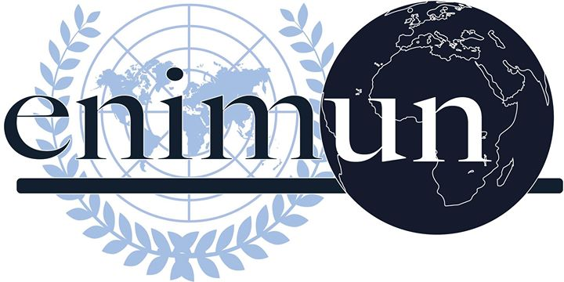

2019

ChaIr REPORT

SECURITY COUNCIL (SC)

QUESTION OF PALESTINE

KAAN KARATAŞ-DEPUTY CHAIR

Introductionn
Since the issue began in the mid 20th century, many attempts have been made in hopes of finding a middle ground between the two sides of the conflict. None of these have proved effective in the long run. At the heart of the Palestinian-Israeli conflict is the growing amount of Israeli settlements in what is considered to be Palestinian Territory. Such settlements have been declared illegal by international law and pose an obstacle towards arriving at a comprehensive solution. The government of Israel supports the settlements legally and financially with the purpose of enhancing Israel’s security, but the settlements also cause fragmentation of the Palestinian territory and as a result, are obstructing the creation of an independent state of Palestine and aggravating the tensions between the two parties. Currently, there are 121 government authorized settlements and 102 “illegal” ones (outpost) in the Occupied Palestinian Territories, which are defined as those beyond the 1949 Green Line and are compromised of the majority of the West Bank, the Gaza Strip and East Jerusalem. In 2004, the International Court of Justice declared that the settlements were a clear breach of international law as an advisory opinion, not only due to legal aspects, but also to human rights violations in such territories. Nevertheless, Israel continues to support settlement activity and despite pressure from the international community, hasn’t ceased supporting the practice through infrastructure and economic aid, regardless of the threat it poses towards the right of self-determination of a Palestinian State.

Key Vocabulary
Aliyah: The immigration of Jews from the diaspora to the promised Land of Israel
Diaspora: The term referring to the Jews living around the world, outside the Land of Israel.
Land of Israel: An area in the southern Levant region with indefinite borders that is promised to the Jewish in Holy Books.
Anti-Semitism: The act of discrimination against Jews.
Zionism: The movement that aims to re-establish (then) and to develop (now) a Jewish nation in the Land of Israel.
British Mandate for Palestine: The state formed after the British Occupation of Palestine from the Ottoman Empire and lasted until the establishment of Israel.
Aliyah Bet: The illegal immigration of Jews to the Palestinian region during the restrictions of the Mandate. The direct translation reads as Aliyah Beta as in the second Aliyah.
Arab League: The organization of the Arab nations in the Middle East and North Africa region that was formed in 1945 by Egypt, Iraq, Transjordan (now Jordan), Saudi Arabia, Lebanon and Syria. It now has 22 members.
Guerilla Forces: Small groups of armed civilians and ex-military personnel using hit and run tactics to fight an organized military.
Fedayeens: Palestinian guerillas that have started fighting for land from Israel after the 1948 Arab-Israeli war.
Palestine (region): The geographical area that includes the Land of Israel, the Gaza Strip and the West Bank.
Palestine (state): a state partially consisting of the geographical regions of the West Bank and the Gaza Strip governed by the Palestinian National Authority. The state of Palestine’s right to self-determination has been granted by the UN but not yet achieved due to the conflict with Israel.
Hamas: An organization with the goal of liberating Palestinians from Zionists. It is considered as a terrorist organization by many nations. It controls the Gaza Strip with a de-facto authority since 2007. It is known for its extremist Islamist actions.
Palestine National Authority: The authority formed with the 1993 Oslo Agreements and is recognized by the UN to govern Palestine. Its political wing is called Farah.

Focused Overview
1) Background Information and the Aliyahs
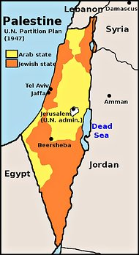
The still ongoing conflict began with the Jewish immigration, referred to as Aliyah, towards the “promised land” which includes Jerusalem and Palestine. The process began in 1882 as a party of over 35000 Jews immigrated to the Palestinian region over the course of 20 years. With the rise of Anti-semitism throughout Europe and particularly in Nazi Germany, the Jewish population in the area reached around half a million in late 1930s. The tensions between Arab and Jew inhabitants kept growing and caused a number of riots and uprisings, the most significant being the Great Uprising of 1936-1939. In the light of the unrest, the British who then controlled the region under the British Mandate for Palestine intensely limited the Jewish immigration to 75000 people for the next 5 years. In response to the restrictions, Jews started the Aliyah Bet movement. Despite being illegal, this method remained the primary form of immigration to the Palestinian Mandate until the establishment of the Israeli State. The stance of the Mandate against Jewish immigration in spite of the Holocaust that was going on in Europe at that time caused many Jews in Palestine to turn against the British Mandate while illegal immigration continued to rise. Approximately 110000 Jews reached Palestinian territory during Aliyah Bet.
2) The Arab-Israeli War of 1948
The United Nations passed a partition plan in 1947, dividing Palestine into separate Jewish and Arab states but the latter side rejected the plan. In 14th of May 1948, the head of the Jewish Agency David Ben Gurion declared the independence of the State of Israel. The declaration triggered the 1948 Arab-Israeli war, starting in the early hours of May 15th 1948 as Egyptian, Transjordanian, Syrian and Iraqi military forces invaded the newborn state and the entire Arab League followed suit. The war lasted for 10 months. In the aftermath, the State of Israel took control over the Jewish State borders proposed in the 1947 partition plan in addition to around 60% of the proposed Arab State. More than 700000 Palestinians Arabs were displaced from the new Israeli lands and around the same number of Jews were forced to flee to Israel from other Middle Eastern states.
Picture 1: 1947 UN Partition Plan Map.
3) Early Years of The State of Israel and The Six Day War
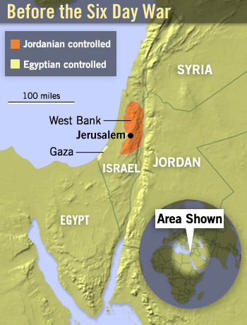
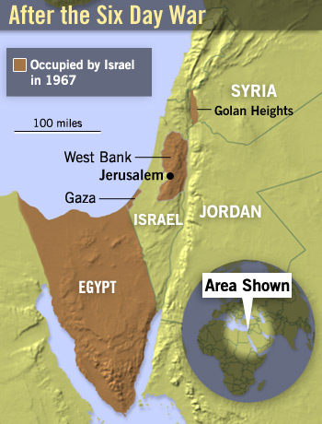
Israel was admitted to the UN in May 1949 by majority vote. During the following 20 years, the population boomed as immigration continued to rise. The 1950s saw frequent attacks from Palestinian guerilla forces called fedayeens and Israeli counterattacks. The first major war was the Six Day War of 1967 following Egypt’s pacts with Syria and Iraq. Israel saw then Egypt Head of State Abdel Nasser’s open statements against Israel as a threat, especially after Egypt stationed 100000 soldiers along with several thousand battle tanks and war planes in Sinai Peninsula, launching the first of a series of attacks constituting the Six Day War against Egypt and the other Arab countries that joined (Syria, Jordan and Iraq). Resulting from the war, Israel gained control of The Sinai Peninsula and the Gaza Strip from Egypt, of The Golan Heights from Syria and of The West Bank (including West Jerusalem) from Jordan. Israel continues occupying the mentioned territories except the Sinai
Picture 2: Region Map Before The Six Day War of 1967.

Picture 3: Region Map After The Six Day War and Israeli Occupied Regions.
Peninsula to this day.
4) Key Issues of The Conflict
THE SETTLEMENT POLICY:
Israel’s settlement policy consists of the construction of civilian settlements in all occupied and annexed territories. These compounds are populated by Jewish settlers who are economically aided by the government. Thanks to this policy, Israel’s influence and control over the occupied lands strengthen, deterring the possibility of the implementation of a Palestinian Arab State in the area. This policy is considered to be illegal under international law.
REFUGEES:
The Palestinian demand that refugees from the 1948-49 war and their descendants return to the homes they abandoned in what is now Israel is where this issue regenerates from. For Israelis, this is a red line. They regard the absorption of these refugees, whose number has in the past 60 years grown from some 800,000 to more than 4.6 million, into their own territory as the effective creation of a Palestinian state inside Israel. For Palestinians, however, what they regard as the "right of return" is highly sensitive, and according to the most recent opinion polls, an approximately two-thirds majority of Palestinians demand the return of refugees to all of Palestine.
In Israel, however, there is almost wall-to-wall consensus against this, with some 87 per cent, according to the most recent opinion polls, saying they are against the return of even one Palestinian refugee to Israel itself, and another 6 per cent saying Israel can absorb just a small number of up to 100,000.

- -

JERUSALEM:
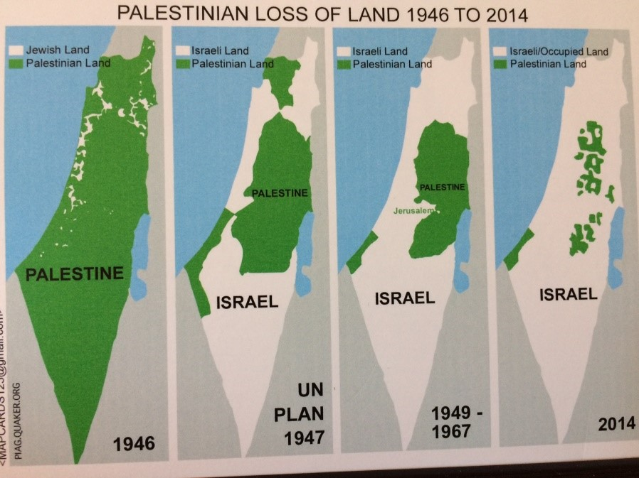
The city of Jerusalem is considered holy for both sides as both Islam and Judaism mention the city in their Holy Books multiple times. This number is over 700 times in the Jewish Old Testament. Palestinians demand the withdraw of Israeli forces from East Jerusalem, which it occupied in 1967’s Six Day War from Transjordan. This was never recognized int the international community. East Jerusalem is where the Arab neighborhoods of the city are mostly situated, along with quite a few Jew neighborhoods and the holy Al Aqsa mosque. The Old City and the Historic Jewish Quarter including the Western Wall (sometimes referred to as the Wailing Wall) are also placed in the eastern part of the city which eliminates any option of withdrawal for Israelis.
--
BORDERS:
The armistice line from the end of the 1948-49 war has become the de facto border separating sovereign Israel from the West Bank.
Palestinians demand a full Israeli withdrawal to these lines; Olmert has spoken about an Israeli pullout from most of the West Bank, without specifying.

Picture 4: Palestine Map Over The Years.
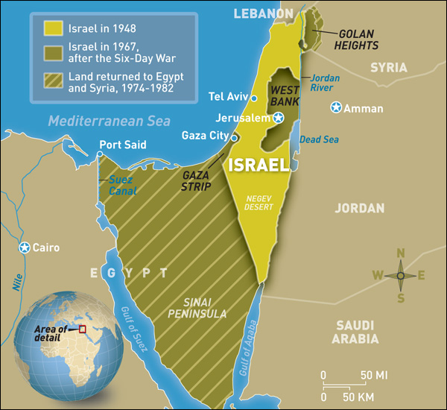
President George W Bush, in a statement from April 2003, seemingly endorsed Israel's refusal to pull out from the entire West Bank, saying that "facts on the ground" had changed since the armistice lines were drawn up.
Palestinians remain unconvinced, rejecting anything less than a complete West Bank pullout, pointing out that as things now stand, a Palestinian state in the West Bank and Gaza Strip would only occupy a small part of pre-1948 Palestine.
But Israelis point out that total withdrawal has security ramifications, with the West Bank border at one point being only about 14 kilometers from the sea.

Picture 5: Israel Borders Over The Years
The experience of the 2005 pullout from the Gaza Strip, which saw the salient then used by militant groups as a base from which to launch makeshift rockets at nearby Israeli towns and villages on an almost-daily basis, has also soured many Israelis on a total withdrawal, and is in fact repeatedly cited by those who oppose such a move.
In addition, a West Bank withdrawal is linked to another issue, namely that of Israeli settlements. Palestinians, who see them as Jewish enclaves on their land, preventing the formation of a contiguous state, insist they be dismantled entirely.
But Israel wants to keep their settlement blocks, notably those near major population centers, some located several kilometers east of Jerusalem, or those situated near the border.
5) The Oslo Accords Onwards
The Oslo Accords are divided in two major parties: Oslo I and Oslo II with the latter taking place two years after the first, in 1995. The accords allow the Palestinians to hold a democratic election and divide the West Bank and the Gaza Strip into three different areas, Area A under full Palestinian control, Area B under Palestinian control, but with joint Palestinian-Israeli security control and Area C with full Israeli control. From 1996 to 2001 all Prime Ministers express the intention of developing the existing and creating new Israeli settlements in the Palestinian territory for the sake of Israel’s security. In 2004, The International Court of Justice declares that Israeli settlements in the lands acquired in the 1967 war are a breach of the International Law and the 4th Geneva Convention. In 2012, the General Assembly votes for Palestine to hold an observer status as a non-member state in the UN. 2013 is marked by rapid growth of settlements and continued financial support of the government towards the development of the Israeli settlements. Israel continues to claim that Palestine is guilty of incitement and of supporting terrorist action against Israel. The end of 2013 and the beginning of 2014 were marked by the official approval of the Israeli government for 1,400 new settler homes in East Jerusalem and 261 the West bank. Further, the number of Israeli demolition of Palestinian building has reached a 5-year high.

6) Fatah vs Hamas
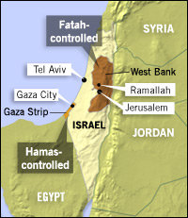
Palestine has two main political parties: Hamas and Fatah. Hamas was founded in 1987 as a Sunni-Islamist party and is regarded as a terrorist organization by the majority of the international community; notably Israel, The United States of America and The European Union. It is known for its extreme Islamist actions. Fatah is a social democrat party which largely held power through the then president Yasser Arafat. After his death in 2004 a 2006 election was held, resulting in Hamas majority in The Palestine Legislative Council. The Fatah-Hamas conflict arised after the election. The conflict quickly escalated to a war with a death toll of around 600 over the years. Since 2007, Hamas has been the de facto governing authority of the Gaza Strip while Fatah holds control in the West Bank region. Hamas has fought several wars against Israel throughout the years. Palestine now has two polities: The Hamas Government in Gaza and the Fatah ruled Palestinian National Authority in West Bank. Both parties see themselves as the true representatives of the Palestinian.

Picture 6: Palestine, governing authorities as of 2019

Major Parties Involved and Their Views

Israel:
The State of Israel is the Occupying Power in the Palestinian territory. To this day, they have continued to support and finance the settlements in the Occupied Palestinian territories, despite harsh criticism from the international community. Furthermore, Israel doesn’t consider the West Bank “occupied territory” but rather “disputed territory” stating that they acquired it in 1967 in self-defense. The Government of Israel claims the return to the pre-1967 borders are unnecessary and certainly not an obligation; therefore, rid themselves of the responsibility of dismantling all settlements in the West Bank, also claiming the settlements don’t violate any Palestinian-Israeli Treaty. The Israel-Palestinian Interim Agreements prohibit any unilateral actions that may alter the status of the West Bank, yet Israel claims that this doesn’t directly affect their settlements.

Palestine
Palestine is the occupied territory in the Israeli-Palestinian conflict. They have been given the right to self-determination but have not been recognized as official states by many countries and still have observer status in the UN. The Palestinians have recognized the right of Israel to exist, but haven’t accepted it as a Jewish state. The Palestinian Authority is in favour of arriving to a two-state solution as long as a fair consensus is reached. The Palestinian Territory of the West Bank is controlled by the Palestinian Authority, representing the Fatah group and yet the Gaza Strip is governed by the de facto authority Hamas. The power of Hamas over the Gaza Strip poses a great problem to the arrival of a comprehensive solution due to their approval of violence as a means of arriving to solution. In order for Palestine to accept a peace treaty, a comprehensive solution to the refugee issues, the settlements and the Jerusalem needs to be arrived to. Palestine accuses Israel of being unwilling to compromise due to their continual approval of settlements in the West Bank and East Jerusalem. Further, they claim Jerusalem as their capital due to its religious significance to Muslims.

The United States of America
The United States and Israel are considered to have one of the strongest diplomatic relationships in the international arena. This good relationship is due to strong economic ties and mutual interests, seeing as the Israeli Lobby in the United States is very powerful. The United States continues to be very involved in the peace process negotiations between Palestine and Israel. Their primary goal is to preserve security in Israel. The US doesn’t have official diplomatic relations with Palestine as they have not recognized them as official states and they consider Hamas, the Palestinian government in the Gaza Strip, a Foreign Terrorist Organization.

ICJ

The Court declared that the Israeli settlements in the 1967 borders were in clear breach of the International Law and the 4th Geneva Convention Regarding the Protection of Civilians in Time of War. Israel denies the illegal nature of their settlements as they claim the land gained in the 1967 was taken in self-defense and therefore doesn’t constitute a breach of the 4th Geneva Convention.

Timeline of Events
Date of Event (Day/Month/Year) | Description of Event
23/05/1939 | Mandate Ban (White Paper)
1939 - 1948 | Aliyah Bet
29/11/1947 | 1947 UN Partition Plan
14/05/1948 | Ben-Gurion’s Declaration of Independence and the Arab Israeli War
05/06/1967 | Six Day War
13/09/1993 | Oslo Accords
2006- Present | Hamas- Fatah Conflict

Evaluation of Previous Attempts to Resolve the Issue

- UN Partition Plan of 1947
Divided the land between a Palestinian and a Jewish State, with Palestine getting the totality of the West Bank, and the Gaza Strip. Jerusalem was made international territory under UN jurisdiction. The border described in this plan, known as the 1947 borders, are not followed by Israel, and are mostly disregarded as an option for agreements. Following this, Israel declared itself an independent while Palestine did not.

https://unispal.un.org/UNISPAL.NSF/0/7F0AF2BD897689B785256C330061D253

- S/RES/242 (1967)
Passed with unanimous vote. Calls for the withdrawal of Israeli armed forces from recently occupied territories. Generally supported by the Arabs and opposed by the Israeli State due to its nature. Was never implemented due to the strong Israeli opposition.

https://unispal.un.org/UNISPAL.NSF/0/7D35E1F729DF491C85256EE700686136

- S/RES/446 (1979)

Called for an immediate cessation of all action that could change the legal or demographic status of the Arab lands acquired in 1967, determined the illegal nature of Israel’s settlements in the Occupied Palestinian territories, asked Israel to abide by the 4th Geneva convention. Wasn’t recognized by Israel, as they didn’t deem their settlements illegal or applicable to the 4th Geneva Convention.
http://unispal.un.org/UNISPAL.NSF/0/BA123CDED3EA84A5852560E50077C2DC

- Oslo Accords
The Oslo Accords, signed in 1993, establish the guidelines for the creation of an interim, democratically elected self-governing body for the State of Palestine. It set up a transitional period of five years in which permanent status issues were to be determined between the State of Israel and the Council elected by the Palestinian peoples. The Oslo Accords failed due to the lack of disposition of both parties to begin peace talks regarding permanent status negotiations on issues such as the settlements, the refugees, etc. Despite the fact that the elected Council was meant to be transitional and last for a period of five years, the Palestinian National Authority (PNA) remains present to this day. The negotiations were meant to have started in 1996, and yet they only got underway in 2000. Even then, the only agreements that were arrived to was the interim withdrawal of Israel from 40% of the West Bank settlements and 65% of the Gaza Strip settlements, leaving the PNA with partial control over such territories. Further, Israeli forces controlled entrance/exit, and the territories given to the Palestinian people were surrounded by Israeli territory.

- Arab Peace Initiative
The Arab Peace initiative of 2002 was a framework drafted by the Arab League that emphasizes the need for the withdrawal of Israel from all territories acquired during the 1967 war and calls for a just solution to the refugee problem. The Secretary General of the United Nations, Ban Ki-moon, expressed his support of it and asked Israel to keep an open mind towards it. Because it was never accepted by Israel, the Arab Peace Initiative did not lead to a step forward in the process.

Possible Solutions
Because the Israeli settlements in Occupied Palestinian territory are at the root of the Palestinian-Israeli conflict, a compromise needs to be arrived to in order to achieve a viable solution, but most importantly, the settlements must end. Due to the sensitive nature of the issue, it needs to be done step by step in order to guarantee both parties security. It is crucial that the solutions proposed are realistic and credible for both sides. It is also very important for the UN and the international community to recognize Palestine as an official member state in order to give it an equal status to Israel and to be able to rebuild their infrastructure as a state as well as to give them an equal position in the negotiation process. Lastly, organizations or states that share close diplomatic ties with Israel such as the United States or the European Union should consider placing pressure on them, and likewise with countries with close economic ties with Palestine, such as the Russian Federation. UN Secretary General Antonio Guterres stated: “In this moment of great anxiety, I want to make it clear: there is no alternative to the two-state solution. There is no Plan B. For my part as the UN Secretary-General, I will do everything in my power to support the Israeli and Palestinian leaders to return to meaningful negotiations and to realize this vision of a lasting peace for both people.” It is clearly understood that a two state solution should be reached in order to implement an environment of persistent peace. Also, all of the key issues of the conflict must be addressed.

Further Reading
- Everything you need to know about Israel-Palestine : https://www.vox.com/2018/11/20/18079996/israel-palestine-conflict-guide-explainer

- Guide: Why are Israel and the Palestinians fighting over Gaza?: https://www.bbc.co.uk/newsround/20436092

- Hamas and Fatah: Palestinian brothers at war : https://www.france24.com/en/20190913-reporters-hamas-fatah-brothers-war-palestinine-west-bank-gaza-israel

- The Oslo Accords and the Arab-Israeli Peace Process: https://history.state.gov/milestones/1993-2000/oslo

Bibliography

- Al Jazeera. “The Arab Peace Initiative.” News | Al Jazeera, Al Jazeera, 28 Mar. 2010, www.aljazeera.com/focus/2009/01/200912764650608370.html.
- AlJazeera. “The Arab-Israeli Wars.” News | Al Jazeera, 9 Dec. 2003, www.aljazeera.com/archive/2003/12/2008410115114656999.html.
- “British White Paper of 1939.” The Avalon Project : British White Paper of 1939, avalon.law.yale.edu/20th_century/brwh1939.asp.
- Hanukoglu, Israel. “Israel Science and Technology Directory.” History of Palestine and Palestinians, www.science.co.il/israel-history/Palestine-history.php.
- History.com Editors. “Oslo Accords.” History.com, A&amp;E Television Networks, 16 Feb. 2018, www.history.com/topics/middle-east/oslo-accords.
- History.com Editors. “Six-Day War.” History.com, A&amp;E Television Networks, 11 May 2018, www.history.com/topics/middle-east/six-day-war.
- Khatib, Ghassan. “Israeli Settlement Policy: Its Impact on the Scope Oj Peace in the Region By Ghassan Khatib.” PIJ.ORG, 2019, pij.org/articles/520/israeli-settlement-policy-its-impact---on-the-scope-oj-peace-in-the-region.
- Lambert, Olly. “Gaza E.R. ~ Fatah vs. Hamas.” PBS, Public Broadcasting Service, 9 Dec. 2008, www.pbs.org/wnet/wideangle/uncategorized/gaza-e-r-fatah-vs-hamas/1227/.
- Tahhan, Zena. “Hamas and Fatah: How Are the Two Groups Different?” Palestine | Al Jazeera, Al Jazeera, 12 Oct. 2017, www.aljazeera.com/indepth/features/2017/10/hamas-fatah-goal-approaches-171012064342008.html.
- Thiel , Melissa. “The Israeli-Palestinian Conflict: A Historiographic Essay.” Twu.ed, twu.edu/media/documents/history-government/The-Israeli-Palestinian-Conflict.pdf.

- “UN Partition Plan - Resolution 181 (1947).” Mfa.gov.il, mfa.gov.il/mfa/aboutisrael/maps/pages/1947%20un%20partition%20plan.aspx.

- Westervelt, Eric. “Six Day War: Shaping the Modern Middle East.” NPR, NPR, 4 June 2007, www.npr.org/2007/06/04/10619929/six-day-war-shaping-the-modern-middle-east.
- “Zionism.” A Definition of Zionism, www.jewishvirtuallibrary.org/a-definition-of-zionism.

