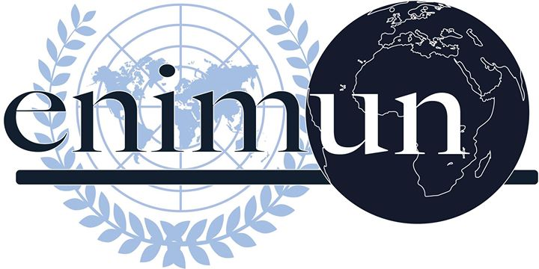

2019

ChaIr REPORT

North atlantıc Treaty OrganIzatıon (NATO)

The future of NAto’s Mandate ın afghanıstan

Utku eren Eroğlu - PresIdent Chaır

Introduction
Being one of the most unsettled countries in the last few decades, Afghanistan has hosted multiple clashes that have led to the death of thousands, with an unstable political structure and an everlasting economic insurgency as consequences. Due to its geopolitical influence as a gate between Asia and Europe, Afghanistan has disputed many nations, including multiple superpowers such as the United States and the United Kingdom, throughout its only as a century-long history as an independent nation. Its impact over the Middle Eastern politics has shaped the balances of the peninsula significantly, especially considering the foreign intervention that is directed to conflicts occurring, in means of either profiting over various circumstances as individual nations, or preserving security over the region.
As an intergovernmental military organization to be founded in 1949, North Atlantic Treaty Organization (NATO) comprises 29 nations under the motto “Animus in consulendo liber” (A mind unfettered in deliberation), serving in order to protect the principles of democracy, individual liberty and the rule of law over the North Atlantic area. Constituting the system of collective defense under Article 6 of the North Atlantic Treaty, all NATO members shall undertake necessary actions if any external party was to attack to any Member State. While the very principle of collective defense serves as a fundamental device in means of safety, its impact cannot be overseen over the modern political sphere around the globe. Following the September 11 attacks, the United States launched an invasion to Afghanistan, as to dismantle al-Qaeda; and NATO became involved following the establishment of the International Security Assistance Force (ISAF). Though the devastation decreases significantly through negotiations, the clash goes on as years go by; and many actions have been taken through various forms throughout the years, while the question at hand, that is the future of NATO’s presence in Afghanistan, remains obscure.

Key Vocabulary

Mandate: The term refers to the authority given to an elected group of people, such as a government, to perform an action.

Interventionism: Interventionism can be explained as a policy to be obtained by an intergovernmental institution or a state that targets the manipulation of another political entity; usually in means of profiting over certain occurrences. Being promoted by a variety of ideologies such as Machiavellism and political realism, interventionist policies can be exemplified by most conflicts to occur throughout the Cold War era, and several doctrines to be obtained by many world leaders throughout the 20th century.

Proxy war: A term repeatedly used in the Cold War era to describe a war between two or more nations that is fought indirectly, neither country directly engages the other; and takes place in another country.
Mujahideen: The term comes from the plural word of mujahid –someone who is commonly called as a fighter for Islam, often a guerilla fighter, and against non-Islam states or parties. It comes from the Arabic word “jihad”, an important phrase from the Quran which means to radiate Islam via fighting. Quran 2:191 reads as “...And slay them wherever you find them, and drive them out of the places whence they drove you out, for persecution is worse than slaughter... and fight them until fitnah is no more, and religion is for Allah.” Mujahideen is the first frequent use of such guerilla warriors seen in the Soviet-Afghan War, led by tribal leaders in rural mountainous areas.
Focused Overview
- Historical background - Foreign influence
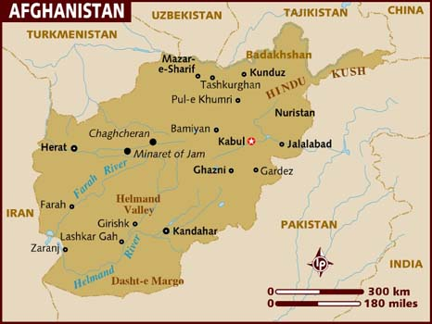
Afghanistan, a nation of 37 million inhabitants, is one of the fastest-growing populations on the planet and is bordered by many prominent countries of the region, including Iran, Pakistan, and China. Its strategic location serves as a crossroad connecting Iranian, Central and East Asian civilizations; though being one of the most mountainous countries in the world. Being handed from one government to another throughout the centuries, Afghanistan was ruled by the United Kingdom before their declaration of full independence in 1919; and the administration initiated proceedings for the modernization of the nation.

Picture 1: Afghanistan map
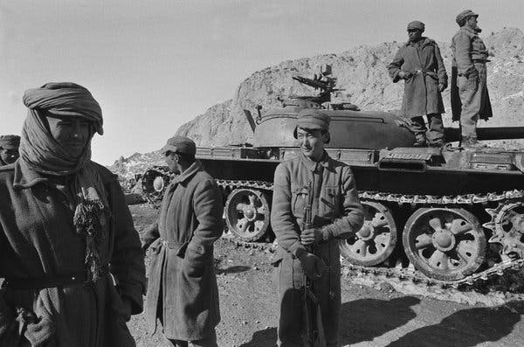
Despite remaining neutral throughout the World War II era, Afghanistan built strong ties with the Axis powers, including Germany, which had the biggest share in the country’s development at the time. As the political sphere of the world shaped following the end of the war, Afghanistan obtained close relationships with both of two Cold War blocs, the US and the Soviet Union. Therefore, both parties vied for bigger influence over the nation, through building infrastructure and highways. The Soviet Union appeared to be predominant over the race, and the growing sympathy towards Soviet policies resulted in the coup d’état to be organized by the People’s Democratic Party of Afghanistan against then-President Mohammed Daoud Khan, which is now known as the Saur Revolution. Soviets backed the new administration, while a tension grew with the United States following the death of Adolph Dubs, the US ambassador to Afghanistan. The Afghan government ratified a treaty in December 1978 which granted them to call on Soviet forces, repeatedly requested the access of troops in Afghanistan in the spring and summer of 1979. Soviet troops were to provide safety and to help the government in the conflict against the anti-communist Muslim mujahideen rebels.

Picture 2: Soviet invasion of Afghanistan
As the opposition against the government escalated, the United States started supporting the rebellious movement; while the Soviets were increasing the aid drastically. Soviet Union deployed thousands of soldiers and military advisors to the borders, and therefore started the invasion in 1979.
The Soviet War in Afghanistan lasted almost 9 years, between the Soviet forces and the Mujahideen. The Mujahideen’s main motivation to overthrow the government, while the Soviet Union was helping the government while the rebels found support from different sources including the United States and Pakistan. The conflict was a proxy war between the two Cold War opponents (United States of America and the Soviet Union), who never actually fought in direct confrontation.
The Soviet army periodically carried attacks out against the mujahideen between 1980 and 1985. Mujahideen resisted against Soviet attacks with the help of CIA providing assistance via Pakistani intelligence services and thousands of young people coming from Muslim countries to Afghanistan in order to wage jihad against the atheist communists these young were called Afghan Arabs. One of those who had a major influence in the following years was Osama Bin Laden, whose Arab group eventually evolved into al-Qaeda.
These military engagements between mujahideen and the Soviet troops lasted uninterruptedly until 1987. The arrival of Gorbachev on the scene 1985 and his new foreign policy was the main reason the Soviet Union withdrawing from Afghanistan, nevertheless, economic and political onerousness of the invasion were reasons that obliged the Soviet Union to withdraw from Afghanistan. In 1988, the retreatment process had begun, the United States and Soviet Union forces started to return. By the February 1989, Soviet army withdrew all of its contingent in Afghanistan.
After 1989, the war continued despite Soviet withdrawal. According to the State Department, “the mujahideen were party neither to the negotiations nor to the 1988 agreement and, consequently, refused to accept the terms of the accords.” Thus there was “a new round of internecine fighting between the various militias, which had coexisted only uneasily during the Soviet occupation. With the demise of their common enemy, the militias' ethnic, clan, religious, and personality differences surfaced, and the civil war continued.”
From 1989-1994, the country sank even further into anarchy. Different parts of the territory were held by different mujahideen groups and warlords. On March 19, 1992, then UN Secretary-General, Boutros Boutros-Ghali, called for an end to the “human tragedy” that had been occurring in Afghanistan for more than a decade, while at the same time noting that the country had been “subjected to total The civil war continued until 1999 when the Taliban – which had captured the southern city of Kandahar from a local warlord in 1994 and slowly expanded its influence over the country – controlled about 90% of Afghanistan. Members of the Taliban are largely from the southern Pashtun ethnic group, which ruled Afghanistan for hundreds of years and today accounts for about 40% of Afghanistan’s population. According to Ahmed Rashid, a Pakistani journalist, a handful of Taliban had fought the Soviet Red Army in the 1980s, more had fought the regime of President Najibullah who had hung on to power for four years after Soviet troops withdrew from Pakistan in 1989, but the vast majority had never fought the communists and were young Koranic students, drawn from hundreds of madrassas (Islamic theology schools) that had been set up in Afghan refugee camps in Pakistan. Taliban had also implemented an extreme interpretation of the Sharia or Islamic law that appalled many Afghans and the Muslim world. The Taliban had closed down all girls’ schools and women were rarely permitted to venture out of their homes, even for shopping. The Taliban’s brand of Islamic fundamentalism was so extreme that it appeared to denigrate Islam’s message of peace and tolerance and its capacity to live with other religious and ethnic groups. They were to inspire a new extremist form of fundamentalism across Pakistan and Central Asia, which refused to compromise with traditional Islamic values, social structures, or existing state systems.
Despite international condemnation of the Taliban’s many human rights violations, international military forces did not enter Afghanistan until after the September 11, 2001 attacks on the Pentagon and World Trade Center, which killed 2,974 people, mostly American civilians. The September 11 attacks were carried out by the Al-Qaeda organization of Osama bin Laden. After Al-Qaeda carried out bombings in Kenya and Tanzania in 1998, the Security Council imposed sanctions on the Taliban to encourage it to expel bin Laden and his group, but the Taliban refused. After the September 11 attacks, the Taliban again refused to expel Al-Qaeda, so the US and its “coalition of the willing,” which included a number of Afghan warlords wishing to retake their territory, attacked the capital city of Kabul, forcing the Taliban to flee. This military operation was not explicitly authorized by the Security Council, but is generally considered to have been in accordance with the UN Charter, which authorizes the use of force in self-defense.
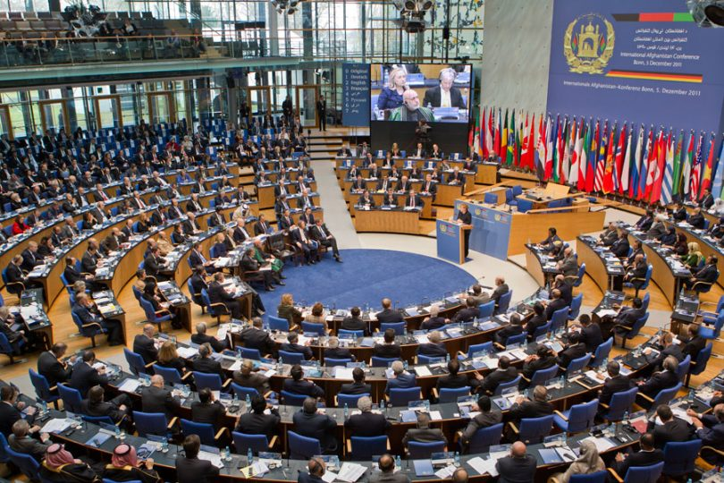
- Involvement of NATO & International Security Assistance Force (ISAF)
In 2001, after the US-led coalition ousted the Taliban government from control in Kabul, the UN sponsored a conference in Bonn, Germany, where Afghan factions opposed to the Taliban created an interim government, the Afghan Transitional Authority (ATA) with Hamid Karzai as chairman. The Bonn Conference also established the International Security Assistance Force (ISAF) to protect Karzai and the ATA in Kabul.

Picture 3: Bonn Conference, 2001
In 2002, Security Council Resolution 1401 established the UN Assistance Mission in Afghanistan (UNAMA) to support the Bonn Agreement and coordinate the UN’s peace and stability operations in the country.
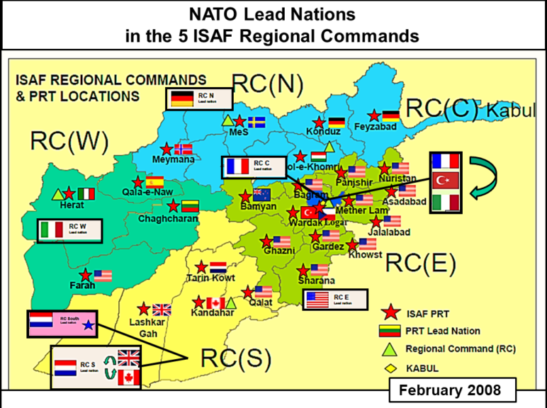
Initially, ISAF was just a small peacekeeping force whose job was to provide security to the Karzai government in the capital city of Kabul. Over time, ISAF’s job expanded. In 2003, at the US’s request, NATO took over ISAF command from the UN and began to operate in the provinces. By October 2006, ISAF commanded international military forces that were fighting local warlords and Taliban insurgents throughout Afghanistan. Beginning in 2011, ISAF gradually transferred responsibility for Afghanistan's security to Afghan forces. ISAF completed its mission officially in 2014, when it was replaced by a NATO-led non-combat mission called Resolute Support (RSM), which "provides further training, advice, and assistance to the Afghan security forces and institutions." At that time, the Afghan military also assumed full control over Afghanistan's security. At its peak in 2009, ISAF consisted of more than 130,000 troops from 51 contributing NATO members.

Picture 4: ISAF map showing the five ISAF Regional Commands (2004-2010) and the Lead Nations in command of these sectors
While most NATO members have assumed an advisory role in Afghanistan, the US has continued to provide more direct aid in the form of "protection, logistical support, and counterterrorism activities.” In 2017, US President Donald Trump announced a shift in US foreign policy from that of the former President of the United States, Barack Obama. Under the new policy, the US would reject "arbitrary timetables" for withdrawal from Afghanistan and instead continually assess the situation in Afghanistan to determine US policy towards the country. As a matter of fact, in August 2017, the US Department of Defense announced that it actually had about 11,000 US troops in Afghanistan, almost 2,500 more than it had formally reported in previous years. This information came weeks after the Trump administration announced that it planned to send 4,000 troops in addition to the already-existing 11,000 currently stationed among the region. Trump's new strategy towards Afghanistan also rejects diplomatic approaches, which Obama and other NATO members had begun in 2014, and instead promulgated a military approach to the situation.
Initially, NATO leaders such as Obama had planned to begin withdrawing troops from Afghanistan in 2011. After ISAF ended operations in 2014, Obama further announced plans to remove all US troops in Afghanistan by 2016. These plans were delayed, however, due to numerous facts. First and foremost, the US and NATO members did not want to remove their forces from the country until the Afghan army was strong enough to keep the Taliban from retaking control of the government and territory. Thus, for almost a decade, ISAF and NATO worked with the Afghan government to build and train domestic security forces. Yet, since the 2014 withdrawal, the Afghan state has struggled to maintain territory vis-à- vis insurgent groups, particularly the Taliban. In fact, when NATO decided to remove troops initially in December 2014, ANSF already began to experience difficulty maintaining territory. This was evinced by the fact that there were a higher number of ANSF casualties in 2014 than in any previous year since 2001. Similarly, the number of attacks from insurgent groups in Afghanistan between 2011-2013 was comparable to the number of attacks in 2009-2010, suggesting that insurgent activity in Afghanistan did not decline before or after NATO withdrawal. This prompted Afghan military leaders to suggest that the withdrawal of international forces was “premature”.
Major Parties Involved and Their Views
United Nations
As the biggest intergovernmental organization in the world comprising 193 Member States, the United Nations has introduced the crisis in Afghanistan as a major issue to be debated upon in many platforms, including the General Assembly and the Security Council, where many resolutions have been adopted as to resolve the problem. UN has also worked in collaboration with NATO, through missions, such as UNAMA, and peace talks.
United States of America
The US intended to invade Afghanistan with a plan to fight the Taliban threatening the stability in the Middle East and the Afghan government, as well as violating international human rights legislation. However, the conflict remains unsolved spreading criticism regarding the necessity of it and the lives of soldiers lost. Robert Crews, a professor of history at Stanford, explained the intervention as, “In Washington, it has become common to view Afghanistan as a country defined by a never-ending struggle among warlords, tribal chiefs, and religious fanatics. This has been particularly attractive as a way of explaining why the American intervention in that country, despite costing more than 2,300 American lives and roughly a trillion dollars, has achieved so few of its goals in over 14 years.”
Pakistan
Pakistan has been highly involved in the crisis since the very beginning of the Soviet intervention period. Pakistani representatives have also attended Geneva Accords in 1988, and stressed over the interventions made by the United States and the Soviet Union. Taliban’s extremist ideologies have also spread across Pakistan throughout the civil war occurring in Afghanistan. Pakistani administration has therefore strengthened its ties with China, to ensure the safety of the country from the ongoing crisis on their western borders.
Timeline of Events
Date of Event | Description of Event
August 19th, 1919 | Emir Amanullah Khan declares Afghanistan an independent state
1953 | Mohammed Daoud becomes the Prime Minister
1963 | Mohammed Daoud is forced to resign as the Prime Minister
1973 | Mohammed Daoud seizes power in a coup and declares Afghanistan a republic
1978 | Daoud is overthrown and assassinated in a pro-Soviet coup d’état, People’s Democratic Party of Afghanistan (PDPA) takes the authority and faces opposition
1979 | Soviet Union invades Afghanistan, backs the communist government
1986 | US government begins supplying mujahideen with military forces
1988 | Afghanistan, USSR, the United States and Pakistan sign peace accords in Geneva
1989 | Soviet troops leave Afghanistan as the civil war continues between mujahideen and Najibullah
1996 | Taliban seize control of Kabul
1997 | Taliban administration annexes over two-thirds of the country, and is now recognized by Pakistan and Saudi Arabia
1988 | US administration launches strikes Afghanistan, in order to counteract to Osama bin Laden for bombing US embassies in Africa
1999 | UN imposes sanctions against Afghanistan
September 11th, 2001 | World Trade Center and Pentagon are attacked by 19 militants associated with the Al-Qaeda
October 2001 | US initiates in bombing Afghanistan
January 2002 | NATO-led International Security Assistance Force is deployed in order to fight against Taliban
2002 | Hamid Karzai is elected as the interim head of state
2003 | NATO takes control of security in Kabul
October 2006 | NATO obtains responsibility for security across the Afghan mainland
February 2009 | NATO Member States pledge to increase military presence and further support in the Afghanistan mission
February 2010 | NATO-led forces launch Operation Moshtarak
July 2010 | Wikileaks exposes thousands of classified government documents relating to Afghanistan
November 2010 | NATO agrees to hand control to Afghan forces by the end of 2014
June 2013 | Afghan army takes control of all military and security operations from NATO forces
December 2014 | NATO officially ends ISAF, though the violence persists
January 2015 | NATO starts the Resolute Support Mission (RSM) in order to provide further support to Afghan security forces, while the Islamic State (IS) emerges in Afghanistan and annexes multiple cities
July 2016 | Barack Obama declares that 8,400 US troops will remain located in Afghanistan due to security concerns, NATO agrees on the maintenance of support until 2020
September 2019 | Protracted peace talks between the Taliban and the US break down

Evaluation of Previous Attempts to Resolve the Issue
- Bonn Agreement
Following the US invasion of Afghanistan and the escalation of the Taliban, the need for an established government structure was addressed in multiple international platforms. The US administration and the UN backed state-building efforts, and therefore encouraged prominent politicians to gather in Bonn, Germany. Afghan Interim Authority (AIA) was inaugurated as a consequence, and the agreement served as a framework throughout the transition period into an agreed-upon government model. The agreement failed, however, and led to a variety of issues, including electoral fraud, corruption, and incompetence. The sharing system of the newly-formed AIA caused many intra-cabinet rivalries and caused a relatively informal approach to be taken on multiple aspects of providing public services.
https://ihl-databases.icrc.org/ihl-nat/a24d1cf3344e99934125673e00508142/4ef7a08878a00fe5c12571140032e471/$FILE/BONN%20AGREEMENT.pdf
- Security Council Resolution 1386
The resolution was adopted in 2001, in order to establish the International Security Assistance Force in Afghanistan, aiming to help the new government establish military control over the country. The document also called upon “all Afghans to cooperate with the International Security Assistance Force and relevant international governmental and non-governmental organizations, and welcomes the commitment of the parties to the Bonn Agreement to do all within their means and influence to ensure security”.
http://unscr.com/en/resolutions/doc/1386
- Security Council Resolution 1401
In 2002, Security Council Resolution 1401 established the UN Assistance Mission in Afghanistan (UNAMA) to support the Bonn Agreement and coordinate the UN’s peace and stability operations in the country. This resolution was one of the very first steps the UN has ever taken regarding the crisis in Afghanistan.
http://unscr.com/en/resolutions/doc/1401

Possible Solutions
It shall be acknowledged that the initiatives to provide security and sustainability keeps on instantly failing due to the insurgent attacks of Taliban. The influence of Taliban over the country that often leads to grave breaches also affirm the need to maintain the ongoing Peacekeeping missions. Resolute Support Mission and the United Nations Assistance Mission in Afghanistan (UNAMA), which has been extended by the Security Council until the end of 2020, shall therefore stay in order to maintain international security, and prevent the extremist ideologies from spreading further.

As to ensure sustainability and political stability, NATO and the UN shall keep on working in collaboration; and promoting peace talks and negotiations between parties is indeed prominent in means of bringing an end to the crisis. Taking actions regarding the increasing numbers of inhumane crimes to be committed is also necessary, and such interventions require international support in means of troop supplies and humanitarian aid; and addressing the problem in various platforms with the help of different intergovernmental organizations may enlarge the awareness and efficiency of the missions.

Further Reading
- The History of Afghanistan (https://www.youtube.com/watch?v=T6usr-C3lcQ)
- Afghanistan Department of State: Background (https://www.infoplease.com/world/countries/state-department-profiles/afghanistan-department-of-state-background)
- Bonn Agreement (https://ihl-databases.icrc.org/ihl-nat/a24d1cf3344e99934125673e00508142/4ef7a08878a00fe5c12571140032e471/$FILE/BONN%20AGREEMENT.pdf)

Bibliography
- “Afghanistan Department of State Background.” Infoplease, Infoplease, www.infoplease.com/world/countries/state-department-profiles/afghanistan-department-of-state-background.
- “Afghanistan Profile - Timeline.” BBC News, BBC, 9 Sept. 2019, www.bbc.co.uk/news/world-south-asia-12024253
- History.com Editors. “September 11 Attacks.” History.com, A&E Television Networks, 17 Feb. 2010, www.history.com/topics/21st-century/9-11-attacks.
- Contributors to Wikimedia. “Proxy War.” Wikipedia, Wikimedia Foundation, Inc., 14 Nov. 2019, www.wikizeroo.org/index.php?q=aHR0cHM6Ly9lbi53aWtpcGVkaWEub3JnL3dpa2kvUHJveHlfd2FyI2NpdGVfcmVmLVVOMV8xLTA.
- Nato. “The North Atlantic Treaty.” NATO, 1 Apr. 2009, www.nato.int/cps/en/SID-ECAE8DB0-F591EC88/natolive/official_texts_17120.htm.

