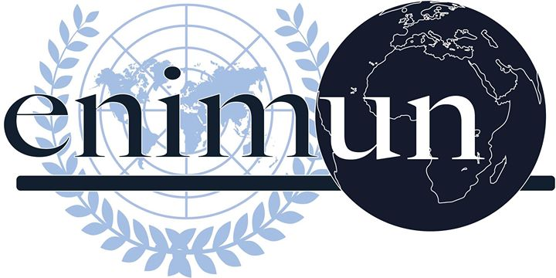

2019

ChaIr REPORT

GA 1: Disarmament & International SecurIty commIttee (DISEC)

The Issue of the u.s. reImposIng of nuclear sanctIons on Iran and wIthdrawal from jcpoa

burcu korkmaz

presIdent chaIr

Introduction
The possibility of having a nuclear war is still there and it is threatening the whole of mankind. Although people believe that the problem of nuclear war is solved, unfortunately, with countries that are producing nuclear weapons and are considered “nuclear-weapon states” (NPS) according to the Treaty on the Non-Proliferation of Nuclear Weapons (NPT), the problem is not even off the table. Iran is one of the biggest potentials to produce nuclear weapons. In 2015, at the time of Barack Obama in the USA, the Joint Comprehensive Plan of Action, in other words, Iran Nuclear Deal, has been signed between Iran and the P5+1 countries (China, UK, USA, Russia, France + Germany).
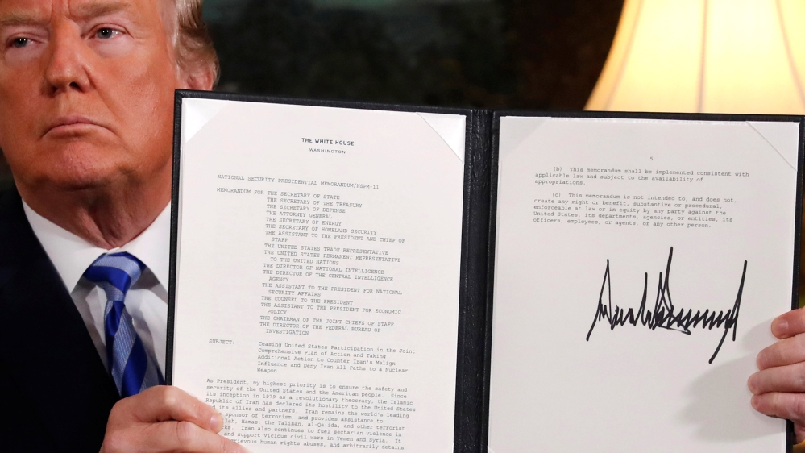
According to this plan, Iran’s “breakout time” would be extended and the International Atomic Energy Agency (IAEA) would be given access to monitor and inspect the uranium enrichment centers in Iran. If Iran would comply with these conditions, then in exchange, the Member States participating in this plan of action would remove the economic sanctions toward Iran and the Middle East area. In 2018, at the time of Donald Trump’s administration, President Trump has officially declared that he withdraws the US from the Iran Nuclear Deal. He had multiple explanations for this decision, however mainly he has stated that the deal had many missing parts and was insufficient to stop Iran’s nuclear actions in many ways. He has even added that the deal even supports Iran’s nuclear production by calling off the economic sanctions.
Figure 1: President Trump & Withdrawal of JCPOA (2018)
This year, the theme of ENIMUN 2019 is the “Global Collaboration: Assets and Liabilities”. Please keep in mind the aim of the disarmament committee and the United Nations itself is to find a mediocre solution for international peace. According to the theme of the conference, keeping in mind that nuclear weapon production is a big threat for future generations, the resolutions should focus on ways to bring the USA and Iran on the same terms.

Key Vocabulary
JCPOA (The Joint Comprehensive Plan of Action): The agreement between Iran and P5+1 members to stop the production of any nuclear weapons.
Fissile / Fissile Material: Materials that are able to produce nuclear fission.
Breakout Time: Amount of time needed to produce enough fissile material for the production of a nuclear weapon.
International Atomic Energy Agency (IAEA): UN Organization which works to promote the safe, secure, and peaceful use of nuclear technologies. According to the JCPOA, its inspectors have the right to inspect Iran’s uranium enrichment facilities.
Enriched Uranium: A raw material used to make reactor fuel and also nuclear weapons. Low enriched uranium is used to produce fuel for the nuclear power plants, and the highly enriched uranium (U-235 isotope) is used to produce nuclear weapons.
Isolationism: Isolationism is a type of national policy, which U.S.A has been using for centuries, which results in avoiding political or economic entanglements with other countries.

Focused Overview
In the 1950s Iran has started to get interested in the topic of nuclear weapons and their production. In 1967, Shah Rıza Pahlavi has asked United States for technical support which was then followed up by Iran receiving its first-ever nuclear reactor from the USA. In 1984, after some diplomatic problems between Iran and the USA, the American government has declared Iran as one of the sponsors to terrorist groups which brought the focus of economic sanctions to Iran. For a long time, Iran did not accept even proposals of peace and suspending enrichment activities. In 2005, after the Presidential Statement of the UN Security Council (UNSC), Iran was called out to adapt to IAEA’s terms. UNSC also prohibited the Member States to sell or send any nuclear technology or missile to Iran. The P5 countries have imposed economic sanctions on Iran. “US Congress sanctioned Iran’s Central Bank and all foreign financial institutions processing Iranian oil” (Goodwin) in 2011-12 which led to the start of a tragic downfall of the Iranian economy. With the increasing pressure, the newly elected president of Iran has agreed to reach an agreement with P5+1 countries.
- Joint Comprehensive Plan of Action (Iran Nuclear Deal)
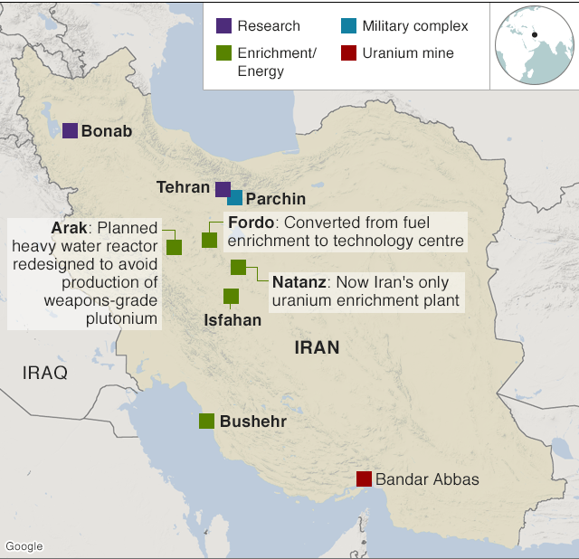
For 2 years, along with the European Union, the permanent 5 states of the UNSC and Germany has negotiated with Iran. In July 2015, the JCPOA was finalized and was ready to be applied in Iran. The main goal of the plan is to extend the breakout time from a few weeks, if the same amount of enrichment proceeded, to a year. Also, the uranium enrichment centers placed at Fordow and Natanz will be restricted. A heavy-water reactor at Arak was redesigned to prevent Iran’s production of weapons-grade plutonium. As well as agreeing to these terms, Iran has even granted the access of International Atomic Energy Agency (IAEA) inspectors to control and monitor these centers. The plan limits the number of centrifuges in Iran that could be operated and the size of the stashes for the uranium isotopes and fissile material.
Figure 2: Changes Agreed Under JCPOA
Although the terms seem to be heavy, the government of Iran was desperately in need of the uphold of the economic sanctions on Iran to straighten out Iran’s economy. With the agreement of the plan, the countries have handed in the frozen assets of Iran which were kept in foreign banks. This will be one of the main reasons that will lead Trump to withdraw the USA from the plan.

- Withdrawal of USA from JCPOA
On the 8th of May 2018, Donald Trump has officially declared that the USA withdrew from JCPOA. In his speech, he has stated the Obama administration made a huge mistake by signing a plan which even sponsors Iran.
The first claim he has made was that even though the deal is present since it was not enough and was not properly negotiated the deal did not stop Iran from the production or enrichment of fissile. He claims that after the deal ends, Iran will immediately continue its activities. However, according to the deal, “JCPOA gradually lifts restrictions on the types of nuclear activities and the level of uranium enrichment Iran may conduct. These and other provisions sunset over 10, 15, 20 or 25 years” (Rizzo & Kelly). Iran is also a signatory to the Treaty on the Non-Proliferation of Nuclear Weapons (NPT) which means that with JCPOA they have even reaffirmed that Iran will never seek, acquire, or produce nuclear weapons.
Another claim Trump has made in his speech was that after the economic sanctions were removed, the USA has handed in money to Iran, some of it even as cash, which means that governments have implicitly supported Iran and its economy. This is not fully right, considering that the money handed in is already Iran’s money which was in assets that were frozen and kept in foreign banks.
With a few more claims, Trump has announced the USA’s withdrawal. Right after, US has reimposed the economic sanctions on Iran. In November 2018, the Trump administration has officially restored the sanctions against Iranian oil, including banking and any transportation actions.

Major Parties Involved and Their Views
Islamic Republic of Iran
Although Iran was not eager to participate in a deal that would restrict the government’s policies about nuclear weapon and their production, after a while, they have been pressured down to have an agreement with the UNSC. Now that the US has withdrawn from the JCPOA and the deal seems to have failed, Iran is getting ready to save its excess uranium and continue the production of the high-enriched uranium. It even threatens the parties with high oil prices and the cancellation of the redesigning of the heavy-water reactors.

United States of America (USA)
As explained in detail previously, the USA, with the election of Donald Trump, changed their perspectives toward the deal which caused the withdrawal from the deal and the reimposition of the economic sanctions. Donald Trump has declared that until the 12 conditions they want are not included in another deal, they would not come into terms with the Iranian government and continue to impose the economic sanctions.

Russian Federation

Some politicians believe that Russia is the country that has benefited the most from the downfall of the JCPOA. Of course, Russia is also a part of the agreement and no government would want to fail a deal that their own country has participated in it. However, “Moscow was a pivotal player in negotiating the original agreement, for which it enjoyed quite a lot of credit… Now that the U.S. has pulled out, Moscow can blame Washington for its impending failure, part of its broader critical narrative about the U.S. in the Middle East and globally” states a former Head of Department of State. Also, although the higher oil prices affect the Russian economy and trade too, the US having a weak relationship with Iran benefited Russia the most making the 2 countries get closer: Russia & Iran.

United Kingdom (UK) & Germany
The United Kingdom and Germany have the same perspective on the issue. They believe that the US leaving the deal was a big mistake but since that could not be prevented now their next aim is, to prevent a bigger catastrophe, to stop Iran from taking any extreme decisions about enrichment centers and the canceled terms of JCPOA. “We urge the Iranians to think very long and hard before they break that deal,” said Jeremy Hunt, British foreign secretary after it was heard that Iran was threatening the parties holding onto their excess uranium and heavy-water reactors.

Timeline of Events
November 1967 | The United States provided Iran with its first-ever nuclear reactor
1979 | - Iranian Revolution transpired  - Iranian hostage crisis
1984 | US Department of State officially added Iran to its list of state sponsors of terrorism
1987 | Iran started planning the design of the P-1 centrifuge building.
1992 | US Congress prohibited the transfer of goods and/or technology to Iran that would help with their weapons production and improvement.
2003 | IAEA called Iran to halt all nuclear enrichment activity
2005-2006 | - Iran informs the IAEA that they would resume their enrichment activities at multiple locations  - Iran officially declared that they would reject a new proposal on the issue
2009 | Iran stated they would be building another enrichment center
June 2010 | US Congress extended the sanctions against Iran
March 2013 | US & Iran has started the negotiations process
June 2013 | - Presidential elections at Iran: New president – Hassan Rouhani  - Change in nuclear enrichment activities policy
14th of July 2015 | The JCPOA was signed by all the parties
16th of January 2016 | JCPOA was officially taken into action

Evaluation of Previous Attempts to Resolve the Issue
- S/RES/1696 – UN Security Council Resolution (2006)
http://unscr.com/en/resolutions/doc/1696
The UNSC has called the Iranian government to halt its enrichment program and accord with the terms and requirements of the IAEA. The problem with the resolution was that, although it is a Security Council, it still did not demand or strictly order anything. If the Iranian government would not comply with this resolutions’ terms, the penalties were not stated exactly, and they were only underlined as “additional measures would be taken” if that would happen. So, when Iran did not agree to the resolution, the council did not take any action.
- The Joint Comprehensive Plan of Action (JCPOA) (2015)
https://www.europarl.europa.eu/cmsdata/122460/full-text-of-the-iran-nuclear-deal.pdf
Even though the claims Trump has stated were generally wrong, there were also some true parts. Trump indicated that the deal had some missing parts about what would happen after the deal expires which is true. Although the agreement lifts the restrictions gradually that still would not be enough in the long run for the safety and peace of the future generations.
- S/RES/2231 – UN Security Council Resolution (2015)
https://www.undocs.org/S/RES/2231(2015)
Resolution #2231 sets a framework for the monitoring mechanisms of the UNSC for the JCPOA. When JCPOA fails, resolution #2231 fails too. One of the problems that may have caused the failure of the deal is about the monitoring systems and the penalties that should have been set by the UNSC previously. As a result of multiple reasons, both the JCPOA and UNSC resolution for that specific deal has failed.

Possible Solutions
On May 21st of 2018, Mike Pompeo listed 12 demands that a new deal with Iran would have to contain for the US to agree to it, some of them being completely halting uranium enrichment, ending the proliferation of nuclear missile systems and allowing the IAEA to have “unqualified access to all sites throughout the entire county”. The US would, in return, end sanctions against Iran, establishing full diplomatic and commercial relationships with the country and allow the nation to pursue more advanced technology. Considering the JCPOA has failed, a new deal that would make Trump administration and Iranian government come to terms should be formed.

Another possible solution is to form collaborative economical trade packs that will be formed under terms of a new deal with the same parties excluding the USA. Since coming into terms with the US may be hard, until that other parties may form a deal that would still prevent Iran to proceed with its uranium enrichment activities but also in exchange, continue the trade of fissile and other products such as Iranian oil. Iran’s focus should be changed from just trying to harm the US into a more moderate one that would uplift Iran’s economy as well.

Further Reading
- President Trump’s Reasons for Leaving the JCPOA: https://www.washingtonpost.com/news/fact-checker/wp/2018/05/09/fact-checking-president-trumps-reasons-for-leaving-the-iran-nuclear-deal/

- Why Russia is the Big Winner of the JCPOA Fallout: https://www.washingtonpost.com/world/2019/05/08/why-russia-is-big-winner-iran-deal-fallout/

- Iran Nuclear Deal: Key Details: https://www.bbc.com/news/world-middle-east-33521655

- Current Status of the Iran Nuclear Deal: https://www.cfr.org/backgrounder/what-status-iran-nuclear-agreement

Bibliography
- Cowen, Tyler. "Nuclear War Is Still Very Possible and Very Scary." Bloomberg. Bloomberg, www.bloomberg.com/opinion/articles/2019-05-15/nuclear-war-is-still-very-possible-and-very-scary. Accessed 20 Nov. 2019. Excerpt originally published in Bloomberg.
- Davenport, Kelsey. "UN Security Council Resolutions on Iran." Arms Control Association, Aug. 2017, www.armscontrol.org/factsheets/Security-Council-Resolutions-on-Iran. Accessed 20 Nov. 2019.
- Goodwin, Conner. DISEC on Renegotiating the Iran Nuclear Deal. Dec. 2018. St. Johns Prep, www.stjohnsprep.org/uploaded/ModelUN/DISEC_-_Iranian_Nuclear_Weapons.pdf. Accessed 20 Nov. 2019.
- "Iran Nuclear Deal: Key Details." BBC, 11 June 2019, www.bbc.com/news/world-middle-east-33521655. Accessed 20 Nov. 2019.
- Joint Comprehensive Plan of Action. European Parliament, www.europarl.europa.eu/cmsdata/122460/full-text-of-the-iran-nuclear-deal.pdf. Accessed 20 Nov. 2019.
- Laub, Zachary. "What Is the Status of the Iran Nuclear Agreement?" Council on Foreign Relations, 31 July 2019, www.cfr.org/backgrounder/what-status-iran-nuclear-agreement. Accessed 20 Nov. 2019.
- "Resolution 2231 (2015) on Iran Nuclear Issue." United Nations Security Council, www.un.org/securitycouncil/content/2231/background. Accessed 20 Nov. 2019.
- Rizzo, Salvador, and Meg Kelly. "Fact-checking President Trump's reasons for leaving the Iran nuclear deal." The Washington Post, 9 May 2018, www.washingtonpost.com/news/fact-checker/wp/2018/05/09/fact-checking-president-trumps-reasons-for-leaving-the-iran-nuclear-deal/. Accessed 20 Nov. 2019.
- Tamkin, Emily. "Why Russia is the big winner of the Iran deal fallout." The Washington Post, 8 May 2019, www.washingtonpost.com/world/2019/05/08/why-russia-is-big-winner-iran-deal-fallout/. Accessed 20 Nov. 2019.
- Timofeev, Ivan. "US Withdrawal from the JCPOA and Anti-Iranian Sanctions: Pros and Cons." Russian International Affairs Council, 26 July 2019, russiancouncil.ru/en/analytics-and-comments/analytics/us-withdrawal-from-the-jcpoa-and-anti-iranian-sanctions-pros-and-cons/. Accessed 20 Nov. 2019.

