2019

CHAIR REPORT

LEGAL COMMITTEE (GA5)

The impact of the immigration policies that the EU put forward

YASEMIN YÜKSEL - DEPUTY CHAIR

Introduction
Conflicts and conditions including resource shortages as well as a search for economic opportunities have led citizens of countries to immigrate to other destination states. Asylum seekers also have the fundamental right to escape serious damage in their country through immigration.
The European Union’s (EU) immigration policy, while aiming to create a “balanced approach to dealing with both regular and irregular immigration”, has failed to prevent migration crises from occurring. Even though the issue is intertwined with all member states involved, the EU’s immigration policy regarding forced migration to the first state the immigrant passes and multiple sections on rules of immigration have been at certain extents ineffective with mainly the increase in irregular and illegal immigrants. An unequal and unfair system has risen causing instabilities for immigrants migrating to Europe.

Key Vocabulary
Immigration Policy: According to a recent definition an immigration policy is “a government’s statements of what it intends to do or not do in regards to the selection, admission, settlement and deportation of foreign citizens residing in the country.”
EU Blue Card: The Blue Card is an official work permit for skilled workers, chosen through a narrow scope, valid at all times in all EU Member States except Denmark, Ireland, and the United Kingdom. This system has the aim of identifying highly qualified employment in the Member States.
Third Country National: According to the definition by the official website of the European Union, this term is used as "any person who is not a citizen of the European Union” while according to Cambridge Dictionary is defined as “a person who is employed by an international organization and who comes neither from the country where the organization has its main base, nor from the country where they are working.''
Focused Overview
- Detailed Account of the EU Immigration Policy
The EU immigration policy can be understood in three pillars.
Firstly, there is a regular immigration policy establishment present at EU level. Within this establishment, there have been multiple directives and developments to the policy. While priorly the EU Blue Card Directive has been implemented, with the occurrence of shortcomings, the scope of criteria of the Blue Card was widened. The Single Permit Directive has also been applied, enabling working opportunities as well as equality in family reunification, social rights as well as other rights. Following directives have not only allowed seasonal migrant workers to reside in an EU Member State at a maximum period between five and nine months, but have also widened the scope of both the rights of immigrants and have simplified their application.
Secondly, the integration policy establishment has helped the settlement of about 20 million non-EU nationals in the EU Member States. To fully apply the policy, instruments including the European Migration Forum and European Integration Network have been established. This is crucial as while the policies are an essential pathway in protecting the rights of migrants, it is also observed that the implementation of these policies for each and every EU Member States differ as approaches change.
Lastly, the combat of irregular immigration policy has been important in taking measures against terrorism and security conflicts. Action plans and directives including the “EU Action Plan against migrant smuggling” have been in effect to prevent human trafficking and protect anyone beign affected by the actions of illegal immigrants. The Returns Directive has also been applied to make sure illegal immigrants return to their third country.
With the economic and social differences between European countries and Third Country Nationals as well as the increase in
- Vast Increase in the Number of Migrants
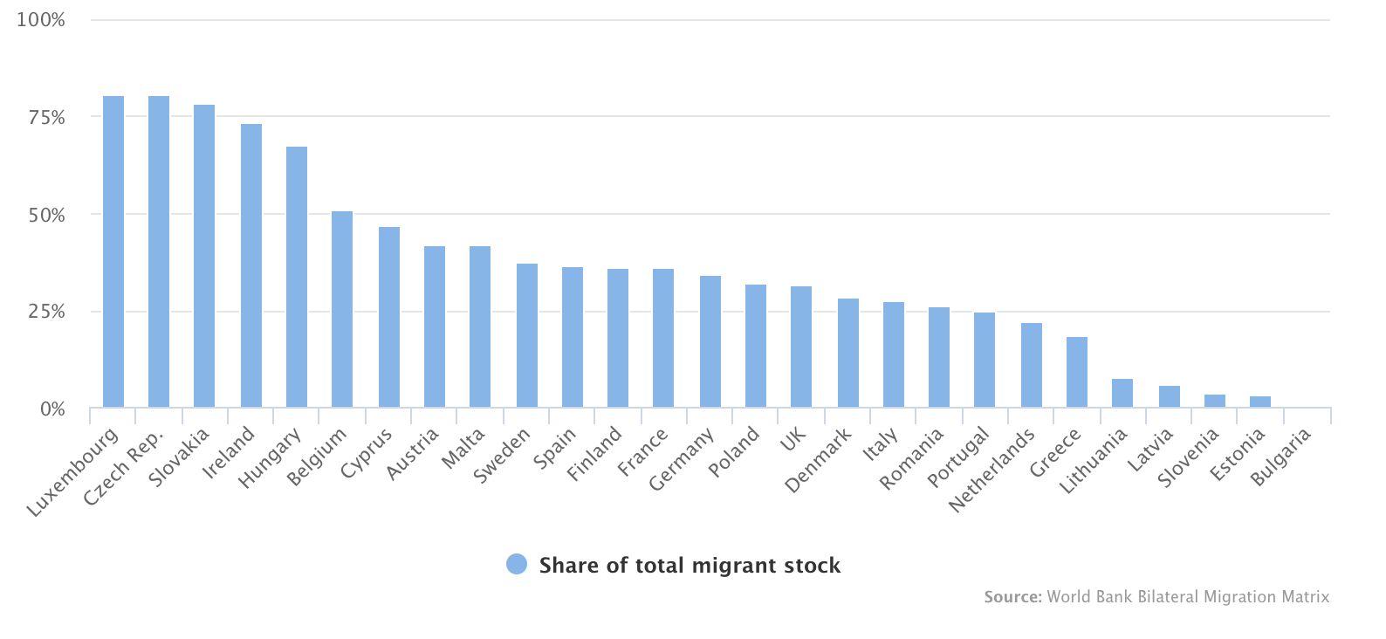
With the gap between European countries and third country nationals as well as the increase
According to the United Nation Department of Economic and Social Affairs (DESA), the constantly changing number of overall migrants has reached 272 million, surpassing the growth rate of the world’s population. As in Europe, the situation is reflected similarly. However, the increase in the number of migrants is not evenly distributed throughout states as seen in Figure 1 and 2. This unequal and subsequently unfair share of immigrants has led to conflicts of burdens on Member States.
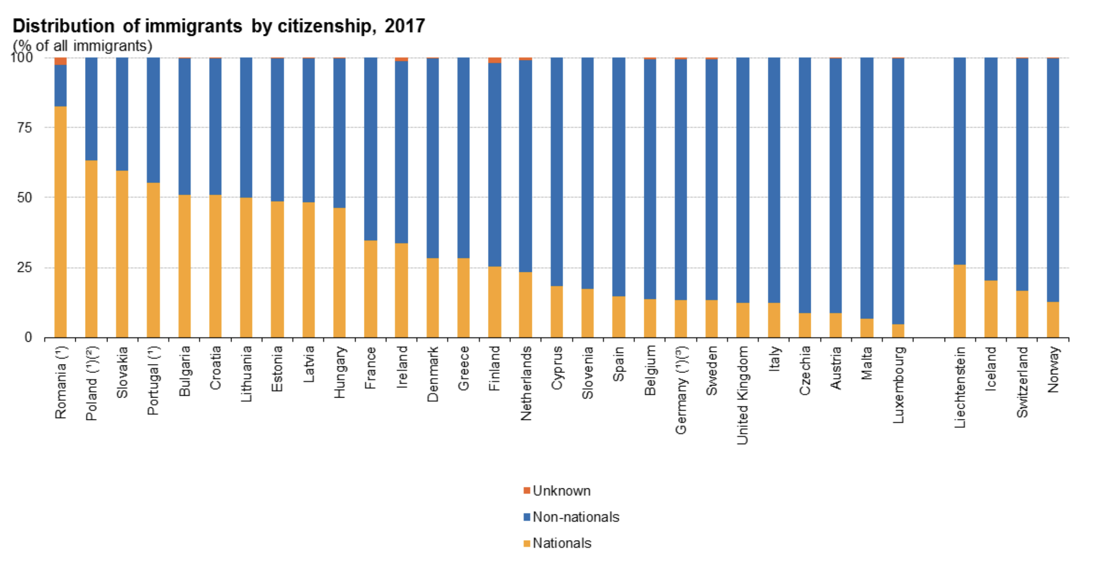
Figure 1: Share of total migrant stock represented by EU migrants 2010
Figure 2: 22.3 million people (4.4 %) of the 512.4 million people living in the EU on 1 January 2018 were non-EU citizens.
Human Rights of Migrants in their Migration Routes
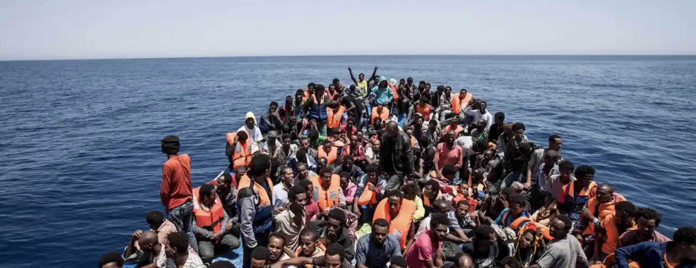
About 362,000 migrants risked their lives crossing the Mediterranean Sea in 2016 with about half and half arriving in Italy and Greece. Thousands of victims have died trying to enter Europe for more than 20 years. Because countries have been rejecting
Figure 3: Crowded migrants on the deck of a wooden boat off the coast of Libya, May 2015. Photograph: Reuters
refugees, many have been in miserable situations, not being able to transport to their state of destination. Even when not rejected, immigrants are at certain times obliged to wait until permission by the state is granted which results in a usual flood of illnesses and appalling conditions.
Stating a wide-known event that has affected countless lives in becoming aware of the issue at hand is also useful.
Figure 4: Death of Syrian refugee
- Impact of EU Immigration Policy on Non-EU States
Solidarity among EU nations has disabled them to prevent the aforementioned disorientation and disproportion of located asylum seekers. This has caused a burden and therefore has left asylum seeker lives at stake.
Major Parties Involved and Their Views
While the issue regards all EU Member States as the EU immigration policies have a present impact on these states, several countries and organizations are also essential in how EU immigration policies affect its surroundings.

International Organization for Migration (IOM)
IOM is a UN related organization aiming to help immigrants settle and provide service to both migrants and migration to states. The EU-IOM Joint Initiative for Migrant Protection and Reintegration is one of the examples of IOM’s support to immigrants of Europe coming from all over the world. This joint specifically assists migrants by filling in voids of security problems and conflict they face along their migration routes in Africa.
The United Nations High Commissioner for Refugees (UNHCR)
UNHCR functions with the aim of protecting forcibly fled people in being integrated and settled into a third country. Considering this, UNHCR has been in consistent contact with the EU in order to prevent any deaths or missing immigrants along the routes set to Europe. With countless lives at risk, UNHCR pursues multiple operations to minimize and ultimately stop the obstacles refugees face.

United Kingdom (UK)
With Britain’s departure conflict from the EU, the immigration policies of the EU will also be affected. The UK has stated that there will be a decrease in immigrant acceptances after Brexit. UK that has had a relatively high increase of rate of immigrants leads to a system change in the EU immigration policies leading to an increase in conflicts which makes the UK highly relevant for the issue.
Turkey
Even though Turkey is not part of the EU, it is part of the Council of Europe. Turkey has a current refugee agreement with the EU in order to minimize Europe’s refugee inflation. However, as the number of refugees has increased to about 3.5 million stated by Turkey, this agreement is also being questioned and has the potential to affect the EU system which makes Turkey a prominent character in the situation.
Timeline of Events
Date of Event (Day/Month/Year) | Description of Event
UK Brexit Dispute
IOM-EU Initiative
Missing Migrant Project

Evaluation of Previous Attempts to Resolve the Issue
- The Treaty on the Functioning of the European Union Article 79 states the policies the EU is to follow while dealing with immigration and can therefore be considered as the written steps EU aims to take. However, as concerns and conflicts of immigrants have not yet been prevented, the policy remains as merely a step to resolve the issue. https://eur-lex.europa.eu/legal-content/EN/TXT/?uri=CELEX%3A12016E079
- The ‘Global Approach to Migration and Mobility’ has also been essential in international collaboration with non EU states as encouraged in the theme of this year’s conference. However, this has also been insufficient as the approach continued to vary from state to state in the EU.
- A European Agenda was prepared in need for an immediate resolution to the issue. However even though responses were immediate, they are still insufficient. https://ec.europa.eu/home-affairs/sites/homeaffairs/files/what-we-do/policies/european-agenda-migration/background-information/docs/communication_on_the_european_agenda_on_migration_en.pdf
- Missing Migrants Project is a project established by IOM. This project collects data on conflicts immigrants go through within their routes and tracks deaths and irregularities such as missing scenarios of immigrants. Even though not a resolution to the issue, this has helped understand the increase in negative effects of lack of security throughout migration routes and has encouraged the help of several organizations and countries.
https://missingmigrants.iom.int/

Possible Solutions
Firstly, I would like to state that I am very much looking forward to the effective and innovative solutions of delegates through the debate process in order to solve the issue. While aiming to guide you, the purpose of the agenda item with integration to the theme of the conference, Global Collaboration: Assets and Liabilities, should be beared in mind. Thus, international collaboration and communication is of utter importance.

A crucial point that is to be considered is the insurance of the immigrants’ fundamental human rights as well as their dignity through being given the right to be sent back to their countries when only the conflicts in their homelands are resolved or are in a stable condition. To provide fair treatment of immigrants, the negative impacts of EU immigration policies have to be avoided through ensuring there are no violations to articles involved with the issue such as Article 79. Moreover, a fair share, in other words, a fair distribution of immigrants into countries could also be a solution to minimize the injustice in the policies by encouraging collaboration and inclusion of the Council of Europe as well as the European Union.

Further Reading
This document explains facts about the EU immigration policy including its objectives, achievements, and a thorough description of its present situation:
- http://www.europarl.europa.eu/factsheets/en/sheet/152/immigration-policy
This site will provide delegates further understanding of the aforementioned initiative by IOM and will also help in acknowledging the updated tracking of immigrants assisted and received:
- https://migrationjointinitiative.org/
This document named “Indicators of Immigrant Integration 2015” provides further insight for key findings of third country nationals, youth with an immigrant background and immigrants in the EU.
- https://www.oecd-ilibrary.org/docserver/9789264234024-en.pdf?expires=1574277435&id=id&accname=guest&checksum=BA0360D9DA3339998102FBF738B828E7
This document named “Labour Market Integration of Third Country Nationals in EU Member States” provides necessary information on
- https://ec.europa.eu/home-affairs/sites/homeaffairs/files/00_eu_labour_market_integration_final_en.pdf
- https://publications.jrc.ec.europa.eu/repository/bitstream/JRC111774/kjnd29060enn.pdf
- https://ec.europa.eu/home-affairs/sites/homeaffairs/files/what-we-do/policies/european-agenda-migration/background-information/docs/communication_on_the_european_agenda_on_migration_en.pdf
- https://www.europarl.europa.eu/news/en/headlines/society/20170629STO78632/migration-in-europe

Bibliography

Anonymous. “Common European Asylum System.” Migration and Home Affairs - European Commission, 6 Dec. 2016, ec.europa.eu/home-affairs/what-we-do/policies/asylum_en.
- Anonymous. “Third-Country National.” Migration and Home Affairs - European Commission, 12 July 2019, ec.europa.eu/home-affairs/what-we-do/networks/european_migration_network/glossary_search/third-country-national_en.
- Bjerre, Liv, et al. “Conceptualizing and Measuring Immigration Policies: A Comparative Perspective.” Wiley Online Library, John Wiley & Sons, Ltd (10.1111), 22 May 2014, onlinelibrary.wiley.com/doi/abs/10.1111/imre.12100.
- “Immigration Policy: Fact Sheets on the European Union: European Parliament.” Fact Sheets on the European Union | European Parliament, www.europarl.europa.eu/factsheets/en/sheet/152/immigration-policy.
- “EU Migrants in Other EU Countries.” Migration Observatory, migrationobservatory.ox.ac.uk/resources/briefings/eu-migrants-in-other-eu-countries-an-analysis-of-bilateral-migrant-stocks/.
- McIntyre, Niamh, et al. “It's 34,361 and Rising: How the List Tallies Europe's Migrant Bodycount.” The Guardian, Guardian News and Media, 20 June 2018, www.theguardian.com/world/2018/jun/20/the-list-europe-migrant-bodycount.
- “Migrant Crisis: UN Says Six Die Every Day in Mediterranean Crossings.” BBC News, BBC, 30 Jan. 2019, www.bbc.com/news/world-europe-47055619.
- “Timeline - Response to Migratory Pressures.” Consilium, 8 Nov. 2019, www.consilium.europa.eu/en/policies/migratory-pressures/history-migratory-pressures/.
- “Migration and Migrant Population Statistics.” Migration and Migrant Population Statistics - Statistics Explained, ec.europa.eu/eurostat/statistics-explained/index.php/Migration_and_migrant_population_statistics.

