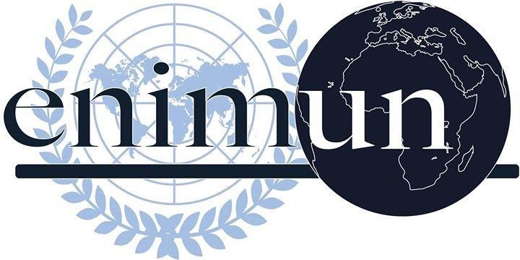

2019

CHAIR REPORT

GA5: Legal Committee

The effect of Brexit on British border policies

NAZ TUNACI - DEPUTY CHAIR
Introduction
According to the New York Times, Brexit is a portmanteau of the words “Britain” and “exit,” and is shorthand for Britain’s split from the European Union, changing its relationship to the bloc on trade, security and migration. On June 23rd of 2016, British participated in a referendum and voted to leave EU because of their concerns regarding immigration and sovereignty. Being a member of the EU since 1973, UK still didn’t officially leave the EU but if it leaves, it would be the first member state to withdraw from the EU. Although the European Union has agreed to extend the Brexit deadline until 31 January 2020, Brexit had -and still has- many effects on United Kingdom. One of the main concerns regarding the Brexit is the effect of it on the British border policies.

A country’s border policy is mainly about the way that their government agrees upon specific terms with the neighbouring countries, the trade relations with other countries, the strategy of controlling the movement of their citizens and the measures that are needed to be taken on the topic of migration. In an era where countries and their populations are increasingly exposed to the opportunities and risks associated with the ever-expanding global movement of people, policymakers have to make approaches to border controls and border management. Related to this, the ongoing rights of EU citizens in the UK -and the reciprocal rights of British citizens in the EU- has been one of the key issues during the withdrawal negotiations in the topic of Brexit. Another important issue that arise from Brexit is about what the UK government plans for the Irish border. Lastly, one of the other key factors regarding the Brexit problem is a crucial one for a country to develop economically: it is the trade relations.

Key Vocabulary

Brexit: The departure of the United Kingdom from the European Union.

Brexiteer also Brexiter: A person in favour of the UK leaving the European Union.
No-deal Brexit: A no-deal Brexit would mean the UK leaving the European Union and cutting ties immediately, with no agreement in place. The UK will leave with no deal on 31 October unless a Brexit deal is agreed, the Brexit deadline is extended, or Article 50 is revoked. In a no-deal scenario, the UK would follow World Trade Organization rules to trade with the EU and other countries, while trying to negotiate free-trade deals.
Hard Brexit: An agreement where the UK would leave not only the EU but also the EU’s Single Market and the EU Customs Union. (of which non-EU countries are also members)
Backstop plan: The backstop was an insurance policy negotiated by former Prime Minister Theresa May, to avoid checks along the Irish border. Had it come into effect; the backstop would have kept the UK effectively inside the EU's customs union but with Northern Ireland also conforming to some rules of the single market. Boris Johnson, the new prime minister, removed the backstop after renegotiating the withdrawal agreement and replaced it with a new customs plan.
Customs union: The EU customs union is an agreement between EU countries not to charge taxes called tariffs on things coming from other EU countries, and to charge the same tariffs as each other on things coming from outside the EU.
Irish border: The border between Northern Ireland and the Republic of Ireland. After Brexit, it will become the only land border between the UK and the European Union.
Political declaration: Document which sets out proposals for how the UK's long-term future relationship with the EU will work after Brexit. Unlike the withdrawal agreement, the political declaration is not legally binding - it sets out the hopes of both sides for the future on things like trade.
Withdrawal agreement: Theresa May agreed a deal with the EU on the terms of the UK's departure. It included how much money the UK must pay to the EU as a settlement, details of the transition period, and citizens' rights. It also covered the so-called "backstop", which ensures that no hard border exists between Northern Ireland and the Republic of Ireland after Brexit even if there's no deal on the future relationship in place by the end of the transition period. After it was voted down three times and Mrs. May resigned, Boris Johnson negotiated changes to the withdrawal agreement where the backstop was replaced with a new Northern Ireland proposal.
Freedom of movement / mobility rights or the right to travel: A human rights concept encompassing the right of individuals to travel from place to place within the territory of a country, and to leave the country and return to it. The right includes not only visiting places but changing the place where the individual resides or works.
Article 50: A clause in the European Union's Lisbon Treaty that outlines the steps to be taken by a country seeking to leave the bloc voluntarily. Invoking Article 50 kick-starts the formal exit process and serves as a way for countries to officially declare their intention to leave the EU. The UK is allowed to stop the Article 50 process completely - but if it only wants to extend it, all the other EU countries must agree.
Single market: A system that enables goods, services, people and capital (money) to move between all 28 EU member states, as well as Iceland, Norway, Liechtenstein and Switzerland. Countries in the single market apply many common rules and standards.
Immigration reform: A change to the current immigration policy of a country. In its strict definition, reform means "to change into an improved form or condition, by amending or removing faults or abuses" In the political sense, "immigration reform" may include promoted, expanded, or open immigration, as well as reduced or eliminated immigration.
Focused Overview
This section covers the main points related to the topic of Brexit and its effects on the British border policies.
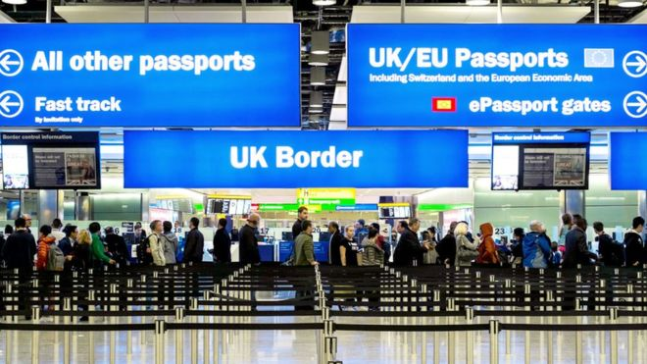
- The Topic of Migration & Rights of Citizens: How Brexit will affect migration is perhaps the most prominent public-policy question resulting from the possible withdrawal. If or when there is a withdrawal deal, there will likely be an implementation period ending no earlier than December 2020. During this period, free movement will continue between the UK. and the EU, unless EU nationals intend to stay in the UK. for longer than three months, in which case they will need to register with the UK government. Then they can apply for "pre-settled" status, which will enable them to take initial steps to obtain permanent residency. EU citizens who have lived in the UK lawfully for five years will be able to apply to stay indefinitely under the new EU Settlement Scheme. This means that they will be free to live in the UK, have access to public funds and be able to apply for British citizenship. EU citizens will need to apply under the scheme, even if they already have permanent-residence documents; they will not automatically get indefinite permission to stay. Similar reciprocal rights would be conferred upon British nationals residing in the EU before the end of the implementation period. The EU Settlement Scheme will be an online application process accessible from any device that has Internet access, and it will be free of charge. People who don't acquire settled status will be removed from the country.
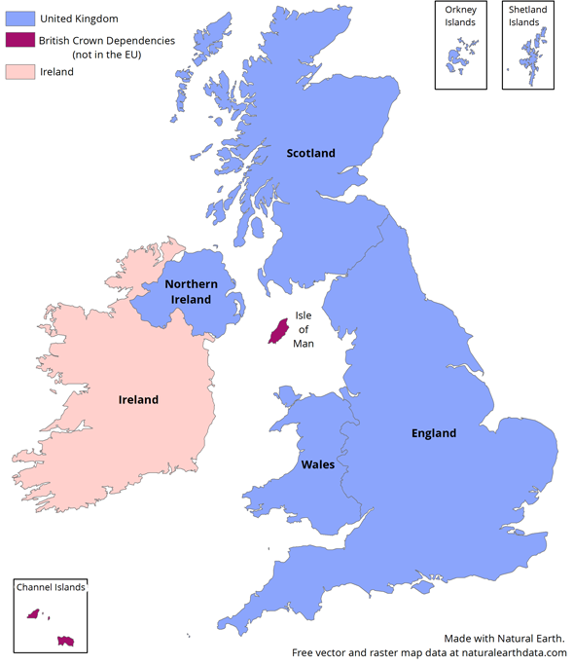
- Irish Border: Ireland is an island which has been divided politically since 1920. It is specifically located in Northern Europe and North Atlantic Ocean, just west of the United Kingdom. The country occupies a large majority of the island of Ireland, with Northern Ireland (part of the United Kingdom) covering the northeast.

The UK’s departure from the EU means Northern Ireland is leaving the bloc too so checks would be required along the 499-kilometre Irish Border as different trade rules would apply north and south after Brexit. The Border in Ireland will become the only land border between the UK and the EU after Brexit. The 1998 Belfast Agreement laid the foundation for Northern Ireland’s peace process with many all-island rules and institutions. Neither side wants the return of border checks because of the risk to peace whereby a physical border infrastructure would be considered a potential target for paramilitaries. The Backstop is an insurance policy that the EU and UK have agreed to include in the withdrawal agreement to avoid this happening. Both sides see it as a last resort to be triggered in the event of no better solution being found to avoid a hard border in a EU-UK trade deal. However there is a sequencing problem: a withdrawal treaty must be agreed before a trade deal, hence the need for the backstop first.
The government discloses it will operate a “no new checks with limited exceptions” policy on the Irish border in the event of no deal. It says it will introduce “necessary changes in legislation” before 31 October to apply the new approach, but it does not give details on what the limited exceptions could be. It recognises the policy involves “significant risks” as it is “temporary in nature and unilateral”. It says the UK will “look to engage with the Irish government and the EU as soon as possible following Brexit”. The report is conspicuously light on detail for farmers and other small businesses, which rely heavily on moving animals, agri-food and other goods across the border into Ireland.

- Trade Relations: According to the website Investopedia, trade is a basic economic concept involving the buying and selling of goods and services, with compensation paid by a buyer to a seller, or the exchange of goods or services between parties. Trade can take place within an economy between producers and consumers. International trade allows countries to expand markets for both goods and services that otherwise may not have been available to it. Therefore trade relations is very important in the development of an economy in a country.
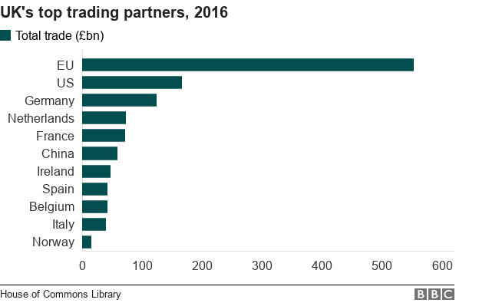
Related to this, the trade in the UK will be heavily affected by the Brexit. In a no-deal scenario, the UK and the EU will trade on World Trade Organization (WTO) terms. The reports claim that for the first time in 50 years the UK will be able to “articulate” its “own voice” in the WTO and set its own tariffs. Exporters to the EU should check the additional paperwork required by the EU and ensure they are ready. Hauliers should explain to drivers that a customs export declaration (P2P) must be completed before they will be allowed to progress on a ferry journey to the EU. The driver should check with the trader that the goods have received the P2P from Her Majesty's Revenue and Customs (HMRC) before going across the border. Those in the fishing industry will need to fill out catch certificates for all exports and potentially three other additional documents to fulfil EU laws. Hauliers can refer to a checklist of must-do’s provided by the government. The chapter also runs through the many other requirements, such as the £10 permit required by UK hauliers on export routes, and challenges that could disrupt cross-border trains and coach services. Importers will need to pay tariffs on a range of goods including meat, dairy produce and clothing. The government finalised its tariff schedule on Tuesday 8 October with just three changes to the tariff schedule published in March. Exporters will also face hefty tariffs overnight for goods sold in the EU and to other countries where there is no deal. In a no-deal Brexit this will include the 52 countries which already have a deal with the EU. The paper says the government “is working intensively to deliver continuity” on EU trade but warns that the EU’s common external tariff will apply on 60% of the UK’s exports to the EU. In some sectors such as life sciences and electronics, the effect of these taxes will be “minor” but, in what farmers will consider an understatement, it says “other sectors will be more affected” with, for example, tariffs of 65% on boneless beef and 53% on fresh bone-in lamb. Therefore, to sum things up as the Sunday Times has stated before, “Business is increasingly concerned over the UK's future trading relationship with the EU.”

Major Parties Involved and Their Views

United Kingdom: It is obvious that the main country involved in this issue is the place where it all happens: the United Kingdom. There are many different parties in the United Kingdom and thus there are many various aspects to Brexit and its effects. To give an example the Conservative Party politician who became prime minister of the United Kingdom in July, Boris Johnson wants the UK to leave the European Union (EU) with the revised deal he agreed. He previously said the UK would leave on 31 October "do or die". However, Mr. Johnson was forced to write a Brexit extension letter to the EU, after MPs failed to approve a revised deal. Mr. Johnson secured changes to the deal previously negotiated by Theresa May. It includes scrapping the controversial Irish backstop and replacing it with a new customs arrangement. Another example is that the Labour wants to renegotiate Mr Johnson's Brexit deal and put it to another public vote if it wins the election. It says it will achieve this within six months and that its referendum would be a choice between a "credible" Leave option versus Remain. The Democratic Unionist Party has its own vision regarding this topic too. The DUP had an agreement with the Conservatives whereby it lent it support in the Commons. However, while the DUP wants the UK to leave the EU, it is unhappy with the revised deal negotiated by Mr Johnson. To look to the bigger picture, it can be said that there are many different views on Brexit and its effects to British border policies inside the UK.

Ireland: Brexit plays into Irish domestic politics more than in any other EU27 member. Its potential impact on the border with Northern Ireland (a nation of the United Kingdom) is well known, but the scale of the issue for Irish politics and society cannot be underestimated. However it isn’t just about the border. The U.K. takes 15 percent of Irish exports, according to a government commissioned report earlier this year, which predicts that Brexit would have between a 2.8 and 7 percent negative effect on Irish GDP, depending on the scenario. On the other hand while the U.K. is a major economic partner, the EU is a bigger one. Its 26 other member countries’ combined buying power represents about double the value of the U.K. to the Irish economy. There is therefore no doubt about which matters more to Dublin, economically speaking.

European Union: The EU is no longer as united as it was on how to handle the British. But just about everyone working on Brexit in the EU’s institutions and governments is fed up with them, and they do not believe that Britain’s politicians are capable of getting their act together and resolving the problem. Ever since the British referendum of June 2016, the EU has maintained an impressive degree of unity. The 27 member-states and the EU institutions understood that they would be in a stronger position vis-à-vis the UK if they kept together.

Germany: Brexit may be the one issue German politicians can agree on these days. German leaders’ strategy was uncharacteristically clear and consistent - maintain EU unity at all costs. U.K. leaders, beginning with former Prime Minister David Cameron, were convinced Angela Merkel would eventually intervene and offer London concessions to protect German car companies from taking a hit. While many in Germany believed the U.K. needs the EU more than Europe needed Britain, in the U.K., the opposite was true. In the nearly two years since, most Germans haven’t changed their view. That’s why even as Brexit day fast approaches, the issue is not even on Berlin’s political radar.

Belgium: Belgium favors a soft Brexit or no Brexit because it would mean less economic disruption. A no-deal could cost northern, Dutch-speaking Flanders up to 28,000 jobs, the head of the Flemish government Geert Bourgeois said last month. In the southern region of Wallonia the impact would be 5,000 jobs, a government think tank estimated. Some of the sectors most impacted include machinery, pharma, food and textiles. Also, Belgium has a huge amount invested in EU unity. Any weakening of the union could equate to job losses in the country’s economic heart, the Port of Antwerp, and its capital, Brussels, which hosts the EU institutions plus its lobbyists, NGOs and law firms. To most parties – especially the Francophones in Brussels and Wallonia — the risk of setting a precedent for other countries by agreeing a special deal with the U.K. likely outweighs the damage of a hard Brexit/no-deal. Therefore Belgium is unlikely to push hard against the EU line.

Date of Event (Day/Month/Year) | Description of Event
23 June 2016 | UK votes to leave the European Union. The results show that the “leave campaign” wins by 51.9% to 48.1%, a gap of 1.3 million votes.
13 July 2016 | Theresa May becomes the Prime Minister. She wins the Conservative Party leadership contest by default, after all her challengers fell away.
17 January 2017 | Theresa May gives her first substantial speech on Brexit. She says that remaining in the single market would mean being bound by EU laws, which “to all intents and purposes, would mean not leaving the EU at all”. Therefore the speech reveals her desire for what has become known as a “hard Brexit”.
29 March 2017 | May triggers Article 50 of the Lisbon Treaty, formally kick-starting a two-year countdown to the UK exiting the bloc.
8 June 2017 | After calling a snap election in an attempt to increase her authority on the topic of Brexit, May loses her parliamentary majority and becomes forced to make a deal with the Democratic Union Party (DUP) to stay in power.
8 December 2017 | The UK and the EU agrees a deal on the UK’s so-called divorce bill, covering both EU and UK citizens’ rights and the so-called Northern Irish “backstop”.
6 July 2018 | After the European Union (Withdrawal) Bill became law at the end of June, May takes her cabinet to her country retreat Chequers in order to sign off a collective position for the rest of the Brexit negotiations with the EU.
25 November 2018 | Following some enforced changes to May’s Chequers Plan at the demand of the EU, a 599-page draft Withdrawal Agreement becomes published that contains a fleshed-out backstop which angered both the DUP and the Tory’s Brexiteers. Under the deal agreed between May and Brussels, the backstop would have kept the whole of the UK very closely aligned to EU customs rules, with some regulatory differences between Northern Ireland and the rest of the UK.
15 January and 12 March 2019 | Having pulled the vote before Christmas over fears that she would lose, May attempts to get her deal approved by Parliament on 15 January. However with Brexiteers worried about the UK remaining in the customs union through the backstop and the DUP concerned about potential disparity between Northern Ireland the UK, the PM suffers the heaviest defeat in modern parliamentary history, losing 432 votes to 202. Moreover, May loses a second meaningful vote on her deal by 149 votes two months later.
12 April 2019 | The UK’s deadline for leaving the EU is pushed back to 31 October - with or without a deal - in the wake of May’s failure to push a deal.
24 June 2019 | After failing three times to get her withdrawal agreement through Parliament, Theresa May sets a resignation date of 7 June.
24 July 2019 | Boris Johnson enters Downing Street after winning the Conservative party leadership election with 66% of the vote, a comfortable victory over rival Jeremy Hunt. He repeats his campaign commitments to “deliver Brexit, unite the country and defeat Jeremy Corbyn”.
28 August 2019 | Reports emerged that the new PM has asked the Queen to suspend Parliament for five weeks in the run-up to 31 October.
4 September 2019 | The PM calls for a general election. However opposition parties collectively refuses to back a general election vote until the legislation blocking a no-deal exit on Halloween had passed into law and the EU agreed the extension.
24 September 2019 | In a landmark decision, the UK Supreme Court rules that Boris Johnson’s five-week prorogation of Parliament in the run-up to the Brexit deadline was “unlawful”.
2 October 2019 | The PM has made a formal proposal to the EU setting out his alternative to the Irish backstop. The proposals would leave the UK in the same customs territory as the EU, and would keep Northern Ireland under EU regulations until a permanent trade deal was reached.
19 October 2019 | Parliament hosts a special session for MPs less than two weeks before the Halloween Brexit deadline. Johnson gets legally obliged by the Benn Act to send a letter to the EU on that date requesting a three-month Brexit extension after Parliament refused to pass his deal.
2 December 2019 | Despite the government’s assurance that the UK would leave the EU at the end of October, the UK votes to once again delay Brexit to January 2020, paving the way for a general election on 12 December 2019.
31 January 2020 | Having agreed to a delay in October, EU leaders agree to a so-called Brexit “flextension” until 31 January unless Parliament passes Johnson’s Brexit deal sooner – assuming he wins a majority at the polls in December.

Timeline of Events

Evaluation of Previous Attempts to Resolve the Issue
- (21 October 2019) EU (Withdrawal Agreement) Bill - https://publications.parliament.uk/pa/bills/cbill/2019-2019/0007/cbill_2019-20200007_en_1.htm

- (2 October 2019) Letter from the Prime Minister to Jean-Claude Juncker, President of the European Commission -
https://assets.publishing.service.gov.uk/government/uploads/system/uploads/attachment_data/file/836029/PM_letter_to_Juncker.pdf

- (26 June 2019 to 25 September 2019) The European Union (Withdrawal) Act and Common Frameworks -
https://assets.publishing.service.gov.uk/government/uploads/system/uploads/attachment_data/file/841824/The_European_Union__Withdrawal__Web_Accessible.pdf

Possible Solutions
All delegates should start their preparations with deciding upon the point of view of their assigned country on the topic of Brexit affecting British border policies. Delegates should touch upon the main points of this issue such as the Irish border, the trade relationships with other countries, the immigration circumstances and the rights of both UK and EU citizens who want to settle in the UK. On the topic of the Irish border, delegates may agree or oppose to the current terms. It is crucial for delegates to try to create solutions regarding the problems that are mentioned because the most important effects of this topic are them. Furthermore, delegates can introduce new regulations about Brexit that may affect many other countries besides UK. Delegates may also think about whether or not they agree to all the EU’s terms and they may write clauses regarding this.

Further Reading
- “How Brexit could create a crisis at the Irish border” https://www.youtube.com/watch?v=e0xGHf8o-9k

- “Brexit explained: what happens when the UK leaves the EU?” https://www.youtube.com/watch?v=7eoDwvl0QGk

- “Travel, trade, new EU migrants and Irish border law: no-deal Brexit plan explained” https://www.theguardian.com/politics/2019/oct/08/travel-trade-phone-bills-and-immigration-no-deal-brexit-plan-released

- “Brexit: defence, security and immigration” https://www.parliament.uk/business/publications/research/eu-referendum/defence-security-and-immigration/

- “Brexit and Ireland Legal, Political and Economic Considerations” https://www.europarl.europa.eu/RegData/etudes/STUD/2017/596825/IPOL_STU(2017)596825_EN.pdf

Bibliography
- “Brexit: Jargon-Busting Guide to the Key Terms.” BBC News, BBC, 21 Oct. 2019, www.bbc.com/news/uk-43470987.

- “Border Security.” Migrationpolicy.org, 1 Aug. 2019, www.migrationpolicy.org/topics/border-security.

- “Immigration Reform.” Wikipedia, Wikimedia Foundation, 11 Nov. 2019, https://en.wikipedia.org/wiki/Immigration_reform.

- “What Is Hard Brexit?” UK in a Changing Europe, https://ukandeu.ac.uk/fact-figures/what-is-hard-brexit/.

- Kenton, Will. “Article 50.” Investopedia, Investopedia, 18 Nov. 2019, www.investopedia.com/terms/a/article-50.asp.

- “Brexit Timeline: Key Dates in the Saga of the UK's Exit from the EU.” The Week UK, www.theweek.co.uk/100284/brexit-timeline-key-dates-in-the-uk-s-break-up-with-the-eu.

- “Who Are the DUP and What Do They Stand for?” The Week UK, www.theweek.co.uk/general-election-2017/85445/who-are-northern-irelands-dup-and-what-do-they-believe.

- Politico. “The Brexit Playbook in the 11 EU Countries That Will Shape a Deal.” POLITICO, POLITICO, 18 Apr. 2019, www.politico.eu/article/brexit-playbook-11-eu-countries-that-will-shape-deal/.

- “Brexit: Where Do the Parties Stand?” BBC News, BBC, 5 Nov. 2019, www.bbc.com/news/uk-politics-48027580.

- “The Brussels View of Brexit.” Centre for European Reform, www.cer.eu/insights/brussels-view-brexit.

- O'Carroll, Lisa. “Travel, Trade, Phone Bills and Immigration: No-Deal Brexit Plan Explained.” The Guardian, Guardian News and Media, 8 Oct. 2019, www.theguardian.com/politics/2019/oct/08/travel-trade-phone-bills-and-immigration-no-deal-brexit-plan-released.
- McMenemy, Simon. “How Brexit Would Change UK Immigration Laws.” SHRM, SHRM, 19 Mar. 2019, www.shrm.org/resourcesandtools/hr-topics/global-hr/pages/how-brexit-would-change-uk-immigration-laws.aspx.

- Morris, Marley. “How Will Britain Treat EU Citizens after Brexit? They Need to Know – and so Does Business | Marley Morris.” The Guardian, Guardian News and Media, 22 Aug. 2019, www.theguardian.com/commentisfree/2019/aug/22/britain-eu-citizens-brexit-business-immigration-policies.

- “Brexit and the Future of Immigration in the UK and EU.” Financier Worldwide, www.financierworldwide.com/brexit-and-the-future-of-immigration-in-the-uk-and-eu#.XeIxsZMzbpJ.

- “Brexit: The Facts.” The Irish Times, www.irishtimes.com/news/world/brexit/brexit-the-facts.

Picture 1: UK Border Line in an Airport
Picture 2: Ireland and UK borders
UK’s Top Trading Partners in 2016

