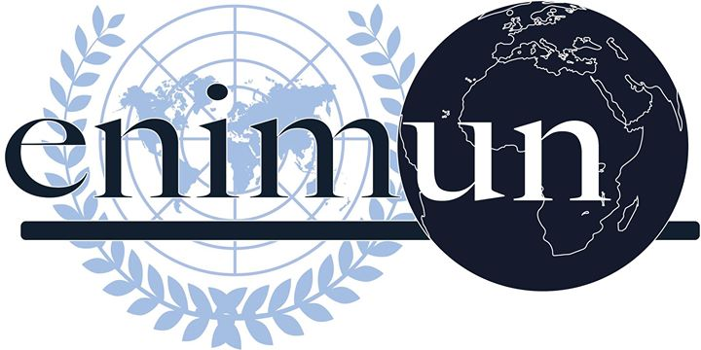

2019

ChaIr REPORT

GA4 ENVIRONMENTAL COMMITTEE

The issue of endangered marine species as a result of individual fishing activities

dEPUTY CHAIR ZEYNEP KAYRA YILDIRIM

Introduction
Until a few centuries ago, communities have thought that the oceans supplied endless amount of fish. As the global population increased, every year demand for fish continued to rapidly increase around the world. Fish carries the vital nutrients needed to proceed a healthy human life. Fish is one of the most traded food commodities and is worth a 362 billion dollar global industry. With the developing technology the industrial fishing companies are in an endless competition amongst themselves. Now the fishermen have the access to use unsustainable methods to capture more fish in a smaller amount of time, in order to meet the demands. In fact the technologies used to catch fish in greater depths were originally developed for war. If these destructive methods continue being used, mankind will have to face commercial extinction. Commercial fishing provides the fish we see everyday, on the grocery shelves. This over exploitation caused by fisheries is the main reason why the oceans lack fish. Despite the saying “there are plenty of other fish in the sea” there are actually almost no fish in the sea. Coastal communities depend on the marine life to make a living. Entire ecosystems and economies depend on the marine life. Overfishing is an issue that needs to be combatted for many reasons. Many scientists claim that the threat marine life faces is greater than all of the other environmental threats. The solution for this global issue goes hand in hand with the privatization of common assets. Fish stocks in oceans are valuable assets for human kind. And if these assets are not protected properly then they might turn into liabilities.
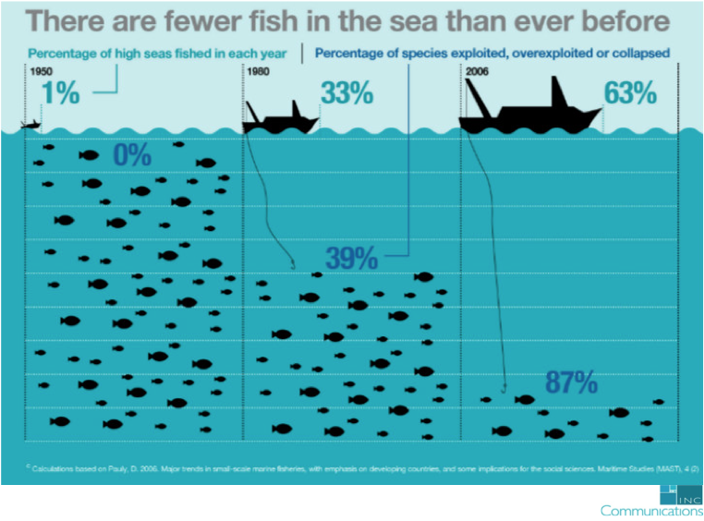

Key Vocabulary
Overfishing: The removal of species from their marine life at a rate that the species can no longer replace themselves.
LEDC: Less economically developed countries
Privatization: relocating something from the public sector into the private sector.
3rd world countries: Countries under difficult conditions and countries that haven’t yet gained an economical development.
Species: a group of living organisms that carry similar genes and are able to breed with each other.
Cyanide: A compound, which is the result of the bonding between Carbon and Nitrogen. It is a very strong chemical.
Bycatch: The unwanted fish accidentally caught by the nets of the fishing vessels. They are often thrown back into the sea.
Assets and liabilities: Properties and debts
Focused Overview
According to the statistics conducted by the World Health Organization (WHO) more than 1 billion people around the world depend on fish as the essential source of protein. Fishing is a critical activity that has to pursue as long as mankind lives. But if it continues at this rate, by the time of 2050 the oceans will run out of seafood. Fish cannot reproduce themselves as fast as mankind consumes them. On the other hand mankind not only depends on the marine life for nutrition purposes but also depends on the marine life for the oxygen they inhale. Fish have a broad affect on our ecosystem. Furthermore products such as medicinal products are produced from the marine life. Humans should remember that the ocean is not dependent to them; they are dependent to the ocean.
- How does overfishing affect our ecosystem?
Overfishing has an enormous negative impact on marine diversity. When a great amount of fish are ripped of from their ecosystems, the marine diversity gets negatively affected and as an outcome, a situation of imbalance occurs. This imbalance leads to the loss of other important marine life since the food web gets disrupted. Vulnerable species such as sea turtles and corals become extinct because of this. Overfishing disrupts the food chain and with that destroys the whole marine ecology. For example tuna fish eats squid, nevertheless due to overfishing a great amount of the tuna species disappear. When a lack of tuna fish comes to appear, squid population increases. Due to this increase in the population of squid the shrimp, which are the vital prey of squid, get harassed and extinction begins.

Overfishing is unsustainable in many ways. The equipment used for overfishing is able to catch hundreds of fish in one dunk. The fish used from the catch is around %5 percent. The rest is bycatch that means they are unwanted so they get spilled back into the ocean but this time they are dead.

Overfishing also harms the coral reef. The equipment used to capture fish damages the coral habitat. Traps set to capture coral reef fish damages the seafloor habitat in many ways that the corals can no longer replenish their population. The extinction of coral reefs not only affects the marine life, but also affects our ecosystem. Coral reefs provide a nurturing habitat for over 1 million diverse aquatic species. Coral reefs also provide protection for coastal communities.

As Greta Thunberg has stated in her speech at the UN Climate Summit “We are at the beginning of a mass extinction and all you can talk about is money and fairytales of eternal economic growth”. This quote from Greta Thunberg’s speech perfectly suits the standards of overfishing. However, Greta Thunberg is missing a point in her speech. Gaining sustainable economical development is also through environmental acts.
- How does overfishing occur

Overfishing is a symbol of greediness often done by fisheries to outstand among their rivals by meeting the demand in a shorter time interval. Overfishing exists when species are caught faster than they can reproduce themselves. This interferes with the reproduction cycle of fish resulting to their extinction.

- 10 most Endangered marine species
According to International Union for Conservation of Nature (IUCN) redlist, 33 percent of the coral reefs and 30 percent of sharks are facing extinction.
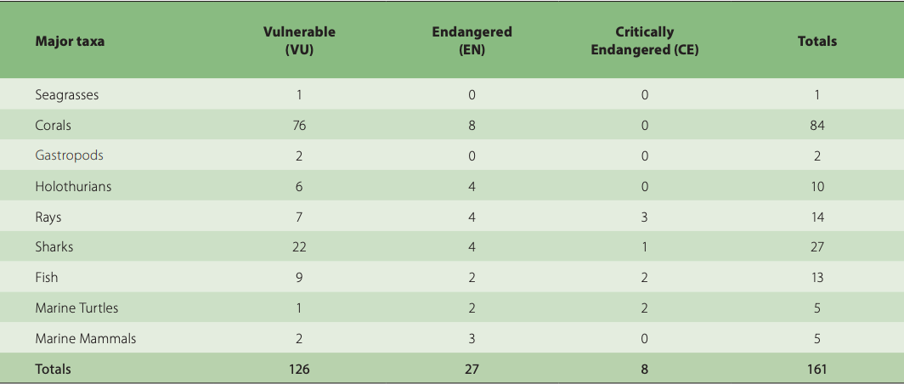Vulnerable and endangered taxonomic groups
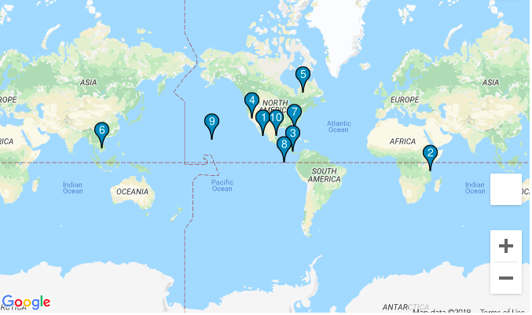The 10 most endangered marine species and where they belong
Usually the most endangered marine species are located in the areas where overpopulation and consumerism is mostly seen. As it’s seen in the map 8 of the 10 most endangered marine species can be spotted in the shores of North America.
- Individual Fishing Quota (IFQ)
But how can the governments reduce the fishing of endangered marine species? Coastal fisheries use any process essential to outstand among their competitors. So they consult to environmentally destroying fishing methods to meet the demand.
And the result of this race is zero to zero since with these methods they make a temporal living but they permanently damage the marine environment, which in the long term causes economic plummeting.
Individual fishing quota is a system governments adopt to regulate fishing activities. IFQ’s are exclusive and transferable rights provided to fishermen. IFQ’s are transferable so that means it can be sold from one fishery to another. For the system to work, a total allowable catch (TAC) is set. The TAC is usually set according to weight, type of fish and a given time period. The earliest to adopt this system were Iceland, Canada and the Netherlands by the end of 1970s. By the time of 2008 almost 10 percent of the marine harvest was being regulated by IFQ’s.
- IUU fishing (Illegal Unreported and Unregulated fishing)
The FAO committee on fisheries has specified that IUU fishing is a vital issue that has to be combatted in order prevent marine crime from happening. Illegal fishing causes the worst ocean impacts. Foreign vessels that exploit fish from the 3rd world countries, negatively affect the local fisheries by fishing in an unregulated manner. Depriving them of fish and with that, resulting in the collapsing of their economy. For example half century ago ordinary fisheries in a coastal community were able to catch 40 kilograms of fish per fisherman in an interval of 24 hours. But now with the developing standards of fishing the fishermen can only manage to catch 3 kilograms of fish. This is the result of overfishing that is caused by IUU fishing. IUU fishing is fishing inside a nations jurisdiction without permission from its authorities or misreporting the catches to its authorities. IUU fishing has a huge negative impact on the coastal fisheries resulting in the economical downfall of the coastal communities. IUU fishing also has a destructive influence on biodiversity and the liveliness of the marine habitat, which is essential for the reproduction of fish. Especially foreign cyanide divers are a pressing concern on the endangered species. Cyanide divers fish by poisoning the marine species with cyanide to kill the fish. Cyanide also kills corals which are, as mentioned before, the oxygen source of the ecosystem. Even though this is an illegal act it can be seen pretty often because of the lack of enforcements implemented on these laws.
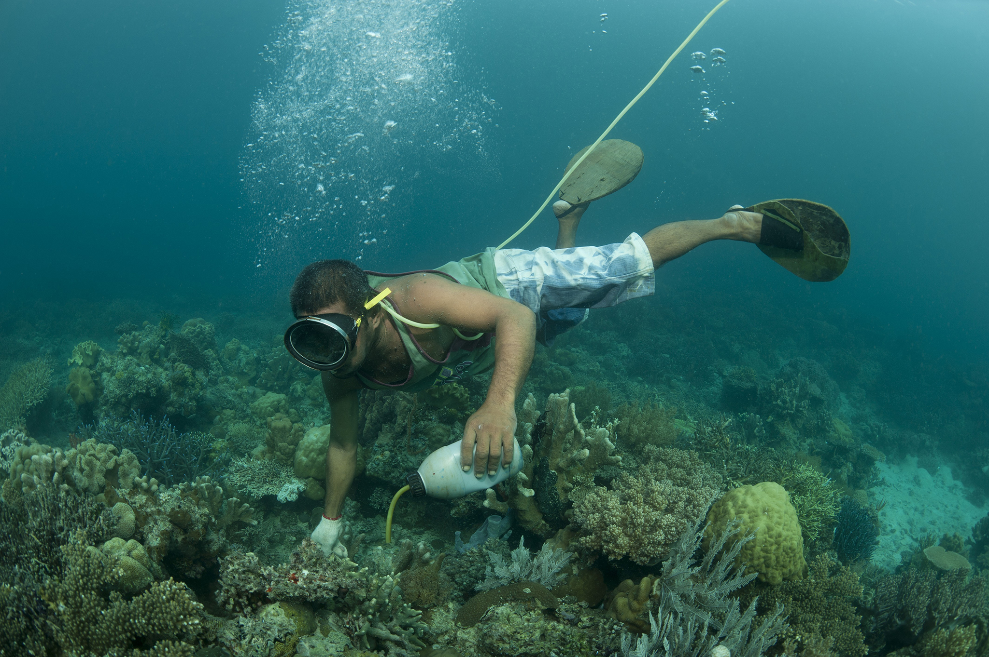 Cyanide divers

Major Parties Involved and Their Views

Japan
Half of Japan’s marine species are facing high-level extinction. Japan has been responsible for exploiting extreme amount of fish in the Pacific. Intense commercial fishing has caused the plummeting of the amount of tuna in the Pacific. Also Japan hasn’t yet implemented IFQ’s.

United States
US is one of the largest importer of fish. Corporate partners in North America collaborated with WWF to implement improvements in fishing methods. US aim preventing overfishing through Annual Catch Limits. USA has adopted some regulative measures such as IFQ’s which shows their policy on developing themselves on this matter.
FAO
FAO specifically focuses on this issue in its committee on fisheries. The FAO Committee on Fisheries has passed many solution-oriented resolutions regarding this issue.
China
50 years ago coasts of China were home to over 20 billion fish. In 2010s the amount of fish in the sea reduced by %95 percent. The Chinese river dolphin is one of the 10 most endangered marine species. The market demand for fish has reached such enormous level because of the overpopulation.
South Korea
The South Korean shores were once rich with fish but over the years it decreased to a level that it’s almost equal to none. The government of South Korea has been making efforts on reducing fishing activites but did not succeed. The government’s regulations stand ineffective. Since these attempts failed, government officials also suggest to solve the issue through creating awareness amongst the consumers. Overfishing is a huge barrier for the country to reach it’s goals.
Indonesia
Indonesia is covered with an extensive amount of sea making it unavoidable for them to gain money through fishing. Indonesia is the second largest producer of fish but for the last few decades it’s oceans are more depleted than ever. The World Bank estimated that if Indonesia used its fisheries in a more sustainable way the country could gain more money from the industry.

Timeline of Events

Date of Event | Description of Event
August 7th 1800 | Beginning of overfishing when humans discover whale population and seek to catch them.
October 9th 1940 | Extreme exploitation of tuna fishing results the tuna across the seas of northern Europe to disappear.
October 31th 1995 | Resolution 4/95 passes.
2005 | This year it is estimated that over %60 are fully or nearly exploited.
19 June 2015 | A/RES/69/292 passes.
23 December 2015 | A/RES/70/235 passes.
24 December 2017 | A/RES/72/249 passes

Evaluation of Previous Attempts to Resolve the Issue.
- Code of Conduct for Responsible Fisheries and Resolution 4/95 (1995)
Code of Conduct is one of the most recognized and extensive global fisheries instrument. It was adopted by the FAO conference.

- A/RES/69/292
A resolution adopted by UN on 19 June 2015 under UNCLOS (United Nations Convention on the Law Of Sea). The establishment of Preparatory Committee took place in this resolution.
https://www.un.org/ga/search/view_doc.asp?symbol=A/RES/69/292&Lang=E

- A/RES/70/235
A resolution adopted by the UN on 23 December 2015 regarding oceans and the law of sea.

- A/RES/72/249
The UN adopted this resolution on 24 December 2017. In this resolution the General Assembly decided to convene an Intergovernmental Conference

Possible Solutions
Coastal fisheries should be motivated to fish more sustainably. In addition seasons for fishing must be strictly defined by the authorities. Governments should restrict fishing during the breeding period of the marine species. Governments should ban the fishing of species under severe danger. Governments should implement more laws on this matter and most importantly ensure the enforcement of these laws. Furthermore fishing of species under certain age and length should be prohibited. Above all, governments should be encouraged to adopt IFQ’s and strictly regulate them. Setting quotas are crucial to solve the issue. Also awareness could be spread amongst consumers and fishermen through effective campaigns.

Further Reading
- 10 most threatened marine species (https://wedocs.unep.org/bitstream/handle/20.500.11822/11349/rsocr_printedition.compressed_Part10.pdf?sequence=11&isAllowed=y)
- Overfishing movie https://www.youtube.com/watch?v=-V4D77N3bZc
- FAO Report on IUU fishing (http://www.fao.org/iuu-fishing/international-framework/code-of-conduct-for-responsible-fisheries/en/)

Bibliography
A/RES/69/292 - E - A/RES/69/292, undocs.org/A/RES/69/292.
“Adopting Two Resolutions, General Assembly Speakers Stress That Healthy, Resilient Oceans, Seas Play Central Role in Achieving Sustainable Development Goals | Meetings Coverage and Press Releases.” United Nations, United Nations, www.un.org/press/en/2018/ga12103.
“Impact of Overfishing On Human Lives.” Marine Science Today, 8 Apr. 2014, marinesciencetoday.com/2014/04/09/impact-of-overfishing-on-human-lives/.
“Intergovernmental Conference on Marine Biodiversity of Areas Beyond National Jurisdiction.” United Nations, United Nations, www.un.org/bbnj/.
“OVERFISHING STATISTICS EVERYONE SHOULD KNOW.” Seafarms Group Limited, 13 Feb. 2015, seafarms.com.au/overfishing-statistics-everyone-should-know/.
projects, Contributors to Wikimedia. “Transferring Ownership of a Business, Enterprise, Agency, Public Service, or Public Property from the Public Sector (a Government) to the Private Sector, to a Business That Operates for Profit.” Wikipedia, Wikimedia Foundation, Inc., 17 Nov. 2019, www.wikizeroo.org/index.php?q=aHR0cHM6Ly9lbi53aWtpcGVkaWEub3JnL3dpa2kvUHJpdmF0aXNhdGlvbg

