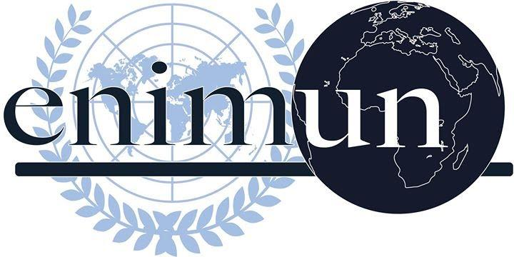

2019

CHAIR REPORT

GA2: SOCIAL, HUMANITARIAN AND CULTURAL COMMITTEE

(SOCHUM)

ENSURING THE SAFETY OF DISADVANTAGED WORKERS TO PREVENT HUMAN TRAFFICKING

CANSU ÇAĞIRAN - DEPUTY CHAIR

Introduction
Humanity has been immersed in a pool of difficulties ranging from world wars to massacres, global crimes to many types of exploitation since the start of time. Although problems such as world wars were dealt with, the ones that are more complex were not successfully solved. They became more critical and prominent with time, because of the inability of humanity to take adequate action. Human trafficking is one of the problems that was not successfully dealt with yet needs action to be taken in order to take a step towards enhancing the application of human rights while protecting the rights of people as well.

Human trafficking first started in the 16th century as the Portuguese started transporting enslaved Africans across the Atlantic Ocean to the Americas. European countries such as Great Britain, France, Spain soon became a part of this slave trade. Then in 1904, the International Agreement for the suppression of the White Slave Traffic was signed, which was the first multilateral agreement to be signed which addressed the issues of slavery and human trafficking. Since that; many treaties were signed in order to stop this condemnable crime. Awareness was started to be raised; meetings were organized to prevent human trafficking yet there are still millions of victims. It is considered modern-day slavery. People from all around the world are forced to doing hard labor and domestic labor, being sexually exploited, sold for prostitution and many more types of human trafficking.

Furthermore, the rapid industrialization of the 19th and 20th centuries brought along the massive need for workers. Factory and industry owners wanted to multiply profits which meant reducing the cost of production which put them in the search for the lowest cost workers possible. This was done through the utilization and exploitation of underprivileged workers back in the day and is still being done. Workers who are not highly developed both economically and socially are exploited more and more every day. Since they are not registered workers in the country that they have been taken to, they are forced to doing hard labor and domestic labor without any safety precautions, under very low standards and poor conditions. The desire to multiply profits for the sake of making millions of dollars led to human trafficking and still does. In most countries, the necessary laws do not exist, or even if they do, they are not properly implemented which makes human trafficking a crime with low risks and high rewards.

All these people who are forced to do hard labor and all the victims of human trafficking rely on all governments and global cooperation to solve this ongoing issue. It is crucial for all countries to cooperate and play their roles whether it is to raise awareness, provide the necessary legal assistance and additions, and recognize why people are vulnerable to human trafficking in order to actually do something about it. If not, the lives of millions of people will still be at stake and their rights will continue to be exploited.

Key Vocabulary
Human trafficking: “the action or practice of illegally transporting people from one country or area to another, typically for the purposes of forced labor or sexual exploitation”
Industrialization: “a progressive transformation of an economic system from rudimentary productive methods to more complex manufacturing processes”
Forced Labor: "all work or service which is exacted from any person under the threat of a penalty and for which the person has not offered himself or herself voluntarily."
Domestic Labor: “the numerous tasks associated with maintaining a household.”
Migration: “ movement from one part of something to another.”
Transnational Organized Crime Groups: a group or network of individuals that coordinates, plans, and executes illegal business ventures.
Exploitation: the action or fact of treating someone unfairly in order to benefit from their work.
Global Crime: it is a violation of the law that involves more than one country in its planning, execution, and impact. It is also known as the term “transnational crime”.
UN Peacekeeping Officers: “UN personnel that are employed to maintain or re-establish peace in an area of conflict”. They provide security and peace-building support to help countries during the transition from conflict to peace.
Transatlantic Slave Trade: “segment of the global slave trade that transported between 10 million and 12 million enslaved Africans across the Atlantic Ocean to the Americas from the 16th to the 19th century. “
Focused Overview
1) Human trafficking
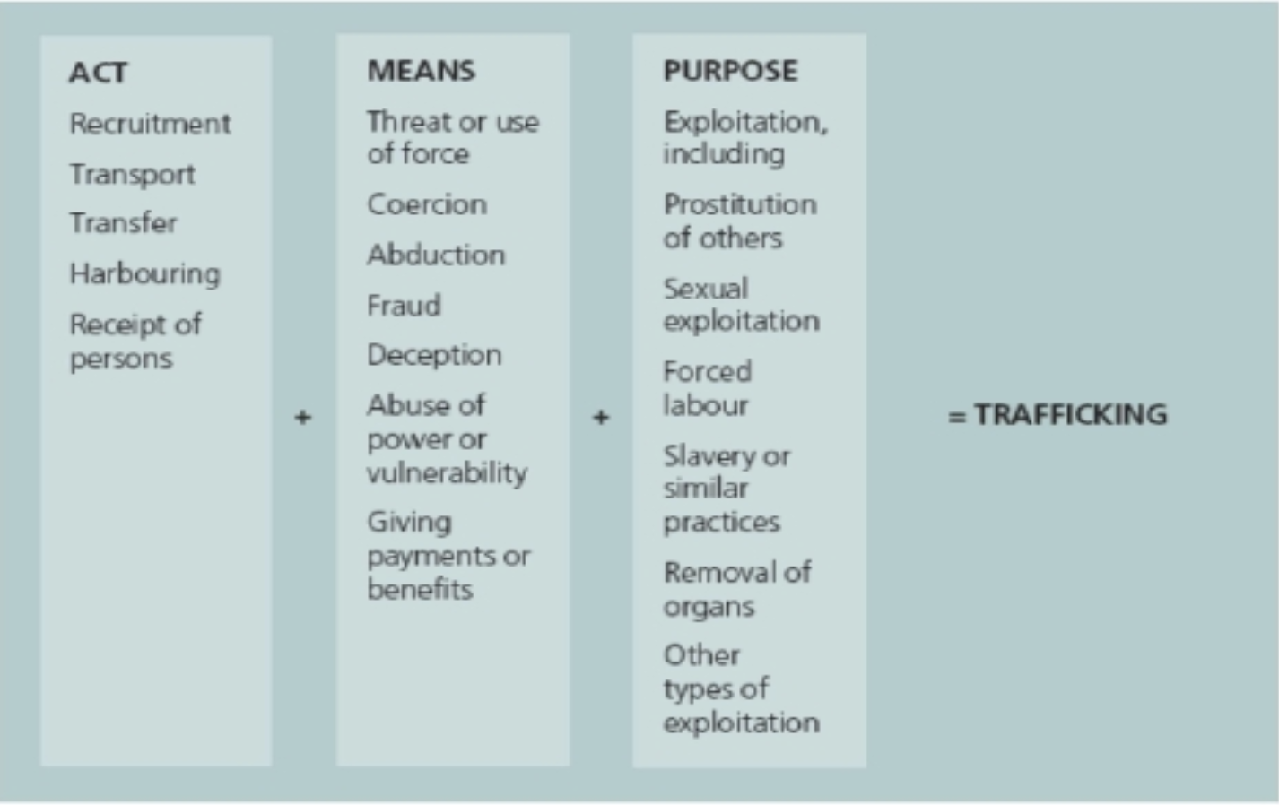
According to the Article 3, paragraph (a) of Protocol to Prevent, Suppress and Punish Trafficking in Persons, human trafficking is “the recruitment, transportation, transfer, harboring or receipt of persons, by means of the threat or use of force or other forms of coercion, of abduction, of fraud, of deception, of the abuse of power or of a position of vulnerability or of the giving or receiving of payments or benefits to achieve the consent of a person having control over another person, for the purpose of exploitation.” Human trafficking is considered modern-day slavery, and there are more slaves today than at any time in history. The number of “slaves” is increasing by second. To further elaborate on the definition of human trafficking, one can distinguish three core elements of it:
- The action of human trafficking: transportation, transfer, harboring or receipt
- The means of trafficking: force, the use of threat, deception, abuse, coercion, abduction, etc.
- The purpose of trafficking: exploitation.
A crucial point about human trafficking is that it does not necessarily require movement. It can include movement and get into the category of transnational crimes; however, it can happen wherever the victims reside in too. The ultimate goal is exploitation and enslavement. People are coerced into harsh employment under horrible conditions, and then have no freedom to leave.
2) The causes of human trafficking
The causes of the issue also are interconnected and complex as the issue itself. They are affected by factors such as economic, social and political factors; so, poverty alone is not necessarily a reason for vulnerability to human trafficking. However, when it merges with other factors, it is a very large contributor. It can cause people to be human traffickers. Moreover, people in poverty are targeted by traffickers. It drives people to migrate, makes education and legitimate work hard to obtain which are other root causes of human trafficking.
Lack of education leads people to both decreased knowledge of human rights and decreased opportunities for a job at a living wage. Lack of legitimate economic opportunities also puts people in a very vulnerable position. Groups that are especially vulnerable in economic opportunities are generally immigrants lacking work permits, people lacking education and people living in places such as rural areas where job opportunities are less available.
Another major cause of human trafficking is that it is a “profitable industry”. The U.N. Labor Agency had stated that trafficking, forced labor, and modern slavery are big business generating profits estimated at $150 billion a year. The large profit that the traffickers gain with very low risks of getting caught in a massive incentive. With forced laborers and bonded laborers, they get cheap labor and can sell their products or service at a much higher cost.
The root cause of human trafficking is the traffickers themselves. Considering the fact that human trafficking is not a naturally occurring phenomenon, human trafficking can be stopped by stopping the traffickers, who are the root cause. Although the issue itself is quite complex, why it cannot be solved is relatively simple. Too often the traffickers are let off with a very small punishment or even no punishment at all. So, a serious attempt to combat human trafficking must include
3) Background of human trafficking
Human trafficking started in the 1400s when the Transatlantic Slave Trade (also known as European Slave Trade) began with the Portuguese transporting Africans to the Americas. This act of the Portuguese inspired other European countries which started the slave trade, until 1904. In 1904, the first international and multilateral agreement which is the International Agreement for the Suppression of “White Slave Traffic” was signed and it made countries realize the shameful and traumatic effects of human trafficking. There were not any other agreements or acts on human trafficking prior to 1904. As a matter of fact, it was seen considered to be a normal practice, especially for the advancement of the Industrial Revolution. The industrialization itself was and still is a cause of human trafficking, as people started to think of ways to multiply profits more and more, which led them to human trafficking.
Unfortunately, after the agreement had been signed in 1904, Japan set up a system of woman trafficking all over Asia during World War II, in defiance of the agreement that had been signed. Many women took non-amendable damage. Many of them died of diseases, suicide, exhaustion and more.
In 1948, the Declaration of Human Rights was signed which allowed many trafficking victims to fight for their rights and lives. India initiated the Immoral Traffic (Prevention) Act in 1956. In 1995, the UN held its 4th World Conference where it addressed the issue of trafficking women. And most importantly, in 2001, the United States Department of States released the first Trafficking in Persons (TIP) Report. Basically, this report ranks countries according to their compliance with the Trafficking Victims Protection Act (TVPA). It is an act made by the US Department of States to combat human trafficking. It monitors human trafficking on a global scale, therefore gives the countries an opportunity to evaluate themselves.
In TIP, countries are categorized as “Tier”s. It is important for countries to comprehend that this report should be seen as an elementary resource in combatting human trafficking. The countries can look at the report and make conclusions from it. They also can take an example from the governments who are considered to be Tier 1 countries.
The Tiers are categorized as followed:
Tier 1: It is the highest ranking. It indicates that the government in this category has acknowledged the existence of human trafficking within their country, made efforts in order to deal with the issue, and is in compliance with the TVPS’s minimum standards.
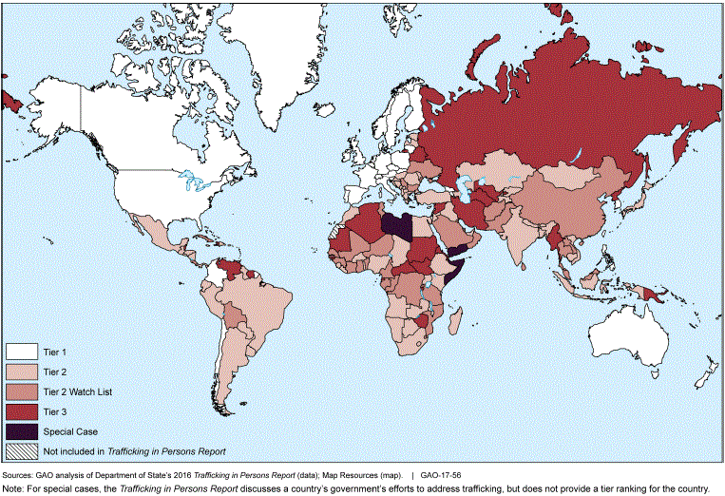
Tier 2: Countries that are in the Tier 2 category are countries whose governments do not fully comply with the TVPS standards. However, the government is putting significant efforts to bring themselves into compliance.
Tier 3: For countries that are in the Tier 3 category, there is more than international shame. Being in this category can seriously cause economic consequences as well as the possibility of facing some financial penalties.
The TIP Report and both the economic consequences and the image it makes the country gain caused the governments to increase the anti-trafficking measures.
4) The vulnerability to human trafficking of disadvantages of workers
According to the “An Introduction to Human Trafficking: Vulnerability, Impact, and Action” by UNODC, “human traffickers prey on people who are poor, isolated and weak”. There are specific issues that make groups of people particularly vulnerable to being trafficked such as social exclusion, disempowerment, and economic vulnerability. Unfortunately, workers possibly carry these types of issues which puts them to a dangerous position. The allure of opportunities, the demand for low-priced goods and services and the expectation of stable income drive people towards potentially risky situations where they are at risk of being exploited and being trafficked.
Major Parties Involved and Their Views

Myanmar (Burma)
Myanmar is a source country for men and women who are subjected to human trafficking, specifically for forced labor. Tatmadaw, the armed forces of Myanmar, exploited hundreds of thousands of Rohingya and other members of other ethnic groups. These victims were left stateless which made more than 700,000 Rohingya flee to neighboring countries, especially to Bangladesh. Economic conditions within the country have led to the increased migration, both legal and illegal, of citizens. The government has yet to address the systemic political and economic problems that cause people to seek employment through both legal and illegal means in neighboring countries. Myanmar's internal trafficking remains the most serious concern. Consequently, Myanmar is considered to be a Tier 3 country and continues to be one, if the government does not take the necessary actions.
Bangladesh
According to UNHCR, more than 723,000 Rohingya have fled to Bangladesh since the human rights crisis in Myanmar in order to escape from the ethnic and religious prosecution of Myanmar’s armed forces. The government had established humanitarian aid for the victims and arrested some of the culprits; however, trafficking crimes remained a severe problem making Bangladesh a Tier 2 watch-list country. Bangladesh is considered to be a “port” that connects the trafficking between other countries. Thus, if the necessary action is not taken, the trafficking will only increase.
Laos
Laos is a source country for human trafficking as well as being a transit and destination country for it. The country is classified as one of the least developed countries in the world and the poorest within Southeast Asia. Human trafficking is interconnected to the increasing legal and illegal labor migration. Lack of economic opportunities, the uncertainty of income and poverty are significant push factors causing people to travel away in search of work. Thus, victims are often immigrants wishing to find opportunities to work abroad. Once they get into the destination country, they experience hard labor as well as sexual exploitation. The insurgency in Laos, as well as the ongoing conflict between the Lao People’s Army and the Vietnam People’s Army Laos, make Laos a Tier 3 country, like Iran.
Iran
Iran is a source, transit and destination country for trafficking victims subjected to both forced labor and sex trafficking. Children in Iran who work within transport, waste disposal, construction, carpet industry, etc. are targets of organized criminal groups as they work under dangerous working conditions. Mainly, street children, these children are kidnapped and taken by organized criminal groups so that they work as street vendors and beggars. According to the “Trafficking in Persons Report of 2018”, Iran is considered a Tier 3 country.
International Labor Office (ILO)
International Labor Office (ILO) is a specialized United Nations (UN) agency for labor and work since 1942. It puts and regulates labor standards, advocates for rights, and promotes proper employment opportunities. Recently, the ILO and Walk Free Foundation have been started working on a new project that has been used to determine the number of people living under the title of modern slavery. They benefit from the inputs provided by other UN agencies, in particular, the Office of the High Commissioner for Human Rights (OHCHR).
United Nations Office on Drugs and Crime (UNODC)
The United Nations Office on Drugs and Crime (UNODC) is a United Nations (UN) agency that works on severe global crimes including human trafficking. According to their vision, “UNODC offers practical help to States, not only helping to draft laws and create comprehensive national anti-trafficking strategies but also assisting with resources to implement them”.
The Protocol to Prevent, Suppress, and Punish Trafficking in Persons, Especially Women and Children, is the protocol that the UNODC is considered to be the guardian of. The protocol itself is a milestone to combat human trafficking. Although most of the countries have ratified the protocol, severe problems still can be seen.

Timeline of Events
Date of Event (Day/Month/Year) | Description of Event
The 1400s | The start of human trafficking from Africa to the Americas
1904 | The International Agreement for the Suppression of “White Slave Traffic”
1932 | The Japanese system where women were forced to sexual slavery all across Asia
1948 | The Declaration of Human Rights was signed
1995 | Human trafficking was recognized as an act of violence against women at the 4th World Conference organized by the United Nations
2001 | The first Trafficking in Persons (TIP) Report was published by the United States Department of State
2002 | The Polaris Project which works on eliminating all sorts of human trafficking was founded by
September 2014 | The International Labor Organization (ILO) estimated that forced labor generated 150 billion dollars in global profits
December 2015 | United Nations Security Council (UNSC) held the first thematic debate on human trafficking
December 2017 | More than 700,000 Rohingyas fled to Bangladesh where they were still exploited

Evaluation of Previous Attempts to Resolve the Issue

- The Protocol to Prevent, Suppress, and Punish Trafficking in Persons, Especially Women and Children (https://treaties.un.org/doc/source/RecentTexts/18-12-a.E.htm)
The Protocol to Prevent, Suppress, and Punish Trafficking in Persons, Especially Women and Children is the first thorough multilateral and global method to combat human trafficking. The United Nations Office on Drugs and Crime is responsible for the implementation. Even though most of the countries ratified it, the lack of clarity makes it hard to implement.

- The International Agreement for the Suppression of “White Slave Traffic”
(https://treaties.un.org/Pages/ViewDetails.aspx?src=TREATY&mtdsg_no=VII-8&chapter=7&clang=_en)
The International Agreement for the Suppression of “White Slave Traffic” is a series of anti-human trafficking treaties. It was one of the first multilateral treaties to address issues of slavery and human trafficking.

- UN Convention Against Transnational Organized Crime
(https://www.unodc.org/unodc/treaties/CTOC/)
The United Nations Convention Against Transnational Organized Crime is the main international instrument in the fight against transnational organized crime. As the role of transnational organized crime groups to human trafficking are undeniable, the role of this convention is quite crucial.

Possible Solutions
A reason why the implementation of suggested measures in order to combat human trafficking is not done efficiently is because of the fact that most of the countries and non-governmental organizations have been trying to deal with the issue by themselves, instead of getting under the same roof to actually be able to do something about it. Thus, if we are talking about possible solutions, an international organization solemnly working on this issue must be founded. Global cooperation is the key to solve this global crisis.
Moreover, the lack of a national legal framework of countries makes it very difficult to punish human traffickers. Since the necessary legal framework is non-existent, or the existent legal framework actually suggest very minor punishments comparing with what the traffickers gain out of human trafficking; human trafficking is becoming a crime with very low risks and high rewards. The national legal frameworks must include coordinated and successful sub regional response policies, prevent traffickers’ freedom of liability and make sure that the traffickers get in return for what they have done.
Other than these, giving the necessary aid and support to the victims of human trafficking is crucial. Enhanced rehabilitation programs for the victims must be found. Anti-trafficking organizations must be supported and helped for conducting better research and assisting victims.
With all of these being done and getting to the bottom of this global crisis by comprehending what the causes are and what can be done to stop them from causing trafficking, the international community will take a huge step towards combatting human trafficking.
Further Reading
- An Introduction to Human Trafficking: Vulnerability, Impact, and Action
https://www.unodc.org/documents/human-trafficking/An_Introduction_to_Human_Trafficking_-_Background_Paper.pdf

- The Root Cause of Trafficking is Traffickers
https://www.traffickinginstitute.org/the-root-cause-of-trafficking-is-traffickers/

“Noy Thrupkaew: Human trafficking is all around you. This is how it works”
https://www.youtube.com/watch?v=oIGBBPspTKM
- Global Estimates of Modern Slavery https://www.ilo.org/wcmsp5/groups/public/@dgreports/@dcomm/documents/publication/wcms_575479.pdf

Bibliography
“10 Causes of Human Trafficking.” Human Rights Careers, 26 Oct. 2019, www.humanrightscareers.com/issues/10-causes-of-human-trafficking/.
Ap. “Trafficking, Forced Labor, Slavery ‘Hugely Profitable," U.N. Warns.” CBS News, CBS Interactive, 20 May 2014, www.cbsnews.com/news/trafficking-forced-labor-slavery-hugely-profitable-u-n-warns/.
Ashley. “The Department of State's Trafficking in Persons Report- What Is It and Why Is It Important?” Human Trafficking Search, 29 June 2015, humantraffickingsearch.org/the-department-of-states-trafficking-in-persons-report-what-is-it-and-why-is-it-important/.
Deutsche Welle. “Unfolding Rohingya Crisis: 'Not Something of a Civilized World': DW: 25.05.2015.” DW.COM, www.dw.com/en/unfolding-rohingya-crisis-not-something-of-a-civilized-world/a-18474683.
Diana.teixeira. “United Nations Office on Drugs and Crime.” FAQs, www.unodc.org/unodc/en/human-trafficking/faqs.html#what_is_the_role_of_transnational_organised_crime_groups_in_human_trafficking.
Diana.teixeira. “United Nations Office on Drugs and Crime.” Treaties against Human Trafficking Key to Fighting Scourge, Supporting Victims, www.unodc.org/unodc/en/frontpage/2016/September/treaties-against-human-trafficking-key-to-fighting-scourge--supporting-victims.html.
“Human Trafficking.” Open Development Laos, 8 Oct. 2018, laos.opendevelopmentmekong.net/topics/human-trafficking/.
“International and Domestic Law - United States Department of State.” U.S. Department of State, U.S. Department of State, www.state.gov/international-and-domestic-law/.
Lewis, Thomas. “Transatlantic Slave Trade.” Encyclopædia Britannica, Encyclopædia Britannica, Inc., 7 Sept. 2018, www.britannica.com/topic/transatlantic-slave-trade.
Liam.MCLAUGHLIN. “United Nations Office on Drugs and Crime.” What Is Human Trafficking? www.unodc.org/unodc/en/human-trafficking/what-is-human-trafficking.html.
Office, U.S. Government Accountability. “Human Trafficking: State Has Made Improvements in Its Annual Report but Does Not Explicitly Explain Certain Tier Rankings or Changes.” U.S. Government Accountability Office (U.S. GAO), 5 Dec. 2016, www.gao.gov/products/GAO-17-56?mobile_opt_out=1.
Rlemke. “7 Things You May Not Know About Human Trafficking, And 3 Ways To Help.” CRS, 2 Oct. 2019, www.crs.org/stories/stop-human-trafficking.
“What Is Forced Labour, Modern Slavery and Human Trafficking (Forced Labour, Modern Slavery and Human Trafficking).” What Is Forced Labour, Modern Slavery and Human Trafficking (Forced Labour, Modern Slavery and Human Trafficking), www.ilo.org/global/topics/forced-labour/definition/lang--en/index.htm?
“What Is Industrialization? - Definition: Meaning: Example.” My Accounting Course, www.myaccountingcourse.com/accounting-dictionary/industrialization.

