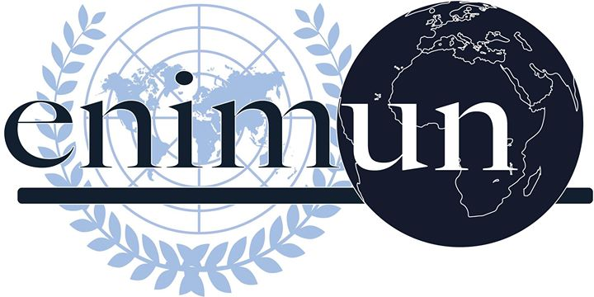

2019

ga 2

social, humanitarian and cultural committee

combating the rise of far-right movements in european countries

kayla sagiz, deputy chair

Introduction
Nationalism has always been a feature across the European continent although a recent boom in voter support for right-wing and populist parties can be observed which can be seen as a huge threat to the stability of the European Union. İn general, far-right parties tend to have a nativist ideology and authoritarian tendencies, all sustained by an organistic vision of the world. In alliance with the worldwide recessions, refugee crisis and the widespread feelings of insecurity, many European citizens started to sympathize with far-right parties. Most of these parties attract citizens by offering to uplift the poor working class in a crippling globalized economy and constricting immigration from the Middle East. Although both the far-right and the left support the welfare systems of Europe, far-right parties do not include immigrants in their welfare agendas. Moreover, most political scientists view this rise as a “domino effect” which spreads rapidly throughout the continent. Also, this process led to polarization and political uncertainty in Europe as a whole.

Key Vocabulary
Populism: a political approach that strives to appeal to the ordinary people who feel that their concerns are ignored by established elite group.

Liberalism: the political doctrine that takes protecting and enhancing the freedom of the individual to be the central problem of politics.

Welfare state: form of government in which the state protects, promotes the economic and social well-being of the citizens.

Nationalism: identification with one’s own nation and support for its interests, especially to the exclusion or detriment of the interests of other nations.

Xenophobia: dislike of or prejudice against people from other countries.

Euro Skepticism: criticism of the European Union and European integration.

Islamophobia: the fear, hatred of, or prejudice against the Islamic religion or Muslims generally, especially when seen as a geopolitical force or the source of terrorism.

Radical: principles focused on altering social structures through revolutionary or other means and changing value systems in fundamental ways.

Immigration: the action of coming to live permanently in a foreign country.

Asylum seeker: a person who has left their home country as a political refugee and is seeking for asylum in another.

Globalization: a process by which businesses/ other organizations develop international influence or start operating on an international scale.

Pluralistic society: a diverse society in which the people in it tolerate each other’s beliefs even when they do not match their own.

Coercion: force to compel people to submit to the regime.

Focused Overview
Over the past year, far right political parties have made major gains in the divisive elections throughout the Western world. One of the major booster for this rise can be considered the ongoing economic crisis since 2009. Although the European Union has worked to subdue the economic crisis by implementing financial support mechanisms, it was not regarded as an impactful solution. As a result, working and middle class Europeans started to have concerns about unemployment, salary cuts, welfare access, pensions and health care. Therefore, this part of society was motivated to support the far-right parties. On the other hand, most left-wing parties were having an identity crisis of its own which causes a distrust in the ability of the left to accomplish its agenda. Like it can be seen from the chart below the percentage of the votes won by the nationalist parties in the recent national elections is a considerably high percentage especially in Hungary, Sweden and Austria. A vast number of Europeans fear the erosion of Western culture sparkled by the Syrian refugee crisis. As a result, many far right parties capitalized on this rise of xenophobia.

- Historical Background and Immigration
Europe could be considered to be a continent that has been and continues to be influenced by migration. Before 1914 Europe had an ‘open policy’ which viewed migration as the gateway to development through labor. After 1880, migration from Europe (the old world) to America’s ( the new world) was very common. In the 1920s the West started to have more closed borders and deported immigrants. From 1945 to 1973 Europe repatriated an ‘open policy’ in which means there were more exit restrictions than entry restrictions. However, since 1973 Europe has been following stricter migration policy following the oil crisis of 1973-1974. As a result of the 1985 Schengen Agreement, there is free travel within Europe although moving from Non-EU states to EU states has been a challenge. With regard to the Schengen Agreement citizens of EU member states have the right to live and work anywhere within the Union. Also, with the Maastricht Treaty of 1992, the abolition of the border within Europe was put in operation. A decade later, the Arab Spring in 2011, and resulting civil wars and regional conflicts, are a direct result of the struggle between globalism and nationalism and should be viewed as the first hot wars between the two sides. On one side stood Europe and the United States, who intervened to dethrone stubborn tyrants in the Middle East. On the other side was Russia, who stood with those tyrants and traditional allies in Syria, Iran, and Egypt. A decade later, an estimated 11 million Syrians have fled their homes since the outbreak of the civil war in March 2011. Now, in the 6th year of the war, 13.5 million are in need of humanitarian assistance within the country. Among those escaping the conflict, the majority have sought refuge in neighboring countries. Meanwhile, about 1 million have requested asylum in Europe. Germany, with more than 300,000 cumulated applications, and Sweden with 100,000, are Europe’s top receiving member states. Following the migration crisis, citizens started to sympathize with right-wing parties because a fear of loss of national identity and Islamophobia. This is why a wide range of political scientists view the 21st century as the battle between nationalism and globalism.
- Terrorism and the rise of Ispamophobia
Since approximately 2000, terrorist attacks have occurred on a global scale, affecting not only Muslim-majority states in Africa and Asia, but also Russia, Australia, Canada, Israel, India, USA and countries within the European Union. After the Al-Qaeda September 11 attacks, United States president George W. Bush and United Kingdom Prime Minister Tony Blair repeatedly stated that the war against terrorism had no connection with Islam, rather was a war against evil. The motivation of Islamic terrorists has been very disputed. Many people attribute it to a struggle against "U.S./Western/Jewish aggression, oppression, and exploitation of Muslim lands and peoples" while others think extremist interpretations of Islam cause these attacks. Starting with the Madrid train bombings in 2004 by Al Qaeda, Europe experienced many terrorist attacks associated with islamic terrorist organizations. From 2004 until 2017 there were numerous attacks in London, Paris, Brussels, Berlin and Barcelona respectively. As a result, Islamophobia in Europe shows itself through individual attitudes and behaviors, and the policies and practices of organizations and institutions. In a climate of rapidly expanding diversity in Europe, Muslim minorities have been portrayed as non-belonging and wanting to separate themselves from the rest of society. Government policies have failed to ensure equal rights for all, forcing significant sections of Muslim minorities to face unemployment, poverty, and limited civic and political participation, all of which trigger even more discrimination. These all resulted in a significant rise in right wing ideologies.
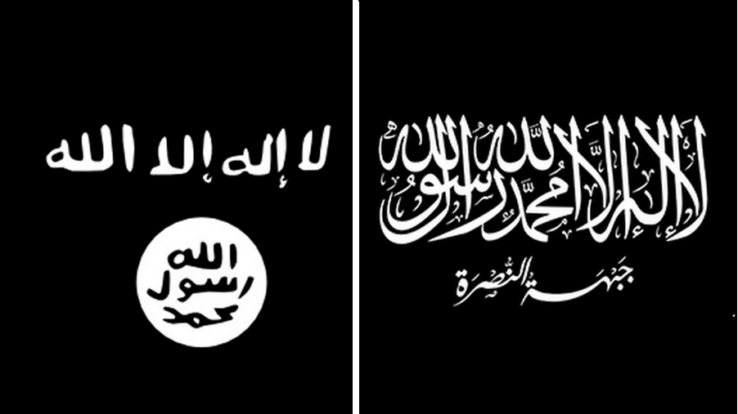
Al-Qaeda and & ISIL (Islamic State in Levant) flags in that respective order.

Major Parties Involved and Their Views

Italy
Italy’s Matteo Salvini has emerged as the predominant figure striving to unify Europe’s nationalist parties. Salvini’s right-wing League party formed a government in June 2018 with the anti-establishment Five Star Movement after an unsettled election. The M5S is divergent in its organization and ideology, neither right- nor left-wing. The League’s rise to power started in the aftermath of the financial crisis along with a big influx of migrants from North Africa. Salvini portrayed an anti-immigration and Eurosceptic stance, turning away humanitarian rescue ships from Italian ports. Italy is a fairly conservative country, but since the weakening of former Prime Minister Silvio Berlusconi’s Forza Italia party, voters have no preferences on the center-right, leaving only Salvini’s far-right League party.

Germany
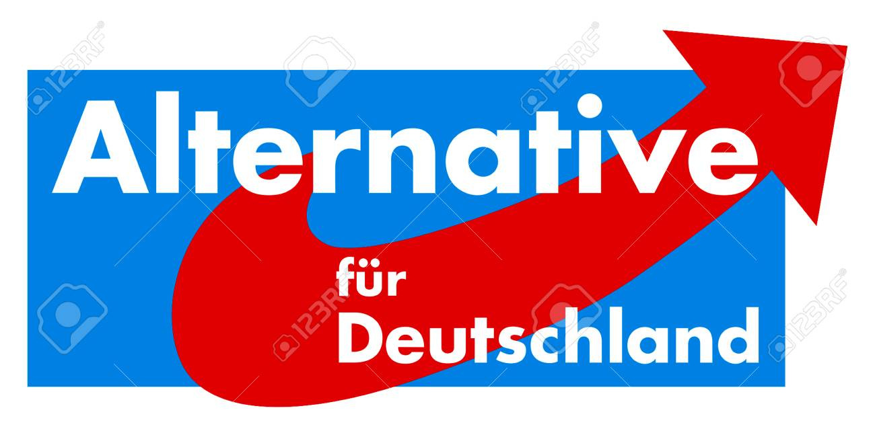
Germany is a country which has strived with nationalism alot. From 1933 to 1945 The Nazi Party (NSDAP), led by Adolf Hitler, believed in an extreme form of German nationalism. The first point of the Nazi said "We demand the unification of all Germans in the Greater Germany on the basis of the people's right to self-determination". Also in the 21st century Germany started to be dominated by right-wing parties especially in the eastern regions of Germany. The Alternative for Germany is a far-right political party in Germany. Founded in 2013, the Alternative for Germany narrowly missed the 5% electoral threshold to sit in the German federal parliament during the 2013 election. Some suggest that AfG has grown from a negligible party to a game-changer in politics. In the party, the concept of integration is interrogated: different beliefs, cultures or languages are not acceptable and compatible.
Austria
Austria is one of the first countries that comes to mind when articulating the rise of right-wing parties in Europe. FPO was formed in 1956 with close association with the Nazi’s, in fact its 2 first chairman’s were SS officers. The Freedom Party (FPO) has achieved electoral gains while forming a coalition with the conservative People’s Party. The party has taken a controversial path with allegations of corruption. Also, the deputy minister of Austria wants to “put an end to this Islamisation policies”. In response to this coalition the European Union provoked an unexpected response by opposing the xenophobic approach. Many EU member states refused to have mutual relations with Vienna.

Sweden
For many decades Sweden has been the go-to destination for refugees although after the rise of many far-right populist parties; its tolerant and generous policy can and will be challenged. Sweden’s previous Prime Minister Stefan Lofven asserted that Europe should be a borderless and tolerant alliance. As a result, Lofven implemented a policy that accepted more refugees per capita than any other country and these refugees were mostly from countries like Syria and Iraq. To integrate nearly 163,000 people into Swedish society, many Swedish languages and integration programs were implemented. However, not everyone supported these efforts. As a consequence, the support for Sweden Democrats; a far-right party with neo-Nazi roots, rose in the polls. Fueled by a contradictory approach on refugees, the party promoted slogans like “Keep Sweden Swedish”. Under Jimmie Akesson, the Sweden Democrats cooperated with new sites to extend their influence on the mainstream media.
Hungary
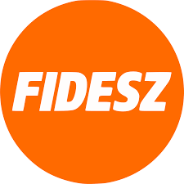
Hungary with the rise of Victor Orban and his acolytes can be shown as an apparent example of the ascending rise of the right-wing throughout the continent. Victor Orban and his Fidesz party is accused of corruption as well as destroying press freedom and legal institutions. Orban is also very critical about the EU Parliament he said: “We have to tackle the difficult task of renewing the EPP and helping it return to Christian democratic origins.” As a settlement, Orban proposed to establish a bloc that gathers all Christian-oriented parties. The Fidesz party has considerable success because it has never lost local or national elections from 2006 to 2018. However, in the 2019 elections opposition candidate scored a shock win in the Budapest mayoral race.

France
The French also have been shaken by nationalism and right-wing parties in its history. Starting with the French Revolution in 1789, the ideals of liberty, equality, and fraternity provided a basis for the modern nation-state concept as well as of nationalism. Nowadays the French remain very adhesive towards their culture, history, language, and ideals. However, the main right-wing party the National Front under the leadership of Marine Le Pain, the candidate failed to gain the presidential election against Emmanuel Macron’s party, En Marche!. Although Le Pen lost in the polls, support for the National Front in the first round of voting was up on former contests. The party's vote share in the first round has escalated in presidential elections since 1995. Especially in the rural North of France, the National Front is highly influential.

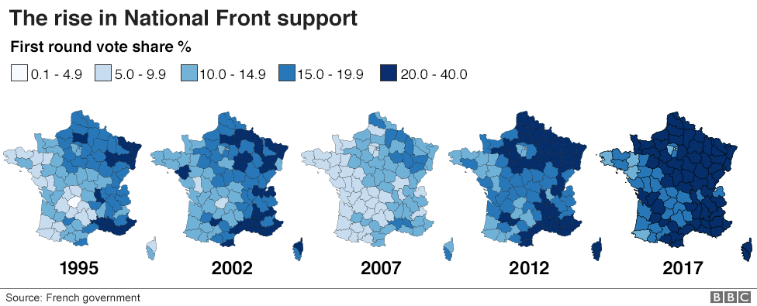

Greece
Greece is geographically isolated from the rest of the European Union, bordering Turkey to the east and Bulgaria, Macedonia and Albania to the west. Since the global economic crisis in 2009, the Greek government is having an everlasting debt crisis. The Greek governments' debt affected not only Greece but all of Europe because it threatened the stability of the eurozone which consists of 28 member states. Because of the Schengen Agreement refugees from Turkey see Greece as a gateway to entering Europe and finding high paying jobs. It can clearly be said that Greece is one of the most affected countries by the refugee crisis. More than a quarter-million refugees have reached Greece by boat and approximately 3,000 of them died in the attempt, according to the Greek governments' statistics. Like most EU member states Greece also experienced an increase in the approval of far-right parties but Greece was more influenced by it because of its already turbulent internal affairs and debt crisis. The major far-right party Golden Dawn is an ultra-nationalist neo-nazi party. The party has used figures from Nazi Germany and the party leader Michaloliakos has officially accepted to be racist and xenophobic. A leading leader even said " Golden Dawn wants to give priority to Christian asylum seekers. And, in any event, Greece can not continue to welcome everyone in. If we ever get into power, we will put economic migrants in jail, instead of hosting them in hotspots, as Syriza does." However, the party is said to have a decline in the polls, losing 18 seats in the Greek parliament since 2012. Although Michaloliakos and his acolytes continue their fight on nationalism, it is not very likely that the party will rise in the polls.

Timeline of Events

Date of Event (Day/Month/Year) | Description of Event
August 27th 2014 | UN Special Rapporteur on the promotion of truth, justice, reparation and guarantees of non-recurrence
9th May 2017 | UN Special Rapporteur report on contemporary forms of racism, racial discrimination, xenophobia and related intolerance
November 17th 2018 | Resolution of the European Parliament on the rise in neo-fascist violence in Europe.

Evaluation of Previous Attempts to Resolve the Issue

- RC-B8-0481 (2018)
- http://www.europarl.europa.eu/doceo/document/B-8-2018-0482_EN.html?redirect

Possible Solutions
Government interference and effective action taking are really important steps in resolving this crisis. The United Nations may encourage governments to implement smarter measures to limit the impact of marches and demonstrations. Also, governments can implement exit programs to help individuals to leave far-right movements and find jobs, safe social networks. To solve this crisis, in the first hand, the causes of it should be closely examined.

Further Reading
- Rising European Nationalism: Will the EU be changed forever?
https://www.youtube.com/watch?v=64UH4T6uZtg&t=89s

- The rise of European populism and collapse of the center-left.
https://www.brookings.edu/blog/order-from-chaos/2018/03/08/the-rise-of-european-populism-and-the-collapse-of-the-center-left/
- How strong is the right-wing populism after the European elections?
https://www.euractiv.com/section/eu-elections-2019/news/how-strong-is-right-wing-populism-after-the-european-elections/

- Face to face with Salvini, Italy’s far-right deputy PM
https://www.youtube.com/watch?v=5yhjyNXvqr4

Bibliography
- Benner, Thorsten. “Handling the Alternative for Germany.” Foreign Affairs, Foreign Affairs Magazine, 1 Oct. 2017, www.foreignaffairs.com/articles/europe/2017-09-29/handling-alternative-germany.
- “Combating Racism and Xenophobia.” European Commission - European Commission, 7 May 2019, ec.europa.eu/info/policies/justice-and-fundamental-rights/combatting-discrimination/racism-and-xenophobia/combating-racism-and-xenophobia_en.
- Deutsche Welle. “Austria's Far-Right Freedom Party Elects Norbert Hofer as Leader: DW: 14.09.2019.” DW.COM, www.dw.com/en/austrias-far-right-freedom-party-elects-norbert-hofer-as-leader/a-50431042.
- The Editors of Encyclopaedia Britannica. “Maastricht Treaty.” Encyclopædia Britannica, Encyclopædia Britannica, Inc., 24 Oct. 2019, www.britannica.com/event/Maastricht-Treaty.
- Foster, Alice. “Terror Attacks Timeline: From Paris and Brussels Terror to Most Recent Attacks in Europe.” Express.co.uk, Express.co.uk, 18 Aug. 2017, www.express.co.uk/news/world/693421/Terror-attacks-timeline-France-Brussels-Europe-ISIS-killings-Germany-dates-terrorism.
- Foster, Alice. “Terror Attacks Timeline: From Paris and Brussels Terror to Most Recent Attacks in Europe.” Express.co.uk, Express.co.uk, 18 Aug. 2017, www.express.co.uk/news/world/693421/Terror-attacks-timeline-France-Brussels-Europe-ISIS-killings-Germany-dates-terrorism.
- Giuffrida, Angela. “Salvini's Far-Right Party Tops Italy's EU Election Polls.” The Guardian, Guardian News and Media, 27 May 2019, www.theguardian.com/politics/2019/may/27/matteo-salvini-far-right-league-party-tops-italy-eu-election-polls.
- Henley, Jon. “Sweden: Far Right Gains Threaten Europe's Most Stable Political Order.” The Guardian, Guardian News and Media, 9 Sept. 2018, www.theguardian.com/world/2018/sep/09/despite-making-gains-swedens-far-right-party-remains-out-of-power.
- Jackson, Richard. “War on Terrorism.” Encyclopædia Britannica, Encyclopædia Britannica, Inc., 19 Nov. 2018, www.britannica.com/topic/war-on-terrorism.
- Joffe, Josef. “The Right Is Rising and Social Democracy Is Dying across Europe – but Why? | Josef Joffe.” The Guardian, Guardian News and Media, 29 Sept. 2017, www.theguardian.com/commentisfree/2017/sep/29/right-social-democracy-dying-europe-afd-far-right-germany.
- Kohn, Hans. “Nationalism.” Encyclopædia Britannica, Encyclopædia Britannica, Inc., 14 Oct. 2019, www.britannica.com/topic/nationalism.
- Mamonova, Natalia, et al. “Right-Wing Populism and Counter-Movements in Rural Europe: ARC2020.” Agricultural and Rural Convention, 5 May 2019, www.arc2020.eu/right-wing-populism-emancipatory-rural-politics-initiative-europe/.
- Mudde, Cas. “What the Stunning Success of AfD Means for Germany and Europe | Cas Mudde.” The Guardian, Guardian News and Media, 24 Sept. 2017, www.theguardian.com/commentisfree/2017/sep/24/germany-elections-afd-europe-immigration-merkel-radical-right.
- “National Front.” The Independent, Independent Digital News and Media, www.independent.co.uk/topic/national-front.
- “The Rise of Radical Right-Wing Populism in the EU.” The Rise of Radical Right-Wing Populism in the EU | Institute of European Studies, ies.berkeley.edu/blog/rise-radical-right-wing-populism-eu.
- “Schengen: Controversial EU Free Movement Deal Explained.” BBC News, BBC, 24 Apr. 2016, www.bbc.com/news/world-europe-13194723.
- Visual Site Design - Esoteric Website Design, website hosting and website management specialists. “The Hermetic Order of the Golden Dawn ® (H.O.G.D.) Central on-Line Resources for the Golden Dawn System of Magic.” The Hermetic Order of the Golden Dawn ® (H.O.G.D.) Central on-Line Resources for the Golden Dawn System of Magic, www.hermeticgoldendawn.org/.
- Zerofsky, Elisabeth. “Viktor Orbán's Far-Right Vision for Europe.” The New Yorker, The New Yorker, 25 June 2019, www.newyorker.com/magazine/2019/01/14/viktor-orbans-far-right-vision-for-europe.

