2019

CHAIR REPORT

GA6: ECONOMIC AND FINANCIAL COMMITTEE (ECOFIN)

INCREASING THE PRODUCTIVITY OF LEAST DEVELOPED COUNTRIES BY SCIENTIFIC INNOVATION

SEZER CAN KABATAS (DEPUTY CHAIR)

Introduction
Lack of qualified labor force, Lack of qualified labor force, insufficient natural resources, unfavorable geographical conditions, insufficient infrastructure and superstructure investments, not being close to energy resources and market etc. factors cause development differences between countries and regions within countries. As this difference goes over an unacceptable level, it may lead to serious socio-economic and cultural problems; poverty, anarchy, terrorism and wars. In order to minimize these problems, various specialized agencies are actively operating. The main purpose of these studies is to develop LDCs, increasing the global competitiveness.

The issue of development in Least Developed Countries (LDCs) has been a dominant issue at the United Nations. United Nations started to pay more attention to economic development in the 1960’s, especially after the establishment of the United Nations Development Program (UNDP) in 1965, and today the majority of the UN budget, and the activities of its specialized agencies, are dealing with development-related issues. This issue has received the most attention amongst others in terms of time and resources in the UN.

Science, technology and innovation (STI) can play a huge role in the process of becoming more efficient, effective and productive. Many innovations have been developed and have spread worldwide very fast, improving health, providing economic opportunities and addressing climate change. Digital technologies like mobile phones and Internet have created an era where ideas, knowledge and data can be shared and spread,

Despite the potential of STI’s to transform countries’ economic conditions, a lack of clarity remains about how Least Developed Countries can adopt it effectively for inclusive and sustainable development. LDCs cannot simply invest substantially in research and development (R&D) activities with limited financial resources.

Key Vocabulary
LDCs are Least Developed Countries
STI is the acronym for Science, Technology and Innovation
UNCTAD is the acronym for United Nations Conference on Trade and Development
UNESCO is the acronym for United Nations Educational, Scientific and Cultural Organization
ECOSOC is a permanent council of the United Nations; responsible for economic and social conditions. Economic and Social Council.
UNDP is the acronym for Development Programme
R&D is the acronym for Research and Development
SDGs is the acronym for Sustainable Development Goals

Focused Overview
1)What are the Least Developed Countries?
“There are 47 countries currently designated by the United Nations as Least Developed Countries (LDCs) to which UNCTAD devotes its annual Least Developed Countries Report published in November 2018. They are:
Afghanistan, Angola, Bangladesh, Benin, Bhutan, Burkina Faso, Burundi, Cambodia, Central African Republic, Chad, Comoros, the Democratic Republic of the Congo, Djibouti, Eritrea, Ethiopia, Gambia, Guinea, Guinea-Bissau, Haiti, Kiribati, Lao People’s Democratic Republic, Lesotho, Liberia, Madagascar, Malawi, Mali, Mauritania, Mozambique, Myanmar, Nepal, Niger, Rwanda, Sao Tome and Principe, Senegal, Sierra Leone, Solomon Islands, Somalia, South Sudan, the Sudan, Timor-Leste, Togo, Tuvalu, Uganda, United Republic of Tanzania, Vanuatu, Yemen, Zambia.

This list is reviewed every three years by the Committee for Development Policy, a group of independent experts that reports to the United Nations Economic and Social Council (ECOSOC). In reporting to ECOSOC, the committee may recommend countries for addition to, or exclusion from (so-called “graduation” from), the list of LDCs.
The committee used per-capita income, human assets, and economic vulnerability criteria in its most recent review in March 2018 (see box below). For all three criteria, the committee uses different thresholds to identify countries to be added to the
category and for countries which will graduate.

A country will qualify to be added if it meets the addition thresholds on all three criteria and does not have a population greater than 75 million. Qualification for addition to the list will effectively lead to LDC status only if the relevant country accepts this status.

A country will typically qualify for graduation from LDC status if it has met graduation thresholds under at least two of the three criteria in at least two consecutive triennial reviews of the list.

However, if the three-year average per-capita gross national income of a least developed country has risen to a level at least double the graduation threshold (i.e., $2,460), and if this performance is considered sustainable, the country will be deemed eligible for graduation regardless of its score under the other two criteria.

The following three criteria were used by the Committee for Development policy in its latest review of the Least Developed Country category in March 2018:
• A per-capita income criterion, based on a three-year average estimate of the gross national income per capita, with a threshold of $1,025 for identifying possible cases of addition to the list, and a threshold of $1,230 for possible cases of graduation

• A human assets criterion, involving a composite index (the human assets index) based on indicators of nutrition (percentage of undernourished population); child mortality (under 5 years of age, per 1,000 live births); maternal mortality (per 100,000 live births); school enrolment (gross secondary enrolment ratio); and literacy (adult literacy ratio)

• An economic vulnerability criterion, involving a composite index (the economic vulnerability index) based on indicators of natural shocks (index of instability of agricultural production; share of victims of natural disasters); trade-related shocks (index of instability of exports of goods and services); physical exposure to shocks (share of population living in low-lying areas); economic exposure to shocks (share of agriculture, forestry and fisheries in gross domestic product; index of merchandise export concentration); smallness (population in logarithm); and remoteness (index of remoteness)”(UNCTAD)
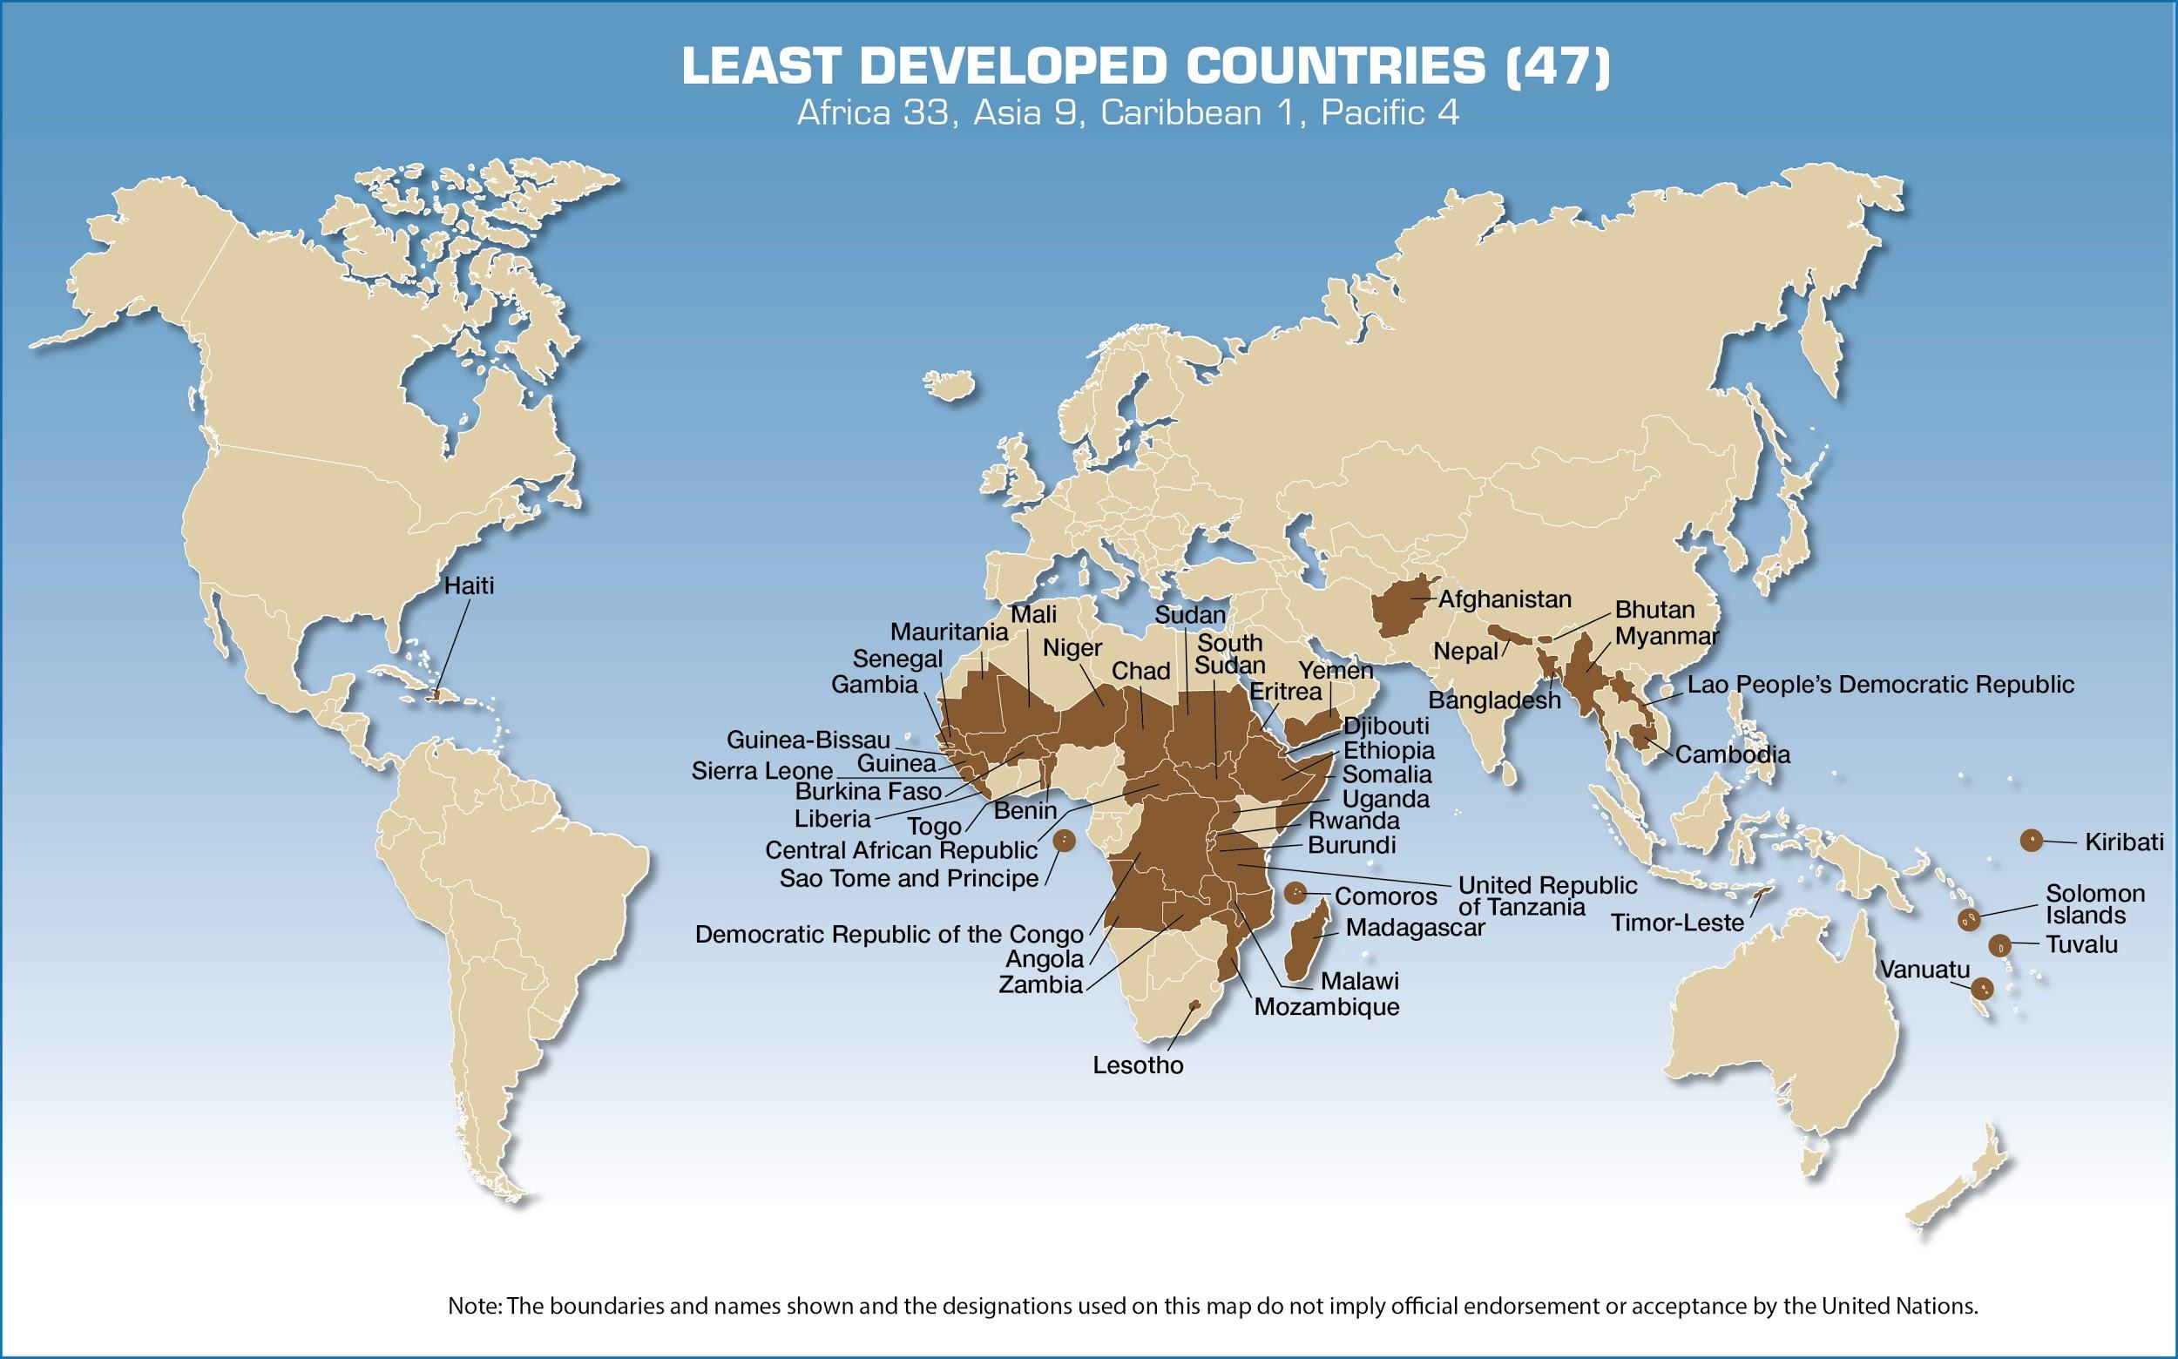

2)Developing Productive Capacities Through Science, Technology and Innovation

“The 2011 Multi-Year Expert Meeting on Enterprise Development and Capacity–Building in Science, Technology and Innovation was the third in as many years. The outcome has been used to design a “policy toolkit” that governments may use to promote entrepreneurship and innovation in domestic firms. The meetings stressed the importance of developing national technological and innovation capabilities, accessing needed technologies, using existing technologies in novel ways, and creating national STI policies for reducing poverty, with a focus on the agricultural sector. An e-forum was created to support the exchange of views and information among the participants and between them and other stakeholders.
Per capita food production in LDCs has declined continuously since the early 1970s. Agriculture is important for food security but building productive capacities in agriculture and linking it to other sectors is vital to supporting sustainable development. UNCTAD’s efforts in identifying processes that will promote technological change, productivity increases and innovation, in support of agricultural development are represented in the Technology and Innovation Report 2010: Enhancing Food Security in Africa Through Science, Technology and Innovation. The Report includes case studies, a section on implementing a uniquely African Green Revolution, and policy recommendations.
In the Science, Technology and Innovation Policy (STIP) Review process, UNCTAD works with national science and technology institutions to improve their overall environment for the development of technology and innovation. Reviews have been done for LDCs Angola, Lesotho and Mauritania.
The 2030 Agenda, the IPoA and the AAAA all recognize the contribution of science, technology and innovation to sustainable development. Indeed, the spread of scientific and technological progress and innovation has a great potential to accelerate human progress, to bridge the digital divide and to develop knowledge societies across areas as diverse as medicine and energy in the LDCs.

“Significant investments in science, technology and innovation (STI) and commitments from governments are crucial to reach the full potential of STI for achieving the Sustainable Development Goals (SDGs), as recommended by the UN Secretary-General’s Scientific Advisory Board, for which UNESCO is the Secretariat. In fact, data from the UNESCO Institute for Statistics indicate that, in 2013, the world spent US$1.7 trillion (in purchasing power parities) on scientific research and experimental development (R&D), but only US$5 billion of that amount, or 0.29% of the total, was spent in LDCs. Similarly, there were almost 7.8 million researchers in the world, but only 59,000 of them were living in LDCs. Many countries and regions have set targets for their relative level of R&D expenditure. The EU for example has pledged to devote 3% of GDP to R&D by the year 2020, whereas the African Union fixed a target of 1% of GDP over a decade ago. China is on track to reach its own target of a 2.5% ratio by 2020. Globally, the world devoted 1.70% of its GDP on R&D in 2013, up from 1.53% in 2000. During that same period, R&D intensity increased from 0.21% to 0.24% in LDCs. While this trend demonstrates that LDCs are focusing more resources on R&D to achieve more inclusive growth and sustainable development, while concomitantly buffering their economies from the vagaries of fluctuating global commodities prices, it is still insufficient to tackle the myriad of development issues which could be resolved with the aid of R&D.

As indicated in the UNESCO Science Report, towards 2030 , the private sector is either not surveyed or makes a negligible contribution to research expenditure in LDCs. This is where LDCs and high-income countries diverge most: the UK government devoted just 0.44% of GDP to R&D in 2013 but British businesses contributed a further 1.05%. Even in Germany and the USA, the government contributed only 0.85% and 0.76% of GDP respectively, compared to 1.91% and 1.92% for the business enterprise sector. As it is the private sector which contributes the lion’s share of research expenditure in developed countries, a stronger private sector could make all the difference in LDCs to boosting investments in R&D.
Malawi is a good example of an LDC that is encouraging more private sector investment in R&D. According to the UNESCO study Mapping Research and Innovation in the Republic of Malawi (2014), cited in UNESCO’s Science Report, the government has introduced a number of fiscal
incentives to attract foreign investors, including tax breaks, in order to foster technology transfer, develop human capital and empower the private sector to drive economic growth. In 2013, the Malawi Investment and Trade Centre put together an investment portfolio spanning 20 companies in the country’s six major economic growth sectors, namely agriculture, manufacturing, energy (bioenergy, mobile electricity), tourism (ecolodges) and infrastructure (wastewater services, fiber optic cables, etc.) and mining. The Malawi Innovation Challenge Fund provides businesses in Malawi’s agricultural and manufacturing sectors with competitive grant funding for innovative projects which have a potentially strong social impact and could help the country to diversify its narrow range of exports. The fund is endowed with US$8 million from the United Nations Development Programme and the UK Department for International Development. The great majority of foreign investors in 2012 came from China (46%) and the UK (46%).
Many LDCs are striving to improve the efficiency of their agriculture sector and to develop their manufacturing capabilities, observes the UNESCO Science Report. There is a need to add value to agricultural products through agro-processing and to improve productivity. As an example, the Perspective Plan of Bangladesh to 2021 acknowledges that industrial expansion will need to go hand in hand with more productive agriculture. Vision 2021 sets out to increase productivity in all spheres of the Bangladeshi economy, including through technology parks and a National Technology Transfer Office. The aim is to attain self-sufficiency in food, reduce the proportion of the workforce employed in agriculture from 48% to 30% and raise the contribution of manufacturing from 17% to about 27% of GDP. One of the key deliverables of the Addis Ababa Action Agenda is the decision by Member States to establish a technology facilitation mechanism (TFM) to support the successful implementation of the SDGs. In collaboration with sister UN agencies, the private sector and the scientific community, UNESCO is actively supporting the development of the three complementary components of the TFM, i.e. a UN interagency task team on STI for the SDGs; a multi-stakeholder forum on STI for the SDGs; and an online platform as a gateway for information on existing 8STI initiatives, mechanisms and programs. UNESCO is also building a global database on STI policy instruments, legislation and institutional frameworks in the framework of its Global Observatory on Science, Technology and Innovation Policy Instruments (GO-SPIN) Programme, which, along with its UNESCO Science Report, provides an important qualitative monitoring mechanism on the role of STI in achieving the SDGs in the LDCs. Further to the TFM, a dedicated Technology Bank for the LDCs is another key deliverable of the IPoA, the AAAA and the 2030 Agenda. UNESCO is actively supporting the development of the technology bank, whose objective is to “help improve least developed countries scientific research and innovation base, promote networking among researchers and research institutions, help LDCs access and utilize critical technologies, and draw together bilateral and multilateral institutes and the private sector, building on existing international initiatives.” Both the TFM and the TB will be important mechanisms for supporting LDCs in fully utilizing science, technology and innovation to achieve their development goals.”(UNESCO)

Major Parties Involved and Their Views

UNESCO

UNESCO has worked with 15 African LDCs over the past three years in the field of STI policy to provide policy advice and capacity building to improve the governance of their STI systems. Through its Global Observatory of Science, Technology and Policy Instruments (GO-SPIN), UNESCO has also been providing support to African LDCs in reforming and upgrading their national STI systems and enabling policy makers and researchers to monitor and evaluate their STI policies and programmes.

UNCTAD
UNCTAD believes that building science, technology and innovation capacity in LDCs is intrinsically linked with the development of productive capacities and is vital for long-term growth.
Since its founding in 1964, UNCTAD has addressed the trade and development challenges of developing countries, consistently advocating special and differential treatment in support of least developed countries (LDCs) since its inception. Initial work on the “differing characteristics and stages of development of developing countries” resulted in the designation of the specific group of LDCs by the General Assembly in 1971.
Through its research and policy analysis, technical cooperation and consensus building, UNCTAD has been in the forefront of efforts in support of LDC development.
The United Nations has convened four decennial United Nations Conferences on the Least Developed Countries. The first three conferences – held in 1981, 1990 and 2001 – were coordinated by UNCTAD. The third conference in Brussels agreed on the Programme of Action for the Least Developed Countries for the Decade 2001–2010. The United Nations Office of the High Representative for the Least Developed Countries, Landlocked Developing Countries and Small Island Developing States (UN-OHRLLS) has organized the 2011 Fourth United Nations Conference on Least Developed Countries (LDC IV) in Istanbul.
Date of Event (Day/Month/Year) | Description of Event
30/12/1964 | Establishment of UNCTAD
22/11/1965 | Establishment of UNDP
1994 | Graduation of Botswana from LDC status
2007 | Graduation of Cape Verde from LDC status
2011 | Graduation of Maldives from LDC status
2014 | Graduation of Samoa from LDC status
2017 | Graduation of Equatorial Guinea from LDC status
2020 | Graduation of Vanatu from LDC status
2021 | Graduation of Angola from LDC status
2023 | Graduation of Bhutan from LDC status
2024 | Graduation of São Tomé and Príncipe from LDC status
2024 | Graduation of Solomon Islands from LDC status

Evaluation of Previous Attempts to Resolve the Issue

A/RES/72/228 https://unctad.org/en/PublicationsLibrary/A_res_72_228_en.pdf

Possible Solutions

Although there have been attempts to resolve the issue, the reason why this issue remains prevalent is not having the adequate infrastructure. LDCs won’t be able to be developed scientifically or technologically as they remain underdeveloped in essential areas such as education, healthcare etc. and don’t provide basic needs of human like food, water, electricity etc.

Further Reading
https://www.un.org/ldcportal/ldc-technology-bank/
https://www.oecd.org/innovation/inno/50586251.pdf
https://www.thoughtco.com/rostows-stages-of-growth-development-model-1434564

Bibliography
- Bokova, I.G. “Sustainable Development in the Least Developed Countries, Towards 2030.” Unesdoc.unesco.org, UNESCO, 2016, unesdoc.unesco.org/ark:/48223/pf0000244835.
- “Building Productive Capacities: UNCTAD Support for LDCs.” BUILDING PRODUCTIVE CAPACITIES: UNCTAD SUPPORT FOR LDCS, UNCTAD, unctad.org/en/PublicationsLibrary/aldc2011d3_en.pdf.
- “Press Release.” UNCTAD, 20 Nov. 2018, unctad.org/en/pages/PressRelease.aspx?OriginalVersionID=486.
- Science, Technology and Innovation for Sustainable Development in Asia and the Pacific Policy Approaches for Least Developed Countries. United Nations, 2016.
- “Third World Development Programming.” Great Debates at the United Nations: an Encyclopedia of Fifty Key Issues 1945-2000, by Robert F. Gorman, Greenwood Press, 2001, pp. 193–201.

